Democracy’s eternal vulnerability: Increasing resilience to disinformation by raising the two components of political truth literacy

Questionnaire Description
Contents
Overview 2
Replication 2
Questionnaire sections 3
Section 1 – Getting Started 4
Section 2 – Review Section (training for 3 treatment groups) 5
Treatment Group 1 – Control 7
Article 1 Training 7
Article 2 Training 10
Article 3 Training 13
Treatment group 2 – Claim Training (LTQ) 17
The concept of truth literacy 17
How arguments work 19
Cherry Picking 19
The Strong Evidence Rule 26
Common Political Fallacies 30
The Personal Truth Test 32
Treatment Group 3 – Claim and Vote Training (LTQ and AAQ) 33
Three rules for the health of democracy 33
The Personal Truth Test – Additional training material 35
Section 3 - Decision Making Section (measurement using 17 statements) 37
1. Crime Is On the Rise – False, appeal to emotion 37
2. Import Tariff – True, correct application of Strong Evidence Rule 38
3. National Minimum Wage – False, flawed application of Strong Evidence Rule 38
4. Golden Opportunity – False, cherry picking 38
5. Water Quality Tourists Sick – False, flawed application of Strong Evidence Rule 39
6. Dumping – False, cherry picking 39
7. Tour Scammers - False, flawed application of Strong Evidence Rule 39
8. Drug Addiction - True, correct application of Strong Evidence Rule 40
9. Unemployment – False, cherry picking 40
10. Strippled Eagle - True, correct application of Strong Evidence Rule 40
11. Highway System Maintenance - False, flawed application of Strong Evidence Rule 41
12. Highest Quality of Life – False, cherry picking 41
13. Lower Traffic Accident Rates – False, false fact lie fallacy 41
14. Asteroid Could Strike - True, correct application of Strong Evidence Rule 41
15. Expert Witness – False, ad hominem 42
16. Trade Agreement Treaty – False, false dilemma 42
17. Teacher Shortage – False, strawman 42
Section 4 - End Section 42
Feedback Questions 42
Demographics 43
Section 5 – Completion 44

Overview
This document describes the Truth Literacy Training questionnaire in detail, for the purpose of evaluation of the strength of the hypotheses it supports via study results, and to aid those considering replicating the study or developing similar studies. For more detail, please contact the lead author.
The questionnaire supports two purposes: Truth Literacy Training and measurement of DTQ and LTQ. Since DTQ = LTQ x AAQ as described in the main paper, AAQ may be calculated by AAQ = DTQ / LTQ.
This was a major study. Questionnaire development was an enormous amount of work, since no directly applicable prior training or measurement research exists, due to the novelty of the DTQ equation. Slowly developing a reliable method of both training and measurement required first a manual system using printed questionnaires, tested on 5 to 10 colleagues for each iteration. This provided the basic concepts. Then we moved to software with a browser user interface, followed by many rounds of self-testing, and then panel testing using Prolific.com subjects. The latter took so long that approximately 80% of panel testing was pre-testing, using group sizes of 5 or 6. The remaining 20% was the 93 subjects used for the final study.
In addition, no available software could support the training user interface required for efficient and effective training. This forced us to build an elaborate software system. For this we chose JavaScript for the frontend and backend, using a Node framework and a relational database.
Please note this is a first-iteration proof-of-concept study implemented rapidly on a low budget. There is plenty of room for improvement.

Replication
For this study to be replicated in a manner that tests the hypotheses that DTQ is currently low in most democracies and can be raised to at least medium with a practical method and a modest amount of training, a researcher(s) would need to:
- Develop their own political statements. To eliminate bias, these should be non-hot, i.e. not related to any politicians, parties, or issues that arouse strong feelings. Yet they should be representative of typical political statements in terms of complexity and wording. Some should be true. Others should be false due to errors in logic, i.e. fallacious reasoning. We found designing statements to be so difficult that production averaged about two per day, since most were eliminated by inspection by others of pre-testing. The study used 17 statements on the first questionnaire run and 9 on the follow up.
- Develop their own training rather than use ours, which could have biases and weaknesses that only developing another training approach could reveal or test. However, we expect that any effective training must have the equivalent of the Personal Truth Test, the Strong Evidence Rule, and a catalogue of fallacies, i.e. errors of reasoning. This is because these components appear to model the way people think when processing statements for truthfulness. The training must also have the equivalent of the Reward the Truth Teller and Penalize the Deceiver rules, which are used for vote training, for reasons discussed in the main paper.
- Design their own measurement questions or use ours.
- Develop their own software or use ours, which can be modified (mostly) without programming by changing the configuration stored in the database. The configuration includes the text used for all portions of the questionnaire and lists of statements, which are presented to subjects in randomized order. Up to 9 different treatment groups are supported. Use of online panels like Prolific.com is supported. Subjects are randomly assigned to different treatment groups.

Questionnaire sections
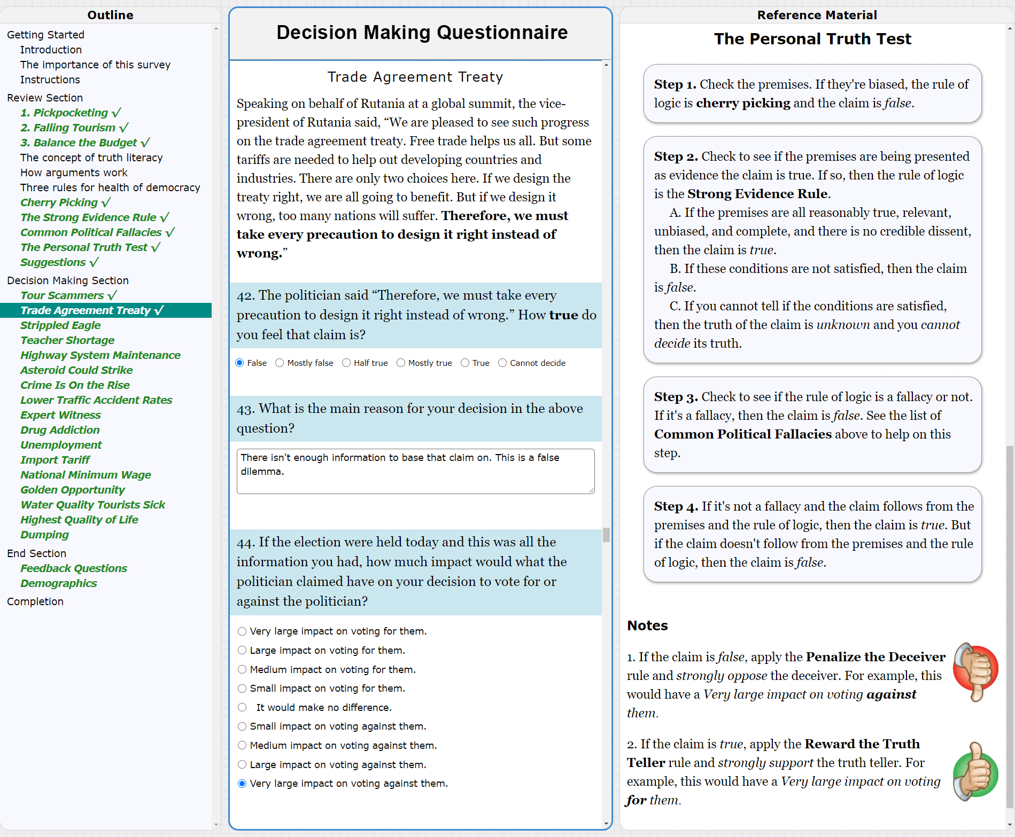
Figure 1. User interface for the online Truth Literacy Training study, group 3. This runs in any popular browser. (This is Figure 4 in the main paper.)
The questionnaire consisted of five sections as seen in the Outline panel in Figure 1. The only section that varied per group was the Review Section, which varied the type of training used for each treatment group: (1) control, (2) claim training, and (3) claim and vote training.
The subject in Figure 1 has completed the LTQ and AAQ training, done in the Getting Started and Review Section in the left panel. They have just answered three questions concerning a statement about a Trade Agreement Treaty. The claim in the statement is bolded. All three answers are correct. The Personal Truth Test is shown on the right panel. Notes are the two vote training rules. The subject scrolls up to see the rest of the Reference Material. Using the left panel, subjects can navigate anywhere in the questionnaire to review their decisions or training material, which reduces anxiety and improves quality of answers. Checks indicate a completed item. Decision answers can be easily reviewed and changed.
We have numbered the sections here from 1 to 5. They are not numbered on the user interface for simplicity.

Section 1 – Getting Started
This is the same for all groups. It contains this text:

Introduction
SPECIAL NOTE - This is a longitudinal study over time. In addition to taking this survey, you will be invited to take a second follow up survey in one to two weeks. If you cannot take the second survey, you should return this survey now.
This is a long questionnaire with lots of reading material, over 80 questions, and an estimated completion time of 70 minutes. You should not start this survey unless you intend to thoughtfully read the material and answer all the questions.
You are welcome to take breaks as needed, including a built in five minute break about half way through.
After you have answered some of the questions, you will be presented with reading material for the next questions. Reading it too fast or guessing at the answers is valid cause for rejection. Please take the time to slow down and thoughtfully read the material and think through the questions. We expect you will find some of the material very useful.
This survey is run by Thwink.org. All data will be held strictly confidential and is only used for research. No personally identifiable data is collected.
The software is designed so that if you leave this page and return, or even close this tab or the browser and return, all your answers are restored. You can then continue until the questionnaire is complete.
The importance of this survey
The goal of this survey is to study how people make decisions about issues and politicians, for the purpose of improving The Health of Democracy. This is an extremely important subject.
Here's why this is important. If the democracies of the world run well, then quality of life can be high for most people, and problems like recurring wars, large-scale discrimination, high inequality of wealth, and environmental sustainability CAN be solved.
But if democracy doesn't run well, these problems will tend to NOT be solved. If that happens, average quality of life cannot be high and will instead fall from where it is now. The result for us and our children would be unpleasant, to say the least.
With this in mind, we deeply appreciate your taking the time to take this survey. We look forward to your thoughtful answers.
Instructions
Imagine yourself living in the fictitious country of Rutania. It has 25 cities, is a democracy, has a temperate climate, and has a thriving manufacturing sector. That is all you know about Rutania.
This survey consists of statements made by politicians living in Rutania and questions about the statements. There are also some practice questions. Each statement contains a claim, which is bolded. A claim is a proposition the speaker or writer claims is true.
Each statement is followed by one or more questions. Your answers should be based only on the content in the statement and should not be affected by knowledge of current events.
After reading statements and providing your answers, click the Review button. This will reveal review material to thoughtfully read. Please note that after you click a Review button, you cannot change the above answers.
All answers are required unless noted otherwise.

Section 2 – Review Section (training for 3 treatment groups)

1. Pickpocketing
Rutania has many tourist attractions, 25 cities, and a temperate climate. In a campaign speech a candidate said,
“Pickpocketing is up 10% in City A. It’s up 12% in City B. Pickpocketing is one of Rutania’s biggest problems, since we depend so much on tourism. We must take action.”
The candidate has said about the same thing in several other speeches. The data about how high pickpocketing is in different cities comes from the average of current government and independent studies.
1. The politician said “Pickpocketing is one of Rutania’s biggest problems, since we depend so much on tourism. We must take action.” How true do you feel that claim is? [This is the TRUTH QUESTION.]
- False, - Mostly False, - Half true, - Mostly true, - True, - Cannot decide

2. What is the main reason for your decision in the above question?
(Textbox for the answer. This answer is not used for scoring, but only to maintain cognitive motivation and give us feedback. This is the MAIN REASON QUESTION.)

3. If the election were held today and this was all the information you had, how much impact would what the politician claimed have on your decision to vote for or against the politician? [This is the VOTE QUESTION.]
Choices:
-
Very large impact on voting for them.
- Large impact on voting for them.
- Medium impact on voting for them.
- Small impact on voting for them.
- It would make no difference.
- Small impact on voting against them.
- Medium impact on voting against them.
- Large impact on voting against them.
- Very large impact on voting against them.

2. Falling Tourism
Recent studies show tourism in Rutania is falling. Referring to those studies, a politician said:
“We have begun more extensive research on the problem of falling tourism using outside experts. However, I have just interviewed two tourists, a couple from Hong Kong. They report that the reason they’re not coming back is we have terribly heavy traffic in their favorite tourist destinations. I heard the same thing last week when my uncle visited from France. He even said that if we could somehow cut the traffic down to normal amounts, Rutania would be the perfect tourist destination and we couldn’t keep people way. So, I think we’ve found the cause of the problem. But let’s wait and see if the outside experts agree.”
Rutania has a highly trusted Office of the Budget, so it is solid data.
(The three questions follow the standard format shown above for the Pickpocketing statement.)

3. Balance the Budget
During a speech, the president of Rutania pointed to her record on balancing the budget.
“When I came into office 3 years ago, the budget hadn't been balanced for eight years, even though we were not recovering from a recession. By adjusting several programs and not cutting any important services, I was able to balance the budget my second year in office. This has continued in my third year and economic growth has not been affected. The budget was balanced during this administration due to my efforts.”
Several articles written by highly credible journalists verified this information, even though some of the president’s political opponents attacked what she said. No article disagreed. The attacks were shown by the same journalists to be groundless.
(The three questions follow the standard format shown above for the Pickpocketing statement.)
Please note that after clicking the Review button, the above answers cannot be changed.
Review Answers
(After the button is clicked, if all questions have been answered, additional text appears.)

IMPORTANT - (The following sections vary per treatment group.)

Treatment Group 1 – Control
(This is training on a neutral topic of similar cognitive demand and time, compared to the training the other treatment groups receive.)

Introduction
The above three statements are typical of political appeals. We see statements like this all the time because in a democracy, politicians are free to say what they want. Freedom of speech and freedom to choose one’s leaders lie at the very core of the concept of democracy.
The following material offers many insights into how democracy is structured, why voters should be informed, and the importance of decision making when it comes to voting. This material is collected from various articles. While the material uses mostly American examples, it applies to any democratic country.

Article 1 Training
Democracy - A good word for the good old way
This article will appear in the right panel. To read it click the button below. After reading it, click the Proceed button.
Show Article
Democracy: A good word for the good old way
By Professor Ringen, September 6, 2018, source.
Amidst the scramble for new-fangled forms of democracy, spare a thought for the excellence of the good old way.
Citizens elect representatives to make laws and oversee governance on their behalf. The simple design of representation by election is in fact a very smart arrangement, much smarter than is often appreciated. Is solves three problems in one go: a problem of power, a problem of size and a problem of quality.
Power. Since representatives are elected by citizens and can be deselected by them at the next election, they govern under popular control. We have one of the requirements of democracy: politician accountability. The problem of power is solved. The people hold power over those who exercise power over them.
Size. When the American republic was created, a way needed to be found to govern a large territory with the consent of the people who lived dispersed over that territory.
The previous republican experience was that of cities governing themselves, such as in the Italian city states of the Renaissance. The previous democratic experience was that of direct democracy. Some of this could be replicated in America on the local level (and there was experience of direct town democracy before the consolidation of the federation) but a new model was needed for national (and state) government.
The Founding Fathers settled for localities sending representatives to the capital to manage public affairs in the place of citizens themselves. The method of representation by election is an invention of the American Constitution. Without this invention we could not have had national democracies.
Quality. Governance should be safe but also effective. The representative method puts decision-making in good hands, which the direct democracy does not, and delegates the responsibility of decision-making to an assembly, which the autocratic method does not.
One purpose of elections is to give us the opportunity to appoint those among us who are the more qualified to do the job. The advantage of decision-making by assembly is that it enables the institutionalization of rules and procedures of good decision-making and that it offers the chance for proper deliberation.
In an assembly of representatives who are more numerous than a small committee of like-minded apparatchiks, who are from different parts of the country and with different backgrounds and who are elected on different political platforms, there is a good chance that decisions will be tested by robust debate.
Although we must make the qualification that democracies always work imperfectly, sometimes very imperfectly, these are real benefits in the method of representation by election. That is a method we should not easily give up on, and one we should probably value more than we do.

Now we have a few questions.
10. How did invention of democracy solve the problem of power?
- By politician accountability.
- By localities sending representatives to the capital to manage public affairs in the place of citizens themselves.
- By citizens electing representatives.

(After each question is answered, additional text appears.)

The correct answer is the third choice, By citizens electing representatives. Elections lead to the first two choices, politician accountability and sending elected representatives to the capital.

11. How did invention of democracy solve the problem of size?
- By the consent of the people who lived dispersed over that territory.
- By localities sending representatives to the capital to manage public affairs in the place of citizens themselves.
- By representation by election.
The correct answer is the second choice, By localities sending representatives to the capital to manage public affairs in the place of citizens themselves. While this looks like good common sense today, it was a radically new invention. It was essentially a new way of thinking.
12. How did invention of democracy solve the problem of quality?
- By delegating the responsibility of decision-making to an assembly.
- By invention of the concept of a nation’s constitution, so that the mechanisms leading to quality are written down.
- By an assembly of representatives who are more numerous than a small committee of like-minded apparatchiks.
The correct answer is the first choice, By delegating the responsibility of decision-making to an assembly. This improves quality, because citizens can elect representatives are more qualified to do the job of government that a typical citizen is. Essentially, citizens elect qualified specialists to perform a specialty job.
This delegation by voting leads to the third choice, an assembly of representatives who are more numerous than a small committee of like-minded apparatchiks. Because the representatives are from different parts of the country and have different backgrounds and are elected on different political platforms, there is a good chance that their decisions will be tested and thereby improved by robust debate.
13. What is the main benefit of representation by election?
- Politician accountability.
- Solving the problems of power, size, and quality in one go.
- Better governmental decisions due to more qualified representatives and robust debate.
The correct answer is the second choice, Solving the problems of power, size, and quality in one go. Amazingly enough, election of political leaders solves all three of these problems at the same time:
1. It solves the problem of power by politician accountability.
2. It solves the problem of size by many citizens elect a small number of representatives. This scales up to large nations of any size.
3. It solves the problem of quality by appointing those who are more qualified to perform the job of governance.
14. In direct democracy, such as practiced in ancient Athens, all voting citizens congregate regularly to discuss and make joint decisions on important governance issues. Why is direct democracy not suitable for modern times?
- Because once the number of citizens becomes very large, over about 20,000 people, it’s impossible to debate a topic thoroughly and in a high-quality manner with equal participation.
- Because direct democracy does not offer the efficiency of representative democracy.
- Because in modern times we have specialization of jobs, while long ago most people could perform many different jobs because they were more self-sufficient.
The correct answer is the first choice, due to the limit of about 10,000 people for a workable direct democracy. For example, 6,000 people attended a typical assembly in ancient Athens. Votes on decisions were taken by a show of hands, or counting of stones or broken pottery.
While the second and third choices are true, neither explains exactly why direct democracy is not suitable for modern times. Today’s nations are much larger than the city state of ancient Athens, which had only 40,000 to 60,000 legal citizens. Of these, only about ten percent attended each assembly.

Article 2 Training

Policy making in the US democracy
This article will appear in the right panel. To read it click the button below. After reading it, click the Proceed button.
Show Article
Policy making in the US democracy

By USHistory.org, source.
Congress, the President, the Cabinet, advisers, agency bureaucrats, federal and state courts, political parties, interest groups, the media... All of these groups interact to make political decisions in the United States.
Public policy is a goal-oriented course of action that the government follows in dealing with a problem or issue in the country. Public policies are based on law, but many people other than legislators set them. Individuals, groups, and even government agencies that do not comply with policies can be penalized. This complicated process goes through a predictable series of steps:
1. Recognizing the problem - At any given time, many conditions disturb or distress people, such as unsafe workplaces, natural disasters like tornadoes and earthquakes, crime, pollution, or the cost of medical care. But all disturbing conditions do not automatically become problems. People have to recognize that government can and should do something about them. For example, most citizens probably do not expect government to prevent hurricanes. However, they may expect government to help hurricane victims through quick relief actions.
2. Agenda setting - An agenda is a set of problems that government wants to solve. Usually there are so many of them that they must be prioritized, with some problems getting earlier and more attention than others. Agenda setting may respond to pressure from interest groups, political parties, the media, and other branches of government. Agendas usually are reshaped when a new president takes office or when the majority party in Congress changes after an election. A crisis such as war, depression, natural disasters, or a tragic accident, almost always re-prioritizes issues.
3. Formulating the policy - At this stage, usually several conflicting plans from various political interests take shape. Various players — the president and White House aides, agency officials, specially appointed task forces, interest groups, private research organizations, and legislators — may take part in formulating new policy.
4. Adopting the policy - Once various plans are presented, one policy is accepted by the decision-makers. In many cases, a policy is adopted when Congress passes a law. Policy adoption may also take place when the president signs an executive order or when the Supreme Court rules on an important case. Policy is often built in a series of small steps passed over time by different players, and eventually, a complex policy emerges.
5. Implementing the policy - Most public policies are carried out by administrative agencies in the executive branch, although sometimes the courts get involved in implementing decisions they make. Agencies use many techniques to see that policy is carried out. Sometimes they punish people and organizations who do not comply with policy. For example, a state can take a driver's license away from a bad driver. Or the government may offer incentives, like tax breaks for contributing to the presidential election campaign. They even appeal to people's better instincts, such as using the slogan, “Only you can prevent forest fires.”
6. Evaluating the policy - Policy makers often try to determine what a policy is actually accomplishing or whether or not it is being carried out efficiently. Often the evaluation process takes place over time with contributions from many of the interacting players. Most evaluations call for some degree of change and correction, and inevitably, at least some of the players will disagree. The whole process then begins again, starting with re-recognition of the problem.
Decision-making, then, is a continuous process with numerous people participating. At any given time, government is at various stages of policy-making in a never-ending quest to provide solutions to countless societal problems.

Now we have a few questions.

15. Are any steps in the process of policy making optional?
- Yes
- No
- It depends on the problem and the situation
The correct answer is no. While the process steps may seem overly complex for some problems, when a problem becomes large enough to be managed by a government, all six steps are required. Otherwise, quality of results will suffer.
16. Why is the first step identifying the problem to solve?
- Because all disturbing conditions do not automatically become problems.
- Because identifying and solving problems is the prime reason governments exist.
- Because the second step prioritizes the problems to solve.
The correct answer is the first choice, Because all disturbing conditions do not automatically become problems. The first step is actually not recognizing the problem exists, but determining which problems to add to the list of problems to consider in the second step.
17. In which step does the most pressure from various interest groups occur?
- Step 1. Recognizing the problem
- Step 2. Agenda setting
- Step 3. Formulating the policy
The correct answer is the second choice, Step 2. Agenda setting. Some pressure occurs in the other steps, but most pressure occurs in agenda setting, where interest groups battle to have their interests near the top of the agenda.
The above article doesn't mention it, but the second most amount of pressure comes in Step 3. Formulating the policy. Here interest group try to get their particular needs addressed in the exact manner they prefer.
18. In which step do politicians vote on policy legislation or create new policies?
- Step 2. Agenda setting.
- Step 3. Formulating the policy
- Step 4. Adopting the policy
- Step 5. Implementing the policy
The correct answer is the third choice, Step 4. Adopting the policy. As the article explains, in many cases a policy is adopted when Congress passes a law. In other cases, new policies are created when the president signs a new policy or a court rules on a ground-breaking case.
19. A complex policy consists of many pieces of legislation and executive branch orders. How do complex policies emerge?
- They emerge gradually in a small series of steps passed over time by different players.
- They emerge as the result of long-range carefully thought out policy formulation plans.
- They emerge due to decisions made in Step 6. Evaluating the policy. In this step, most evaluations call for some degree of change.
The correct answer is the first choice, They emerge gradually in a small series of steps passed over time by different players.
The second choice may work in theory, but in practice there is very little long-range policy planning, due to the contentious nature of politics and the high turnover rate of politicians.
The third choice is true, but it’s only one aspect of how complex policies emerge.
20. Who carries out most policy implementation?
- The president and their cabinet.
- Administrative agencies in the executive branch.
- A mixture of the three branches of government: legislative, executive, and judicial.
The correct answer is the second choice, Administrative agencies in the executive branch.
The president and cabinet do not implement any policies themselves. Only the agencies run by members of the cabinet do that.
The third answer is incorrect, because the legislative branch implements no laws. It only creates and passes laws.
21. Good governmental policy is policy that optimizes the long-term quality of life for the people in a particular political system. Why is good policy making so important?
- Because good policy is the top goal of good government.
- Because citizens have elected representative to create policy, so that each citizen doesn’t have to do that themself.
- Because good policy demonstrates that a democracy is working well, for the benefit of The People.

The correct answer is the first choice, Because good policy is the top goal of good government.
While the second choice has some truth to it, that choice doesn't answer the question.
While the third choice is true, it also doesn't answer the question. The fact that a democracy is working well does not explain why good policy is so important. Only the first choice explains that.
Sometimes several answers are true. When that occurs, pick the best answer.
22. Why does “Step 6. Evaluating the policy” exist?
- Because policy making is inherently a tricky process.
- Because the exact results of new policies are unpredictable.
- Because this leads to continuous improvement of the process of policy making.
The correct and best answer is the third choice, Because this leads to continuous improvement of the process of policy making. It’s the best answer because a strategy of continuous improvement is the only known way to optimize the design of complex systems, including political system.
The first and second choices are true, but they do a poor job in explaining why step 6 exists.

Article 3 Training
Types of democracy
This article will appear in the right panel. To read it click the button below. After reading it, click the Proceed button.
Show Article
Types of democracy

By Dallas Learning Cloud with some small changes, source.

Democracy comes in many shapes and sizes:

Direct Democracy vs. Representative Democracy
A direct democracy is a system of government in which public decisions are made by the people directly, rather than by elected representatives. Generally only possible in small communities, although elements of direct democracy exist in state referendums, initiatives, and recall elections.

A representative democracy is a form of government in which representatives are elected to make policy and enforce laws while representing the citizens. All modern democratic countries are representative, not direct, democracies. A representative democracy is also known as a republic.

Constitutional Democracy vs. Non-constitutional Democracy
A constitutional democracy is a system of government based on popular sovereignty in which the structures, powers, and limits of government are set forth in a constitution.

A non-constitutional democracy is a form of government that does not have, or follow, constitutional rules. The government does whatever those currently in power choose to do. For a citizen, such governments are unpredictable and they may violate a person’s rights with impunity.

Federal Democracy vs. Unitary Democracy
A federal democracy is a system of government in which power is constitutionally divided between a central governing authority and constituent political units (like states or provinces). Each enforces its own law directly on it citizens and neither the national government nor constituent political units can alter the arrangement without the consent of the other. The United States is a example of a federal democracy.

A unitary democracy is a system of government in which constitutional authority lies in the hands of a single central government. Administrative divisions (subnational units) created by the central government are responsible for the everyday administration of government, but exercise only powers the central government chooses to delegate. Great Britain is an example of a country with a unitary system of government.

Presidential Democracy vs. Parliamentary Democracy
A presidential democracy is a form of government in which the executive branch is elected separately from the legislative branch. The chief executive, the president, is elected for a fixed term and cannot be removed except by extraordinary measures. The powers vested in the president are usually balanced against those vested in the legislature. In the American presidential system, the legislature must debate and pass bills. The president has the power to veto a bill, preventing its adoption. However, the legislature may override the president's veto if it can muster enough votes.

A parliamentary democracy is a form of representative democracy in which political power is vested in an elected legislature, but the executive and legislative branches are not separate. The elected legislature (parliament) chooses the chief executive (prime minister). The legislature may remove the prime minister at any time by a vote of no confidence and often approves the prime minister's cabinet members. The fusion of the legislative and executive branches in the parliamentary system leads to party members voting along party lines.

Now we have a few questions.

23. Which of these countries is a direct democracy?
- Mexico. - Saudi Arabia. - Great Britain. – United States. – None of these.
The correct answer is the last choice, None of these. All modern democracies are representative, rather than direct.
24. What is the main disadvantage of a democracy that lacks a constitution?
- There would be no standard rules to follow.
- Its government would be unpredictable and may violate a person’s rights with impunity.
- Such a system would rely too much on tradition and precedent.
The correct answer is the second choice: Its government would be unpredictable and may violate a person’s rights with impunity.
Democratic governments without a written constitution are the exception. The main exception is Great Britain and those nations basing their approach to democracy on the Great Britain model, such as Canada and New Zealand.
25. Wikipedia describes Australia as “a federal parliamentary constitutional monarchy.” Given this description, is Australia really a democracy?
- Yes, because the Queen is a royal figurehead. The real power is vested in The People as specified in the constitution.
- Yes, because despite being a monarchy, Australia has the three democracy qualities of federal, parliamentary, and constitutional.
- No, because Australia is a monarchy.
- You cannot tell from this description, because it omits whether Australia is a direct democracy, a representative democracy, or something else.
The correct answer is the last choice, You cannot tell from this description.
First, the description doesn’t say what type of monarchy. If it’s a strong monarchy, then power resides in the King or Queen.
Second, for a country to be a democracy, the four qualities listed are in conflict. The first three (federal parliamentary constitutional) imply a democracy. But the fourth quality (monarchy) implies a non-democracy.
Finally, there is only one essential quality for a country to be a democracy. It must be a direct democracy or a representative democracy. If it’s neither, then it’s not a democracy. The Wikipedia description does not say whether Australia is a direct or representative democracy, so you cannot tell if it’s a democracy from this description.
26. Why is the United States a federal democracy?
- Because power is constitutionally divided between the central government and the states.
- Because many states have united to become a nation. Hence they chose to be called the United States.
- Because the United States has a strong central governmentBecause the states have rights that the government must respect.
The correct answer is the first choice, Because power is constitutionally divided between the central government and the states.
While the other choices are all true, they do not explain the exact reason the United States is a federal democracy. The key is a written constitution that specifically divides power between the central government and the states.
27. What is the key difference between a presidential and parliamentary democracy?
- A president cannot be removed except by unusual measures, such as impeachment, while the prime minister can be removed anytime by the legislature.
- One has a president and the other has a prime minister.
- A parliamentary democracy lacks separately elected legislative and executive branches.
- In a presidential democracy, the president can veto bills.
- In a parliamentary democracy the prime minister has no effective veto power.
The correct answer is the third choice: A parliamentary democracy lacks separately elected legislative and executive branches.
This is THE key difference. Presidential democracies are best visualized as consisting of three branches of government: legislative, executive, and judicial.By contrast parliamentary democracies are best visualized as consisting of two branches of government: legislative and judicial.
28. Direct democracy has historically only worked on very small countries, due primarily to the difficulties of assembling all voters in one place and allowing all voters to communicate with each other and the speaker easily.
However, by using online information, communication, and voting, it is now possible to design computer-based systems for direct democracy. What do you think is the main reason online direct democracy has not happened?
- Because the larger the group, the less people know each other, and therefore the less they can trust each other to act in the best interests of the group as a whole.
- Because good governmental decision making requires specialization.
- Because the average voter is too busy to regularly participate in online democracy assemblies, which would probably run for several hours several times a month and would require serious study of the issues beforehand.
The correct answer is the second choice, Because good governmental decision making requires specialization. We live in The Age of Specialization. The average voter does not have the deep knowledge and skill set needed to methodically analyze complex governance problems.
The first answer is true. However, it’s a small reason compared to the second answer.
The third answer is also true. But it’s actually a way of saying that in order to do a good job of making good governance decisions, one has to engage in serious study of the issues beforehand and commit large blocks of time to the job. That in turn is a way of saying that the job requires some specialization.
29. Is it possible for a democracy to be a mixture of a constitutional and a non-constitutional democracy?
- Yes, if some but not all of how the government works is written down.
- Yes, if the government has the option to follow a constitution most of the time, but deviate from it when unusual circumstances arise.
- No, because a mixture would be too awkward. One would too often not know what procedures to follow, because they are not written down.
The correct answer is the first choice, Yes, if some but not all of how the government works is written down.
The outstanding example is that of Great Britain, which follows a mixture of the two systems. Rather that writing down the foundational rules of government in a single document, such as a constitution, Britain has many such documents. Examples are the Bill of Rights of 1689, the Act of Union of 1707 which unified England, Wales, and Scotland, and the Representation of the People Act of 1928, which gave adult citizens the right to vote.

This completes training on some of the important aspects of democracy. Now it’s time to take a break.
This is a long survey, so it's time to take a 5-minute break to reduce fatigue and refresh the mind. To start the break, click the button below.
Start Break
(The break can be as long as the subject wants. They can also take a break anytime, including overnight since it’s a long questionnaire.)
Good luck with the rest of the questionnaire!
Suggestions
30. We are still developing the training you have just taken. Considering the extreme importance of the health of democracy, do you have any comments or suggestions for how this training material could be improved?
(Textbox for answer)

Treatment group 2 – Claim Training (LTQ)
(This group receives LTQ training, so they can determine the truthfulness of political claims. The first step is to shatter the subject’s illusion of invulnerability, as discussed in the main paper. Most people think others can be fooled, but not themselves. They are invulnerable to deception.)

The concept of truth literacy
Let’s consider just the “how true” question in the above three statements. The correct answers are:
Statement 1. Pickpocketing – False.
Statement 2. Falling Tourism – False.
Statement 3. Balance the Budget – True.
Your answers were False, False, and True. (This is for a subject who got them all right.)

You can use the Outline on the left to review the statements and your answers by clicking on “1. Pickpocketing” and so on. How did you do? When done, click on “The concept of truth literacy” to return here.

If you got all the answers right, congratulations. However, here’s how other people did. In a past survey with 34 participants, none got the answer to the first question right. Three got the answer to the second question right. On the third question 19 people got the answer right.

Why are the first two questions so hard? It’s because they use clever forms of deception, which makes it terribly difficult to determine how true the claims are.

The reason so many people got the third question right is it’s not deceptive. Generally, it’s much easier to spot the truth as opposed to deception, because we are so used to processing true statements from people we talk to, books we read, and so on.

The above statements are typical of political appeals. We see statements like these all the time.

What we don’t see is a label on each statement telling you how true it is. That’s up to you to decide.

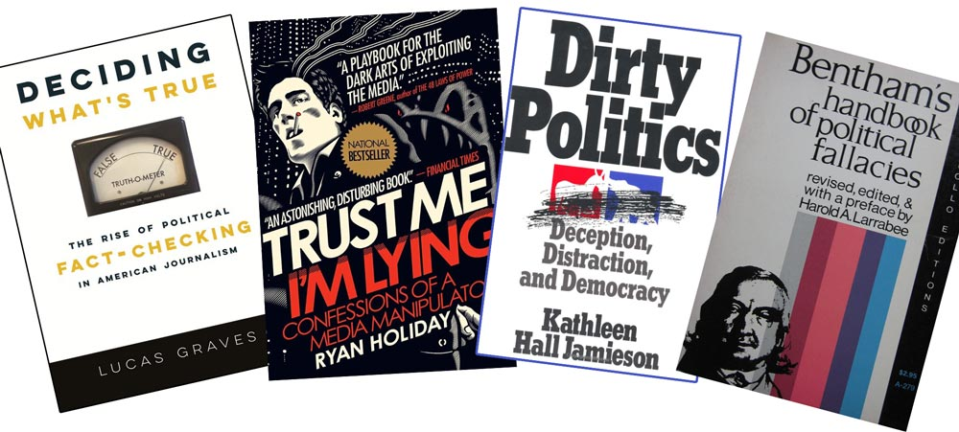
However, it’s incredibly hard to determine the truth of statements like these because of the power of deception. Political deception works so well that there is LOTS of it. The world is full of lies, spin, half-truths, appeals to emotion instead of logic, biased samples, and countless other ways to deceive people. Stop and think for a few seconds about all the deception you’ve seen lately coming from politicians.

This creates a critical problem, because democracy depends on citizens being able to tell truthful politicians from deceptive ones on voting day. If citizens cannot tell the difference, they will tend to elect too many deceptive politicians who work for themselves and powerful special interests, instead of for The People and the common good.

Fortunately, there’s a solution to this problem.

Here’s the solution. The reason citizens are so easily fooled by deceptive statements is low truth literacy. The average person has never been trained in telling truth from deception, so their truth literacy is low. Because it’s low, they are unable to reliably tell truth from deception.
For example, the average person is unable to instantly see that the claims in the first two statements are false, because they both use the cherry picking fallacy.
Truth literacy is the ability to tell truth from deception. Universal truth literacy is just as important to the health of democracy as reading literacy, because if people cannot “read” the truth they are blind to what the truth really is. They are easily controlled by any politician who uses deception to hoodwink the masses into supporting him and his positions.

In the Truth Literacy Training that follows you are going to learn two things:
1. How to spot the cherry picking fallacy, a form of deception.
2. How to spot the strong evidence non-fallacy, a form of telling the truth.

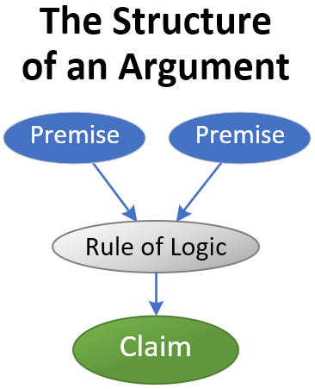
How arguments work
An argument consists of one or more premises that a rule of logic uses to reach a conclusion, known as a claim. The structure of an argument with two premises is shown.

Here’s how an argument is either true or false:
1. If the rule of logic makes a logical error it’s known as a fallacy and the claim is false.

2. If the rule of logic is sound it’s a non-fallacy. If all the premises feeding into a non-fallacy rule are true, relevant, and complete, and there is no credible dissent, then the claim is true.
All logical thinking works this way, since all logical thinking consists of premises, rules of logic, and conclusions. Now let’s learn a very common rule of logic.

Cherry Picking
Cherry picking occurs when the premises in an argument are biased. The name “cherry picking” comes from picking only the ripe cherries in a basket of cherries to provide evidence to someone the basket contains only ripe cherries. The evidence has been cherry picked, so it’s biased. Cherry picking is very common and is one of the many types of fallacies used to fool people into believing something is true, when it’s actually false.
The fallacy of cherry picking uses two main premises:
1. The population the sample is picked from, such as a basket of 100 cherries.

2. The sample drawn from the population, such as 3 cherries.
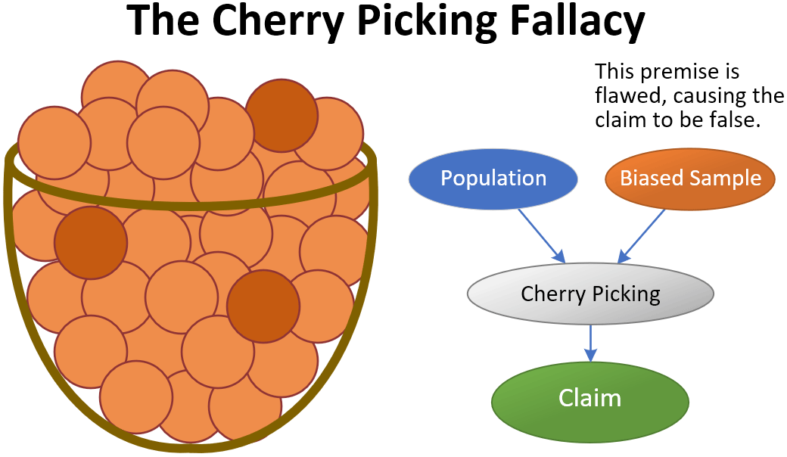
How cherry picking works looks like this:
The population is the entire basket of cherries. A sample is how many cherries you draw from the basket. This population has 97 unripe and 3 ripe cherries. Suppose you draw a sample from the basket. If the sample is only the 3 ripe cherries, then that’s a biased sample and the claim is false. Cherry picking has occurred.
Here’s the key to understanding how cherry picking works:
If the sample is not representative of the population then it’s biased and cherry picking has occurred. Cherry picking is also known as a biased sample.
Now let’s practice what we’ve learned. Consider this statement. The claim is bolded:
A basket contains 97 unripe cherries and 3 ripe cherries. A man picks 3 ripe cherries from the basket, hands them to you, and says “Here, taste these. This is a really good basket of ripe cherries.”

10. What is the population in the above statement?
-
A basket containing 97 cherries.
- A basket containing 3 cherries.
- A basket containing 100 cherries.

Note that after you click on the Review button you cannot change your answers.
Review Answers
The correct answer is A basket containing 100 cherries.
Next Question
(We are not showing all buttons to keep this document shorter. To enforce slow, thoughtful training, each question has two buttons as shown above. We discovered subjects like to race through and need slowing down, in a manner that encourages quality engagement.)

11. What is the sample in the above statement?
- 3 unripe cherries.
- 3 ripe cherries.
- 3 cherries.

The correct answer is 3 ripe cherries.

12. The claim was “This is a really good basket of ripe cherries.” How true do you feel that claim is?
- False, - Mostly False, - Half true, - Mostly true, - True, - Cannot decide

The correct answer is false. Claims based on fallacies (such as cherry picking) are always false. They are not half true or mostly false. They completely false.

A fallacy is an error in reasoning. Any claim based on a fallacy is always false.

If you encounter a fallacy (such as cherry picking) and decide the claim is anything but false, then you have been fooled into a false belief, however small it may be. If you are fooled many times, then all those tiny little false beliefs pile up, and you will start to believe something false really is true, or is at least half true, and so on. This is how repeated lies work their diabolical magic on people who are truth illiterate, whether in advertising, politics, or anything else.

Don’t be fooled. Don’t be an easy target of deception. Take the time to learn how to spot cherry picking instantly. That’s a skill that will make you more intelligent, as well as more fool proof.

13. “My fellow citizens, Rutania has a problem,” said the president of Rutania in the annual address. “In the last year, our national electrical transmission system failed twice. It was off for a total of sixteen hours. That indicates a severe problem that needs immediate attention. Therefore, in my annual budget, I will be allocating an extra twenty-five million Rutavos for system maintenance and upgrades.”
Nearly every citizen of Rutania knows the facts here, since these power outages were highly unusual. The facts agree with what the president said.
The claim is bolded. How true do you feel the claim is?

- False, - Mostly False, - Half true, - Mostly true, - True, - Cannot decide

The correct answer is false, because the data is biased. One year of data with just two outages is too small a sample to tell if this is a general trend. Plus, what if there were unusual causes for the outages, like hurricanes or software failures? That data is omitted.

14. A candidate was running for reelection to the office of Postmaster General in Rutania. Pointing to his record on delivering first-class mail on time in 3 days or less, he said:
“Look at this graph. Last month 92% of first-class mail was delivered on time. And the month before it was 93%. Not only that, but the graph shows that on-time delivery per month dipped below 90% only twice in the last six years, when we first started tracking this data. Our goal is 90% or above, so the data shows I’m doing a great job and should be reelected.”
Articles from two highly trusted newspapers verified all the data was true.
The claim is bolded. How true do you feel the claim is?

The correct answer is true. If the only data was the 92% and 93% for the last two months, that would be cherry picking. It’s not enough data to show the general trend. However, the graph also showed “that on-time delivery per month dipped below 90% only twice in the last six years.” That’s a complete sample of the data, so it’s unbiased and fully supports the claim.

15. A long letter to the editor from a politician running for office said:
“Regarding the recent article on cases of job discrimination, I fully support the suggestion that this problem needs attention. It’s an indicator we have a new crisis, though it’s still small and just beginning. For the last year, it’s deplorable that about 40% of job applicants over the age of 50 never get a first interview, while 60% of applicants under 50 get a first interview. That data is a smoking gun. It points to a real problem that must be solved.”
The claim is bolded. How true do you feel the claim is?

The correct answer is false, because only one data point is considered, the data for the last year. That’s a biased sample because it’s too small.

Deceivers often use one attention grabbing data point to “prove” their claim is true. If the one data point is not representative of all the relevant data, then it’s biased. Cherry picking has occurred and the claim is false. Here we would want to use at least the last ten years, so we could see what the trend is.
16. The president of Rutania is running for reelection. At the start of the president’s first six-year term, a bill designed to lower crime was passed. Citing the bill, a campaign ad said:
“Vote for me if you want to continue to see more prosperity and less crime in Rutania. I wrote that bill. I pushed to get it passed, at the request of thousands of citizens who have seen first hand the effects of crime. Crime is down the last two years compared to when I started by 15%. Vote for me, because I cut crime in Rutania.”
An article from the Rutania Times, a very highly respected newspaper, reported the 15% figure was correct.
The claim is bolded. How true do you feel the claim is?

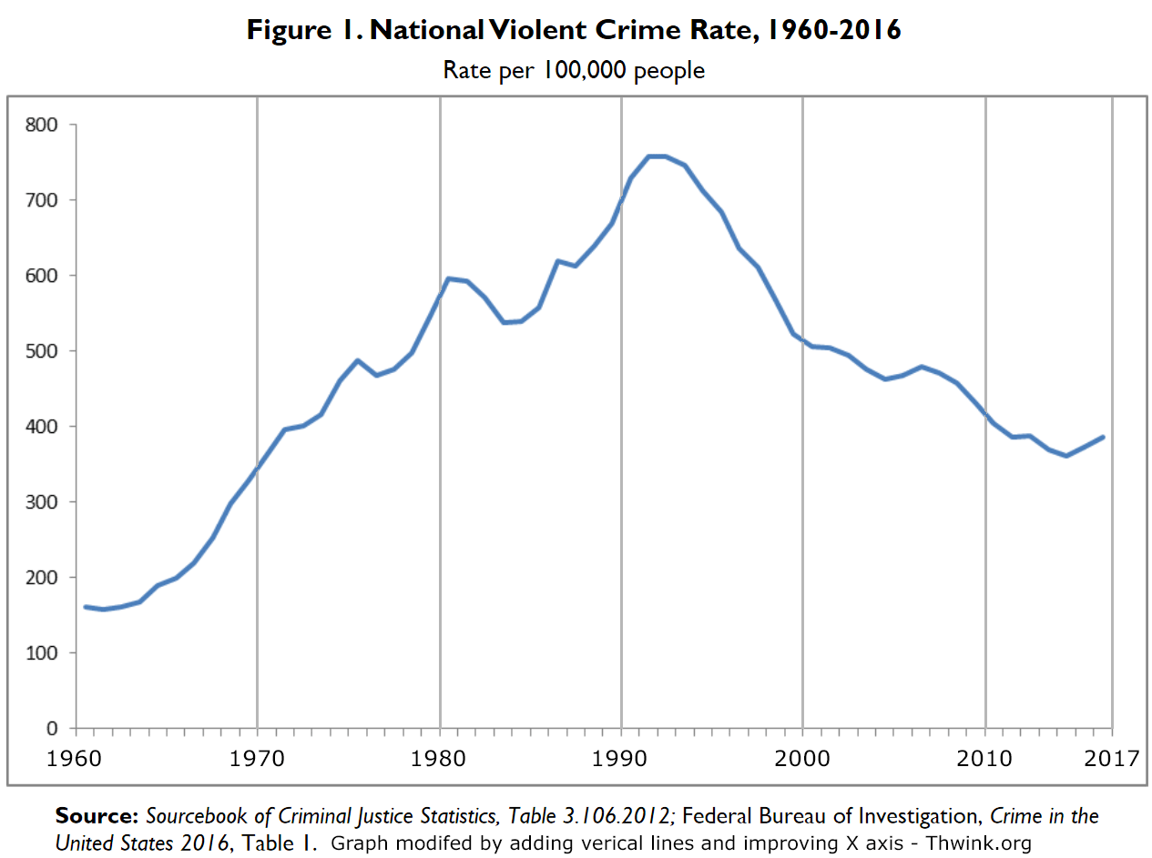
The correct answer is false, because the campaign ad cites data for only the last two years. Things like crime bob up and down from year to year. Only by examining the crime trend over a long period of time, at least ten years, can you tell what the trend is. By citing only the last two years the ad has cherry picked a favorable period of time. For example, examine the graph below:

If we cherry picked only the last two years of data, we could say crime is going up. But if we picked data since the graph peaked in 1992, we could say crime has gone down by 50%, which is clearly the general trend since then. Are the last two years the beginning of an upswing? That’s impossible to determine from the graph.

Now you’re going to apply what you’ve just learned. Let’s answer the questions again for the Pickpocketing statement.

Statement 1. Pickpocketing (review)
Rutania has many tourist attractions, 25 cities, and a temperate climate. In a campaign speech a candidate said,
“Pickpocketing is up 10% in City A. It’s up 12% in City B. Pickpocketing is one of Rutania’s biggest problems, since we depend so much on tourism. We must take action.”
The candidate has said about the same thing in several other speeches. The data about how high pickpocketing is in different cities comes from the average of current government and independent studies.
17. The politician said “Pickpocketing is one of Rutania’s biggest problems, since we depend so much on tourism. We must take action.” How true do you feel that claim is?
- False, - Mostly False, - Half true, - Mostly true, - True, - Cannot decide

18. What is the main reason for your decision in the above question?
(Textbox for the answer.)

19. If the election were held today and this was all the information you had, how much impact would what the politician claimed have on your decision to vote for or against the politician?
Choices:
-
Very large impact on voting for them.
- Large impact on voting for them.
- Medium impact on voting for them.
- Small impact on voting for them.
- It would make no difference.
- Small impact on voting against them.
- Medium impact on voting against them.
- Large impact on voting against them.
- Very large impact on voting against them.

The correct answers are:

Truth question - False, because the cherry picking fallacy was used. The data comes from only 2 out of 25 cities.

Main reason question - Because cherry picking was used.

(No correct answer is given for the vote question, since group 2 does not receive vote training.)

Let's answer the questions again for the Falling Tourism statement.

Statement 2. Falling Tourism (review)

Recent studies show tourism in Rutania is falling. Referring to those studies, a politician said:
“We have begun more extensive research on the problem of falling tourism using outside experts. However, I have just interviewed two tourists, a couple from Hong Kong. They report that the reason they’re not coming back is we have terribly heavy traffic in their favorite tourist destinations. I heard the same thing last week when my uncle visited from France. He even said that if we could somehow cut the traffic down to normal amounts, Rutania would be the perfect tourist destination and we couldn’t keep people way. So, I think we’ve found the cause of the problem. But let’s wait and see if the outside experts agree.”
Rutania has a highly trusted Office of the Budget, so it is solid data.

20. The politician said “So, I think we’ve found the cause of the problem.” How true do you feel that claim is?
- False, - Mostly False, - Half true, - Mostly true, - True, - Cannot decide

21. What is the main reason for your decision in the above question?
(Textbox for the answer.)

22. If the election were held today and this was all the information you had, how much impact would what the politician claimed have on your decision to vote for or against the politician?
Choices:
-
Very large impact on voting for them.
- Large impact on voting for them.
- Medium impact on voting for them.
- Small impact on voting for them.
- It would make no difference.
- Small impact on voting against them.
- Medium impact on voting against them.
- Large impact on voting against them.
- Very large impact on voting against them.

The correct answers are:
Truth question - False, because the cherry picking fallacy was used. The politician made the claim on the basis of only two data points, the two tourists from Hong Kong and the uncle who visited from France. That’s two data points out of thousands, since Rutania attracts lots of tourists. It’s impossible for two data points to be representative of thousands, so the sample is biased.

Main reason question - Because cherry picking was used.

Note that it doesn’t matter if the data is deliberately cherry picked to support a claim or not. All that matters is whether the sample is biased or not.

This completes training on the cherry picking fallacy. Learning how to spot that fallacy equips you with a reliable way to spot one form of deception. Next we explain a reliable way to spot one form of the truth.

The Strong Evidence Rule
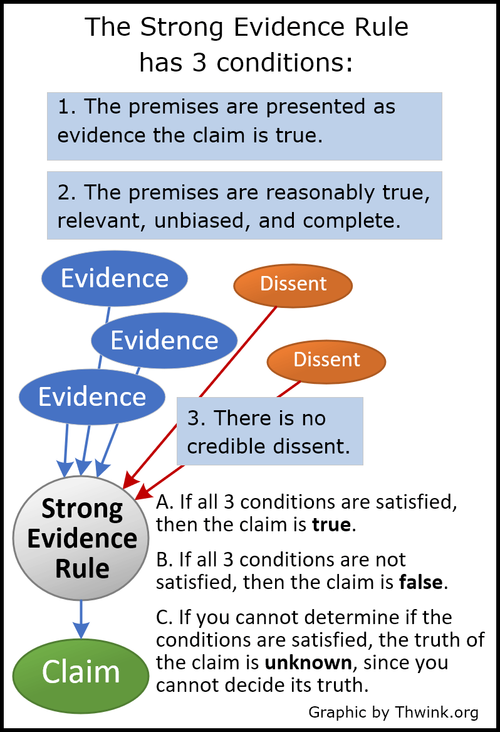
For typical political statements, the most common rule of logic that is not fallacious is the strong evidence rule:

If the premises are presented as evidence the claim is true, and the premises are all reasonably true, relevant, unbiased, and complete, and there is no credible dissent, then the claim is true.
It’s lightning in a bottle. It’s the surprisingly simple but powerful rule that has built the world we live in, because this is how juries think when charged with determining guilt or innocence “beyond a reasonable doubt.” It’s how scientists think when testing a complex hypothesis. It’s how sharp managers and smart people think when weighing the evidence behind an important decision. And so on. In short, the strong evidence rule is by far the most common rule for making correct complex decisions based on evidence.
To apply the Strong Evidence Rule, follow steps A, B, and C as listed in the diagram.
Now let’s practice what we’ve learned.

23. Two people are hiking high in the mountains of Rutania, where a few tigers still survive. Suddenly they see a tiger, though it’s down in the valley half a mile away. Hiker A says “Hey! Tigers are dangerous. We’d better run.”
Which is not a relevant premise (piece of evidence) in the above statement?
- Two people are hiking high in the mountains of Rutania
- where a few tigers still survive
- Tigers are dangerous.
- The tiger is down in the valley half a mile away.
The correct answer is where a few tigers still survive. That piece of evidence has nothing to do with their decision.

24. Why does the above statement use the Strong Evidence Rule?
- Because all correct logic uses the Strong Evidence Rule.
- Because for a claim to be true, evidence is needed.
- Because the premises are presented as evidence the claim is true.

The correct answer is the third choice, “Because the premises are presented as evidence the claim is true.” The first choice is not right, because there are other correct logic rules. The Strong Evidence Rule is merely the most common one. The second choice is not right, because premises can be presented as other than evidence. For example, the premise that 2 + 2 = 4 is always true, if there’s also a premise that standard mathematics is used.

25. The claim in the above statement is “We’d better run.” Is the claim true?
Thinking calmly because the tiger is so far away, you think through the conditions of the Strong Evidence Rule:
Condition 1. The premises are presented as evidence the claim is true. This condition holds, because the two premises (The tiger is down in the valley half a mile away and tigers are dangerous.) are considered as evidence.

Condition 2. The premises are reasonably true, relevant, unbiased, and complete. The premises are true, relevant, and unbiased. But are they complete?

No. We don’t know what the safe distance from a tiger is. Less than that distance and you are in danger. Also omitted is the well-known rule that if you start running from a large predator, that will let them see you better and frequently provoke a chase response from the predator, who will run you down and eat you. Without these important premises, the Strong Evidence Test cannot be applied, due to missing information.
Therefore, the claim that “We’d better run” is false and the correct answer is no.
In fact, if the hikers believed the claim was true and ran, there’s a good chance one of them would become the tiger’s lunch. The tiger would see them moving and chase one of them down. That’s what happens when you make logical errors. The hikers are apparently ignorant of crucial information. They should not have been hiking in those mountains.
The Siberian tiger, as a metaphor of how we must react correctly or someone else will get the best of us.
Now let’s try a variation of the above statement.

26. Two people are hiking high in the mountains of Rutania, where a few tigers still survive. Suddenly they see a tiger, though it’s down in the valley half a mile away. Hiker B says “Hey! Tigers are dangerous. If we stay quiet, keep our heads down, and don’t move, the tiger is far enough away that it won’t see us. If we do that, it will keep moving and stay in the valley, where there’s more food.”
The claim is bolded. Is the claim true?
- Yes, - No, - Cannot decide
Thinking calmly because the tiger is so far away and you are rapidly increasing your truth literacy, you think through the conditions of the Strong Evidence Rule:
Condition 1. The premises are presented as evidence the claim is true. This condition holds, because the three premises (The tiger is down in the valley half a mile away, tigers are dangerous, and if we stay quiet, keep our heads down, and don’t move, the tiger is far enough away that it won’t see us.) are considered as evidence.

Condition 2. The premises are reasonably true, relevant, unbiased, and complete. The premises are true, relevant, and unbiased. But are they complete?
This time the answer is yes. The hikers should stay quiet, keep their heads down, and don’t move, and the tiger will continue what it was doing and eventually walk out of sight.
Condition 3. There is no credible dissent. There is none.
Therefore, the claim is true and the correct answer is yes.
Note that the claim is not half true, or mostly true. When all three conditions of the Strong Evidence Rule are satisfied, the claim is completely true.
Here completely true means over a 95% or 99% probability of being true. You would use 95% in most situations and 99% in critical situations where very high certainty is needed, like a life-or-death decision in choosing a medical treatment.
Now let’s apply what you’ve just learned by answering the questions again for the Balance the Budget statement.

3. Balance the Budget
During a speech, the president of Rutania pointed to her record on balancing the budget.
“When I came into office 3 years ago, the budget hadn't been balanced for eight years, even though we were not recovering from a recession. By adjusting several programs and not cutting any important services, I was able to balance the budget my second year in office. This has continued in my third year and economic growth has not been affected. The budget was balanced during this administration due to my efforts.”
Several articles written by highly credible journalists verified this information, even though some of the president’s political opponents attacked what she said. No article disagreed. The attacks were shown by the same journalists to be groundless.
27. The politician said “The budget was balanced during this administration due to my efforts.” How true do you feel that claim is?
- False, - Mostly False, - Half true, - Mostly true, - True, - Cannot decide

28. What is the main reason for your decision in the above question?
(Textbox for the answer.)

29. If the election were held today and this was all the information you had, how much impact would what the politician claimed have on your decision to vote for or against the politician?
Choices:
-
Very large impact on voting for them.
- Large impact on voting for them.
- Medium impact on voting for them.
- Small impact on voting for them.
- It would make no difference.
- Small impact on voting against them.
- Medium impact on voting against them.
- Large impact on voting against them.
- Very large impact on voting against them.
Looking at the statement through the lens of truth literacy, we notice it’s not a fallacy. Rather, it’s piling up evidence to prove the claim. This tells us to think through the conditions of the Strong Evidence Rule:
Condition 1. First, we see that the premises are being presented as evidence the claim is true. The premises are:
1. When I came into office 3 years ago, the budget hadn't been balanced for eight years, even though we were not recovering from a recession.

2. By adjusting several programs and not cutting any important services, I was able to balance the budget my second year in office.

3. This has continued in my third year.
Condition 2. Then we ask, are the premises reasonably true, relevant, and complete? Yes. This is enough data to make a solid decision with. The premises are true since they come from highly credible sources. By inspection they are all relevant.
Condition 3. Finally we ask, is there any credible dissent? The statement says, “No article disagreed. The attacks were shown by the same journalists to be groundless.” There is no dissent.
Therefore the correct answers are:
Truth question - True, because the Strong Evidence Rule was used and all its conditions are satisfied. As complex as this answer may seem, it's the only known way to think correctly when making decisions based on complex evidence.

Main reason question - Because the Strong Evidence Rule was used.
Note how essential the paragraph beginning with “Several articles” is for determining the truth of the claim. Without verification information like this, you cannot determine if the premises are logically true.
Most of the time the needed verification information is missing. That’s a problem, because most people feel pressured to guess if they cannot logically determine if a claim is true. Guessing is a mistake. It can cause you to become someone else’s lunch. What you should do instead of guessing is realize that you have insufficient information. When that occurs, the correct decision is that you cannot decide how true the claim is. Therefore, the claim should make no difference in your reaction to the statement.

Common Political Fallacies
Now that we've covered the Strong Evidence Rule, it's time to cover the most common fallacies.

There are thousands of fallacies. Fortunately, a very small number of them account for most political fallacies. Learn how to spot these and you will know how to spot about 80% or more of the political fallacies you encounter. To see a list of them click the button below. After studying the list in the right panel, click the Proceed button.

(Here is what the right panel contains for the list of Common Political Fallacies:)

Cherry picking - We've already covered this one. Cherry picking occurs when the premises in an argument are biased.

Ad hominem attack - This occurs when the argument attacks some irrelevant characteristic of the person making the argument, such as their background, intelligence, courage, education, race, or who they associate with. The most common form of ad hominem attack in politics is negative advertising.

False dilemma - This occurs when the argument presents fewer choice than the choices actually available. Usually only two choices are presented.
A classic example, used by US President George W. Bush after 9/11, is “You're either with us or against us in the War on Terror.” It's a false dilemma because you can also be undecided, neutral, or a little for and against the various policies involved.

Appeal to Emotion - This occurs when the argument substitutes emotion for logic to justify the claim. Common types of emotion are jealousy, envy, greed, fear, and hate. Examples of appeal to emotion are:
Painting immigrants or people of another race as bad people to be feared and hated.

Painting an opposing political party, its members, and its candidates as bad people to be feared and hated.

Painting some possible problem that does not yet exist as something to fear, because it could soon exist.
False fact lie - This occurs when a false premise is knowingly presented as the truth. For example, Russian President Vladimir Putin promotes an ideology centering on the “fact” that Russia is being victimized by the rest of the world, notably the West and the US. That fact is totally false.

Strawman - This occurs when the original argument is replaced with a weaker one. The weaker argument is “knocked down like a flimsy strawman” and shown to be false, which implies the original argument is also false.
For example, “You ask if I have proof my plan will work. That doesn't matter, because no one can prove with 100% certainty a plan will work. What you should be asking is does my plan make good sense. Of course it does.”

(After studying the list of fallacies and clicking Proceed, the questionnaire continues.)

30. What if instead of being in tiger territory, the hikers are in political territory. A politician claims a terrible menace has appeared that needs immediate action. However, it's such a foggy argument that the hikers cannot tell if the premises are true. Which fallacy is used here?
- Cherry picking, - Ad hominem attack, - False dilemma, - Appeal to emotion,
- False fact lie, - Strawman, - Other

The correct answer is Appeal to emotion. The politician is using emotion instead of logic to get you to believe there's a terrible menace, because no proof is provided the menace exists.

31. A politician said, “I deeply respect my opponent. However, have you heard about the reports that in the past he played golf with known gangsters? Photos exist proving he did this.” Which fallacy is used here?
- Cherry picking, - Ad hominem attack, - False dilemma, - Appeal to emotion,
- False fact lie, - Strawman, - Other

The correct answer is Ad hominem attack. This is the very common guilt-by-association trick, a form of an ad hominem attack.

32. Politician A says, “People need to do their fair share for a sustainable future, and not drive when then can bike or walk.” Politician B replies, “What, you think people should stop driving? That's nuts!” Which fallacy is used here?
- Cherry picking, - Ad hominem attack, - False dilemma, - Appeal to emotion,
- False fact lie, - Strawman, - Other

The correct answer is Strawman. Politician A never said people should stop driving, only that they should drive less. It's easy to see that people should not stop driving, but that's not the same as saying they should drive less.

33. Yesterday an article appeared about the obesity epidemic, a common problem in developed countries. Referring to the article, a politician said, “It's a problem, but it doesn't have to be. People can decide to eat a good healthy diet or they can decide not to. This is a question of will-power.” Which fallacy is used here?
- Cherry picking, - Ad hominem attack, - False dilemma, - Appeal to emotion,
- False fact lie, - Strawman, - Other
The correct answer is False dilemma. Causes of the obesity epidemic are not nearly so simple. Studies have shown it's not a question of deciding to eat a healthy diet or not. Exercise is also needed.
Furthermore, many of the cheapest foods, the ones people typically buy, are high in carbohydrates and are designed to be tasty and addictive. In addition, junk food is heavily promoted in ads, making junk food seem desirable and healthy because healthy people are seen eating it.

34. Politician A says, “If Politician B gets elected, we're going to have a gigantic problem when he starts taking away our constitutional rights. I will absolutely not stand for that. We must all take a stand here, before it's too late.” Which fallacy is used here?
- Cherry picking, - Ad hominem attack, - False dilemma, - Appeal to emotion,
- False fact lie, - Strawman, - Other
The correct answer is False fact lie. Note how Politician A breezes right through the lie that Politician B will start “taking away our constitutional rights” and moves on to talking about taking a stand. No proof of loss of constitutional rights is presented.
Note that for all fallacies, the claim is false.
We're almost done with the Truth Literacy Training, but it's time for a break.
This is a long survey, so it's time to take a 5-minute break to reduce fatigue and refresh the mind. To start the break, click the button below.
Start Break
(The break can be as long as the subject wants. They can also take a break anytime, including overnight since it’s a long questionnaire.)

The Personal Truth Test
Everything we've covered can be summarized in The Personal Truth Test. To see this test, click on the button below. After studying the test in the right panel, click the Proceed button.

(Here is what the right panel contains:)

The Personal Truth Test
Step 1. Check the premises. If they're biased, the rule of logic is cherry picking and the claim is false.

Step 2. Check to see if the premises are being presented as evidence the claim is true. If so, then the rule of logic is the Strong Evidence Rule.
A. If the premises are all reasonably true, relevant, unbiased, and complete, and there is no credible dissent, then the claim is true.
B. If these conditions are not satisfied, then the claim is false.
C. If you cannot tell if the conditions are satisfied, then the truth of the claim is unknown and you cannot decide its truth.

Step 3. Check to see if the rule of logic is a fallacy or not. If it's a fallacy, then the claim is false. See the list of Common Political Fallacies above to help on this step.

Step 4. If it's not a fallacy and the claim follows from the premises and the rule of logic, then the claim is true. But if the claim doesn't follow from the premises and the rule of logic, then the claim is false.
(After studying the material and clicking Proceed, the questionnaire continues.)

Let's review the summarized material in the right panel.

35. What would you do if a statement did not contain cherry picking or the Strong Evidence Rule?
- The Truth Test only covers cherry picking and the Strong Evidence Rule, so I would not do anything.
- I would use my best judgement.
- Start at step 3 or 4 and go from there.
- Start at step 3 and go from there.

The correct answer is the last choice, Start at step 3 and go from there.

Steps 3 and 4 allow the Truth Test to cover any argument, regardless of the rule of logic used. If the rule of logic is not cherry picking and not the Strong Evidence Rule, then steps 3 and 4 handle everything else. Step 3 handles when it's a fallacy. Step 4 handles when it's a non-fallacy.

This completes the Truth Literacy Training. Now you know how to spot cherry picking fallacies and strong evidence non-fallacies, and your truth literacy has increased considerably. You also know how to spot political tigers and avoid becoming their lunch.
Good luck with the rest of the questionnaire!
Suggestions
36. We are still developing the training you have just taken. Considering the extreme importance of the health of democracy, do you have any comments or suggestions for how this training material could be improved?
(Textbox for answer)

Treatment Group 3 – Claim and Vote Training (LTQ and AAQ)
(This group receives the same LTQ training that group 2 did, plus vote training. This section describes only the vote training. After How arguments work, the Review Section of the Outline has an additional item for group 3, which is:)

Three rules for the health of democracy
The health of democracy depends on voters like you not being fooled by deceptive politicians, so there are three very important rules you should follow.
Please remember these rules are simplified general rules that can serve as guidelines. In the real world things are more complex, because you would have much more information to consider. However, in this training all the information you have is contained in the single statements that are presented with the questions.

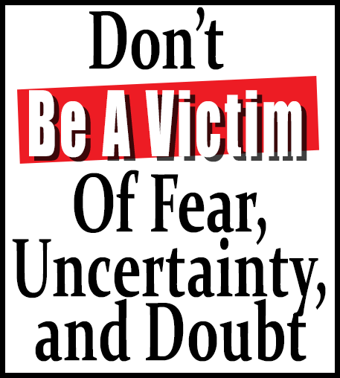
1. Don't Be a Victim of Doubt – If you cannot determine the truth of a politician's claim, then don't feel pressured into making a decision. If you do, you have become a victim of the strategy of fear, uncertainty, and doubt. This occurs when fear of being wrong and uncertainty of information lead to doubt, such as thinking something is mostly false when it's actually false, or half true or mostly true when it's completely true. Instead, realize you have insufficient information and cannot decide.
For example, on your vote, It would make no difference.
There’s an exception. If you can spot a fallacy, that takes precedence over everything else. This is because a fallacy is an error in logic, and that automatically makes the claim false.


2. Reward the Truth Teller – If you discover a politician has told the truth, then when you vote or take action you should strongly support the politician or the source of the truth. In this manner we encourage more truth tellers.
For example, this would have a Very large impact on voting for them.
What if two or more politicians tell the truth in an effort to gain a person’s support? Then the finer shade of discrimination is to reward the politician whose claim does the best job of optimizing the common good. How that’s done is beyond the scope of this training.


3. Penalize the Deceiver – If you discover a politician has attempted to deceive you, then when you vote or take action you should strongly oppose the politician or the source of the deception. This will have the effect of reducing attempted deception.
For example, this would have a Very large impact on voting against them.

These rules are essential. If enough citizens do not become truth literate and routinely follow these rules, then the health of democracy is in serious danger.

On the other hand, if enough citizens become truth literate and follow these rules, then democracy can thrive. It can also begin to focus on successfully solving its most pressing problems, like climate change, war, poverty, and systemic corruption, because we have elected politicians who work for the common good, instead of the uncommon good of special interests.

(For brevity the main paper only discusses rules 2 and 3. This is because rule 1 is minor. In practice, most deceptive political claims are clearly false. None of the Decision Making Section questions have a correct answer that uses rule 1. For the truth questions, “Cannot decide” is never correct. For the vote question, “It would make no difference” is also never correct. Further research should include rule 1.)

(Since group 3 has received vote training, the two review questions in cherry picking training discuss the vote question answer:)

Statement 1. Pickpocketing (review) – The correct vote question answer is “Very large impact on voting against them, due to Penalize the Deceiver.”

Statement 2. Falling Tourism (review) – The correct vote question answer is the same as for statement 1, since both use the cherry picking fallacy.

(Since group 3 has received vote training, the one review question in the Strong Evidence Rule training discusses the vote question answer:)

Statement 3. Balance the Budget (review) - The correct vote question answer is “Very large impact on voting for them, due to applying the Reward the Truth Teller rule. We want to encourage truth telling in politics.”

The Personal Truth Test – Additional training material
Everything we've covered can be summarized in The Personal Truth Test. To see this test, click on the button below. After studying the test in the right panel, click the Proceed button.

Be sure to study notes 1 and 2. These explain how you can make correct vote decisions. (This paragraph is not in group 2’s Person Truth Test text.)

(The right panel contains:)

The Personal Truth Test
Step 1. Check the premises. If they're biased, the rule of logic is cherry picking and the claim is false.

Step 2. Check to see if the premises are being presented as evidence the claim is true. If so, then the rule of logic is the Strong Evidence Rule.
A. If the premises are all reasonably true, relevant, unbiased, and complete, and there is no credible dissent, then the claim is true.
B. If these conditions are not satisfied, then the claim is false.
C. If you cannot tell if the conditions are satisfied, then the truth of the claim is unknown and you cannot decide its truth.

Step 3. Check to see if the rule of logic is a fallacy or not. If it's a fallacy, then the claim is false. See the list of Common Political Fallacies above to help on this step.

Step 4. If it's not a fallacy and the claim follows from the premises and the rule of logic, then the claim is true. But if the claim doesn't follow from the premises and the rule of logic, then the claim is false.

Notes (These are not in group 2’s Person Truth Test text.)

1. If the claim is false, apply the Penalize the Deceiver rule and strongly oppose the deceiver. For example, this would have a Very large impact on voting against them.

2. If the claim is true, apply the Reward the Truth Teller rule and strongly support the truth teller. For example, this would have a Very large impact on voting for them.

(After studying the material and clicking Proceed, the questionnaire continues.)

Let's review the summarized material in the right panel.

36. Notice how the Truth Test provides a reliable method for determining whether a claim is true or false. Once you've determined that, how do you determine what's the correct action to take, such as how to vote, if that single claim is all the information you have?
A. If the claim was false, Penalize the Deceiver applies and I would strive for a very large impact on voting AGAINST the deceiving politician.
B. If the claim was true, Reward the Truth Teller applies and I would strive for a very large impact on voting FOR the truth telling politician.
C. I would do A and B.
D. How to vote is such a personal decision that I would weigh the truth of the claim and make my own judgement.
E. I would do a mixture of C and D.

The correct answer is C. I would do A and B. Choices A and B refer to notes 1 and 2. These notes specifically explain what to do, give whether a claim is true or false.

Choices D and E should be avoided in this situation. Because the statements in this questionnaire provide all the information you have, choice C is you best decision. However, in the real world, where there are many competing claims, choice E would be the best decision.

Here's something amazing. Our studies show that the average person does nothing like Penalize the Deceiver or Reward the Truth Teller, given whether a political claim is true or false. Instead, they choose all sorts of answers for the vote question. From our point of view only the correct answers, as stated in choices A and B, make sense. Why would anyone NOT want to penalize deceivers? And why would anyone NOT want to reward truth tellers? Isn't that what's required is we want our government and our democracy to work for the best interests of voters?

We suspect the reason for this is hardly anyone has received the equivalent of Truth Literacy Training.

37. For the Penalize the Deceiver rule, if a claim is false, what is the key reason the correct vote decision is a “very large impact on voting against them?”
A. Because we want to do all we personally can to discourage deception in politics.
B. Because the claim is false.
C. Because anyone who would deliberately deceive voters will most likely not work for The People if elected.,
D. Because when answering the vote question, we should always pick either the first or last choice.

The correct answer is choice A, Because we want to do all we personally can to discourage deception in politics. The whole idea behind Truth Literacy Training is currently average truth literacy is low. Because it's low, political deception is the winning strategy. That's why you see so much deception in politics.

And that's why when we spot deception, we need to do everything we can to make political deception the LOSING strategy.

Choice B is true, but it doesn't deeply explain the correct decision. It's a shallow answer.

Choice C is also true. However, it doesn't follow the strategy of discouraging deception in politics, which is a better answer because it's a solution strategy. Choice C revolves around a goal, not a solution strategy to achieve that goal.

Choice D is true if the truth of the claim is known. But this answer doesn't explain why in this case the correct answer is the last vote question choice.

This completes the Truth Literacy Training. Now you know how to spot cherry picking fallacies and strong evidence non-fallacies, and your truth literacy has increased considerably. You also know how to spot political tigers and avoid becoming their lunch.
Good luck with the rest of the questionnaire!
Suggestions

38. We are still developing the training you have just taken. Considering the extreme importance of the health of democracy, do you have any comments or suggestions for how this training material could be improved?
(Textbox for answer)

Section 3 - Decision Making Section (measurement using 17 statements)

(This is the same for all three groups. 17 statements are presented in random order. The claim in each statement is bolded to make the subject’s work easier. This document presents the first statement and its three question their entirety. The remaining ones have only the statement listed. The statements have been numbered to aid reader use of this document. Note the complexity of the statements, which is necessary for high quality training. Such complexity reflects the real world.)

1. Crime Is On the Rise – False, appeal to emotion
Crime is on the rise in Rutania’s capitol. Currently it’s 8% above what the International Crime Index, a very highly trusted measure, defines as a “comfortable safe level.” That’s only a little above the acceptable level. However, citizens are beginning to notice more cars broken into, more burglaries and petty theft, and so on.
One politician was asked about the issue and responded: “It’s become a serious problem. Look around. Do you want to be living in a crime infested city? Why put up with thieves and drug dealers and scammers? When I walk down the street, I don’t feel safe anymore. Just look at all those burglar bars! Criminals are everywhere! Because of these reasons, crime is a big problem in Rutania and we must do something about it.”

39. The politician said “Because of these reasons, crime is a big problem in Rutania and we must do something about it.” How true do you feel that claim is?
- False, - Mostly False, - Half true, - Mostly true, - True, - Cannot decide

40. What is the main reason for your decision in the above question?
(Textbox for answer)

41. If the election were held today and this was all the information you had, how much impact would what the politician claimed have on your decision to vote for or against the politician?
Choices:
-
Very large impact on voting for them.
- Large impact on voting for them.
- Medium impact on voting for them.
- Small impact on voting for them.
- It would make no difference.
- Small impact on voting against them.
- Medium impact on voting against them.
- Large impact on voting against them.
- Very large impact on voting against them.

(The claim is false due to use of the appeal to emotion fallacy. Phrases like “serious problem”, “crime infested”, “I don’t feel safe”, “all those burglar bar”, and “criminals are everywhere” are all appeals to emotion rather than logic. While it is logically true that crime is on the rise, there’s a large difference between “That’s only a little above the acceptable level” and “crime is a big problem”. The evidence does not justify the claim.)

2. Import Tariff – True, correct application of Strong Evidence Rule
An import tariff is a tax on the price of imports, which is generally added to the price of a product and makes it more expensive. On the campaign trail, a politician was asked about a flip-flop on their position on tariffs. The politician said:
“Twelve years ago, I supported small tariffs on textile machinery imports to protect that sector in Rutania, because it was new and growing. But now that sector is mature and should stand on its own. It no longer needs tariff protection. That’s why this is not a flip-flop. I’m not being inconsistent. I have changed my position because the underlying facts have changed.”
All studies on this matter found that the textile sector is now mature, compared to those in other countries. It is standard procedure to place small protective tariffs on fledgling industries.
(The claim is true due to correct application of the Strong Evidence Rule. For reference, the rule diagram is shown.

The review of premises followed by “that’s why” tells you the speaker is making a strong evidence argument. To apply the rule, perform steps A, B, and then C.
First, the premises presented as evidence that the claim is true are identified. The first premise is “Twelve years ago, I supported small tariffs on textile machinery imports to protect that sector in Rutania, because it was new and growing.” The second premise is “But now that sector is mature and should stand on its own. It no longer needs tariff protection.”
Second, the premises are evaluated as to whether they are reasonably true, relevant, unbiased, and complete. They are because of the additional information provided: “All studies on this matter found that the textile sector is now mature, compared to those in other countries. It is standard procedure to place small protective tariffs on fledgling industries.”
Third, there is no credible dissent noted.
Step A is “If all 3 conditions are satisfied, then the claim is true.” It is.

3. National Minimum Wage – False, flawed application of Strong Evidence Rule
The United Nations sets the standard minimum wage at the equivalent of 17 Rutavos per hour, well above Rutania’s current minimum wage of 8 Rutavos per hour. Addressing this discrepancy, a politician said:
“The press and many of my colleagues have been asking if Rutania can afford to move with rest of the world and raise the minimum wage in Rutania to 17 Rutavos per hour. While this is a large increase, analysis by the Office of the Budget shows that it would have no effect on national budget expenses. Therefore, Rutania should raise the national minimum wage to 17 Rutavos per hour.”

It’s well-known that the Office of the Budget produces bipartisan, high-quality reports. Several articles pointed out that while raising the minimum wage would not affect national budget expenses, it would decrease national budget income, due to lower demand for more expensive products, since the wage increase must be passed on in the form of higher prices.

(The claim is false due to flawed application of the Strong Evidence Rule.

4. Golden Opportunity – False, cherry picking
In an editorial in Rutania’s most popular and very highly trusted newspaper, a politician wrote:
“Our fine country faces a golden opportunity. Should we take advantage of the recent surge in popularity of Rutania as a place to go for higher education? University enrollments from abroad increased 8.5% from the previous year. This data indicates we have something valuable that international students are searching for. We need to take advantage of that opportunity before it slips through our fingers. Therefore, I propose we initiate a study of the potential to maximize college enrollments from abroad, and that we take its recommendations seriously.”

(The claim is false due to use of the cherry picking fallacy.

5. Water Quality Tourists Sick – False, flawed application of Strong Evidence Rule
The largest newspaper in Rutania, a consistently reliable source of information, reported that average drinking water quality in Rutania's cities had tested at a count of 80 per liter for bacteria X. The safe level is 40. Another article reported how some tourists had been getting sick while visiting Rutania. They recovered when they went home. Commenting on these events, a politician said:
“I was reading the paper and spotted a problem. Tourists are getting sick because of low water quality. This is a serious problem, because Rutania depends so much on tourism. We don't want to develop a reputation as a bad place to go, because you will get sick there if you drink the water.”

(The claim is false due to flawed application of the Strong Evidence Rule.

6. Dumping – False, cherry picking
During a televised interview a politician said: “We’ve got to do something about the problem of dumping. It’s everywhere and it’s getting worse. Last week I saw a pile of trash someone had dumped by the road in the night. It was right in my own neighborhood! The Minister of the Interior told me she had personally seen a dump in her neighborhood that was growing. Someone was dumping construction rubbish off there every few days. Dumping is a real problem and it must be solved. Therefore, at the beginning of my next term, I will be introducing a comprehensive Anti-Littering and Dumping bill.”
The politician published pictures and full details of the dumping that had been seen on a website. A few days later, several articles from highly trusted journalists confirmed that the two cases of dumping did indeed exist.

(The claim is false due to use of the cherry picking fallacy.

7. Tour Scammers - False, flawed application of Strong Evidence Rule
Scammers have descended on Rutania to prey on its tourists. The most common scam is prepaid tours of Rutania’s most beautiful mountain valleys and villages. Tourists arrive to get on a tour bus, and there’s no bus there. The website they signed up on has vanished.
Tourism is vital to Rutania’s economy, so this is a serious problem. Speaking about the problem, a politician said:
“This is astonishing! Nobody has solved this problem yet? The scam has happened dozens of times and continues. Yet the police have not been able to find the scammers. They are too clever. They hide their tracks. But that doesn't matter. We can solve the problem by licensing all tour companies and their buses. That's not so hard to do. We’re at the height of tourist season right now, and tour companies are running about 30 tours a day. That is not too large a number to manage.”
A local writer, reviewing what the politician said, remarked that the proposed solution assumes that all tour companies can be found.

(The claim is false due to flawed application of the Strong Evidence Rule.

8. Drug Addiction - True, correct application of Strong Evidence Rule
A small but noticeable and growing amount of opioid drug addiction has been detected in Rutania. Because Rutania relies so much on a squeaky-clean reputation as a great tourist destination, three studies were launched on how bad the problem was and what interventions would work best.
At a panel discussion reporting on the results of the studies, a politician commented that: “I would not have believed it if I hadn’t heard about this problem from several of my constituents. This is a problem that must be solved while it’s still small. And it can be solved, by following the consensus of the recommendations of these three studies on how to bring opioid drug use down to a low acceptable level. They are top quality. Each study has collected solid evidence on which they made their decisions. Therefore, I would place my full support behind their recommendations.”
The studies were conducted by highly reliable organizations. The studies included consideration of all information available on the problem, including disagreement.

(The claim is true due to correct application of the Strong Evidence Rule.

9. Unemployment – False, cherry picking
Rutania has been having problems lately. People are in a dour mood because jobs are getting scarce. This is unusual. But recently, things have started looking better. In a campaign speech a politician addressed the problem directly:
“Sunny days are ahead. We’ve got some good news. Unemployment is down. I've got 12 years of data right here, with the unemployment rate for each month. For the last six months, unemployment fell from 8% to 5%. This data shows Rutania’s unemployment problem is solved. That’s solid data, prepared by the Office of the Budget.”
Rutania has a highly trusted Office of the Budget, so it is solid data.

(The claim is false due to use of the cherry picking fallacy.

10. Strippled Eagle - True, correct application of Strong Evidence Rule
Rutanians care a lot about the quality of their environment and thought all was okay. But a new study by a very dependable organization found that the national bird of Rutania, the Strippled Eagle, was in trouble. There are 40 nesting pairs left. The minimum viable population is 30 nesting pairs. Below that, the species will go extinct due to inbreeding. Responding to the problem, a politician said:
“This is a serious problem. I see the study also found the Strippled Eagle's population is on a steady downward trend. Extrapolating, the minimum viable population will be reached in about 3 years if nothing is done. The evidence points to one fairly certain conclusion. We must launch a project immediately to save our national bird from extinction.”
A number of experts and politicians disagreed, and felt nothing needed to be done. However, their conclusions were not based on the data included in the study, but on their own interpretations.

(The claim is true due to correct application of the Strong Evidence Rule.

11. Highway System Maintenance - False, flawed application of Strong Evidence Rule
An independent study from a trusted organization found that Rutania's national highway system was in dire need of maintenance. However, Rutania has a number of problems that are just as big or bigger, a fact that was omitted from the study. Citing the study, a politician said:
“We need to put an ample amount in Rutania’s national budget over the three years to bring our highway system up to good repair. This is a serious problem and it must be fixed now.”

(The claim is false due to flawed application of the Strong Evidence Rule.

12. Highest Quality of Life – False, cherry picking
Rutanians are proud of their quality of life, especially since a recent study showed that since last year it was now the highest on the continent. Citing the report, a politician said:
“This is terrific news and I know I speak for all when I say I'm proud of it! The study found that in the last year, we moved from third place to first place on the continent. This means Rutania is now the best long-term place to live on the continent, if you want things like a long life expectancy, access to good jobs and education, and an incredibly low crime rate, which I'm also proud of!"

(The claim is false due to use of the cherry picking fallacy.

13. Lower Traffic Accident Rates – False, false fact lie fallacy
Two politicians were discussing a puzzling development in Rutania. All across the country, traffic accident rates were falling and no one could explain why.
Speaking calmly, Politician A said, “My friend, you may not know this, but one of Rutania's traffic engineers has invented a new city traffic routing algorithm that calms drivers down and reduce chances for accidents. Yellow lights are longer. Phased lights, so you can cruse right long without stopping for five lights in a row. Reversible lanes that open up when needed. And so on. It's a miracle. The new algorithm is what's lowered traffic accident rates. But hey, keep this a secret. We want people to think Rutania has miracles!”
Politician B shook her head and replied, “Are you sure about that? I haven't seen a thing in the news about this. And I work for a traffic light company, so I should know.”

(The claim is false due to use of the false fact lie fallacy.

14. Asteroid Could Strike - True, correct application of Strong Evidence Rule
It’s rare but possible that an asteroid could strike planet Earth and cause extremely large damage, including extinction of Homo sapiens. Asked what they would do about solving this problem, a politician replied:
“That’s an incredibly complex question. I would work with the United Nations to setup and fund an international study of the problem, potential solutions, and their costs versus benefits. After the report was submitted, I would follow the recommendations, as long as they were based on solid evidence, and the evidence was complete, and there was no significant disagreement that had not been fully addressed. That’s the best we can do to solve incredibly difficult problems like this one.”

(The claim is true due to correct application of the Strong Evidence Rule.

15. Expert Witness – False, ad hominem
Reporting on expert witness testimony to the legislature of Rutania about a large problem, an article quotes a politician as later saying: “I don’t think we can trust this particular witness. You may not be aware of this, but he's a professor at one of Rutania's largest universities, and they are under investigation for tax fraud.”
The article, from a very highly trusted news organization, verified that indeed he is a professor there and the university is under investigation for tax fraud.

(The claim is false due to use of the ad hominem fallacy.

16. Trade Agreement Treaty – False, false dilemma
Speaking on behalf of Rutania at a global summit, the vice-president of Rutania said:
“We are pleased to see such progress on the trade agreement treaty. Free trade helps us all. But some tariffs are needed to help out developing countries and industries. There are only two choices here. If we design the treaty right, we are all going to benefit. But if we design it wrong, too many nations will suffer. Therefore, we must take every precaution to design it right instead of wrong.”

(The claim is false due to use of the false dilemma fallacy.

17. Teacher Shortage – False, strawman
In a campaign ad a politician said:
“My opponent argues that solving the school system’s teacher shortage problem can be mostly solved by an average of 10% better salaries and less burdensome paperwork without sacrificing report quality, as shown by several studies. I respectfully disagree. Those studies miss the point. Huge raises and cutting corners on reports is not the answer. Where are we going to get the money to pay for those raises? What if we cut so many corners on reports that some of Rutania’s schools start to lose accreditation? Those are the questions we should be asking.”

(The claim is false due to use of the strawman fallacy.

Section 4 - End Section

Feedback Questions
Now we arrive at the most important questions of them all. Thank you very much for your thoughtful answers on the next three questions. They can make a big difference in our research.

90. Please describe your thought process for how you answered the questions in the Decision Making Section. In general, what was your logic? What did you find yourself thinking over and over? What were the key considerations when you made your decisions?
(Textbox for answer)

91. How much do you think what you’ve just learned will help you in the real world?
(Textbox for answer)

92. We are still in the early stage of this study. Do you have any suggestions in general on how we could improve this questionnaire or any comments? We would really appreciate your thoughts here.
(Textbox for optional answer. All other answers are required.)

Demographics
Before we finish, we have a few demographic questions.
93. What is your nationality?
Australia, Canada, France, Germany, Italy, Mexico, Poland, Portugal, Spain, United Kingdom, United States, Other

94. What is your highest education level?
- No formal qualifications
- Middle school/secondary school/GCSE
- High School(US)/College(UK)/A levels
- Undergraduate degree (BA/BS/Other)
- Graduate degree (MA/MSc/MPhil/Other)
- Doctorate degree (PhD/MD/Other)

95. What is your political orientation?
- Extremely liberal
- Liberal
- Slightly liberal
- Moderate, middle of the road
- Slightly conservative
- Conservative
- Extremely conservative
- Don't know, haven't thought much about it

96. What is your age?
(Box for enter an age)

97. What is your gender?
- Male
- Female
- Other

Section 5 – Completion
Please enter your Prolific Participant ID if not already entered:
(Box for ID)

Thanks for your insights into what we feel are important questions. When you have completed the questionnaire, click the Complete button.
Complete

