Solving Difficult Large-scale Social Problems with
Root Cause Analysis
A Thwink.org Publication

WE CAN NEVER CREATE A PERFECT WORLD. But we can improve the one we have by improving our problem solving tools. Then we could understand why, in the table below, we’ve been able to solve some problems but not others:
The natural sciences, like physics, chemistry, and biology, routinely solve their central problems with ease. But the same cannot be said for the social sciences, like economics, political science, psychology, and sociology. Table 1 lists six large-scale social problems that have resisted all attempts at solution. One of these, environmental sustainability, now looms so large it threatens to cause catastrophic global collapse. Despite its best efforts, society is unable to solve these problems.
Large-scale Social Problems
Solved | Not Solved
Serfdom | Environmental Sustainability
Slavery | War
Basic Civil Rights | Poverty
Universal Suffrage | Excessive Income Inequality
Autocratic Rule | Large Recessions
 | Corruption
Table 1
WHY is this?
Because popular solutions do not resolve the root causes. We know this to be true because Newton’s third law of motion states that “For every action there is an equal and opposite reaction.” Therefore every cause has an effect and every effect has a cause. This can be restated as the Law of Root Causes: all problems arise from their root causes. This raises a second question: How can we find the root causes?
By using a problem solving process based on root cause analysis. Once a problem’s root causes are found, night becomes day. What was a murky cloud of befuddling complexity becomes a social problem structure so clear that its correct solutions are obvious. This is identical to the way that once astronomers had the telescope they could see the structure of the planets and the universe beyond. Once biologists had the microscope they could see cells, their contents, and ultimately the structure of life itself. And once chemists had the Periodic Table they could see structural patterns that had previously been opaque, and had been preventing the field from gaining the maturity needed to solve its central problems.
Root cause analysis is the process of finding and resolving the root causes of a problem. Since all problems arise from their root causes, all problem solving methods are some variation of root cause analysis, whether the root causes are explicitly sought or not. Thus the central challenge facing social problem solvers is how to perfect a problem solving process based on root cause analysis.

The System Improvement Process
This leads into the research performed by Thwink.org. Founded in 2001, Thwink has focused on solving the environmental sustainability problem as a global whole. At the core of our research results lies the System Improvement Process (SIP). SIP is a comprehensive analytical framework for solving difficult large-scale social system problems. SIP centers on root cause analysis, a proven and uniquely powerful business tool. SIP takes that tool and adapts it to social problems in an innovative manner. SIP looks like this:
SIP is a simple, fill-in-the-blanks matrix style framework. First you define the overall problem to solve. Then the one big problem is decomposed into smaller (and hence much easier to solve) subproblems. Then each subproblem is subjected to root cause analysis. This is done with an eye to building a feedback loop based model of how a subproblem behaves, as described in the five substeps of analysis. The basic process has 26 steps: eight for each of the three standard subproblems plus the problem definition and continuous process improvement steps.
SIP was developed by iteratively applying it to the environmental sustainability problem. Whenever we encountered a roadblock for a long time, we didn’t just keep flailing away at the problem with new educated guesses. Nor did we give up. Instead we assumed that it was not us who was at fault—it was the process. So we analyzed the process to see where it had failed and why it was generating defects in the form of hypotheses that were consistently wrong. Then we fixed the process and returned to the problem.
Over time this cycle of continuous improvement stabilized into a productive process and a preliminary analysis that offers insightful conclusions. The sustainability problem appears to be solvable. It has four main root causes. All have easily understood solution elements that would work, if problem solvers can unite in agreement on the process used and the body of knowledge produced by the process. Astronomers, biologists, chemists, and many more scientific fields have done this, so we see no reason why sustainability problem solvers cannot do the same.
Social Force Diagrams
The simplest way to get started with applying SIP to a problem is with social force diagrams. These use three types of forces to illustrate the analysis of a problem, as shown below. All problems arise from their root cause forces, which is the first type of force. The second is the superficial solution forces that problem solvers apply when first attempting to solve a problem, as they work on the superficial layer where problem factors are easy to see and require no deep analysis. Superficial solutions push on low leverage points in an attempt to resolve a problem’s intermediate causes. This invariably fails because superficial solution forces can never exceed root cause forces, as illustrated by the relative size of the arrows running into the Intermediate Causes node. This is a crucial insight. It explains why the solutions directed at the unsolved problems in Table 1 aren’t working.
Once this insight is grasped, social problem solvers may come to realize what the business world accepted long ago: the only way to solve a difficult problem is to employ root cause analysis so your understanding can penetrate to the fundamental layer of the problem. This will lead to creation of the third type of force: fundamental solution forces. These forces change the structure of the system in such a manner as to resolve the root cause forces. The result is the system undergoes a mode change from unsolved to solved. An important example is the way that once modern democracy was invented, it swept the world. Other mode transitions are the industrial revolution, the scientific revolution, and starting around ten thousand years ago, the agricultural revolution. In each case the system stays locked into the new mode due to the new root cause forces introduced by the fundamental solution forces. This solves the problem rapidly, efficiently, and, if the solution is well engineered to be self-managing, permanently.
An example of a completed social force diagram is shown below. In the Autocratic Ruler Problem, after thousands of years of rule by warlords, dictators, and kings, a period characterized by countless superficial solutions like revolutions, uprisings, assassinations, and coups, the shift to the fundamental layer began with the signing of the Magna Carta in 1215. This introduced the high leverage point concept that people have rights that must be respected. This innovative concept steadily diffused and eventually reached critical mass. The invention of modern democracy in the late 16th century signaled the beginning of pushing in a comprehensive manner on the high leverage point. The fundamental solution of modern democracy resolved the root cause so well that a historic mode change occurred. Democracy has since swept most of the world.
The superficial solutions force is especially instructive. The low leverage point is “forced replacement of a bad ruler with a good one.” This failed to permanently solve the problem because it did nothing to change the system. More bad rulers appeared to replace the good ones, or good rulers went bad once in power. By contrast the fundamental solution of democracy changed the system so that a permanent new mode resulted, where far fewer bad rulers naturally appeared.

Essential Structure Models
Social force diagrams are useful for becoming familiar with how the SIP approach to root cause analysis works and a quick first pass at how a particular problem might be analyzed. For a problem of medium difficulty the fundamental solution might work. However, for a highly difficult problem use of social force diagrams alone is too intuitive because it lacks modeling of the essential forces involved. The forces causing or solving a social problem always arise from particular feedback loops. For example, in the Autocratic Ruler Problem the new root cause forces include the voter feedback loop, as well as other loops related to checks and balances. It is these loops that cause the mode change and keep the system locked into the new mode.
In traditional integrated global models like the World3 model of Limits to Growth, a problem’s essential structure is the feedback loops explaining why the symptoms are occurring and how the problem can be solved. Historically this has generated overly complex models and superficial solutions because nothing like SIP was employed. To correct this, SIP requires that the essential structure include only the symptoms plus the items analyzed in the five substeps of analysis. This focuses the model and results in much smaller and more easily understood models. Since the models are widely understandable and contain the root causes and their high leverage points, how to strategically solve the problem is obvious to all.
As an example, the model showing the essential structure of the change resistance subproblem of environmental sustainability is shown below. The model is so simple it takes only a few minutes to explain at the high level.
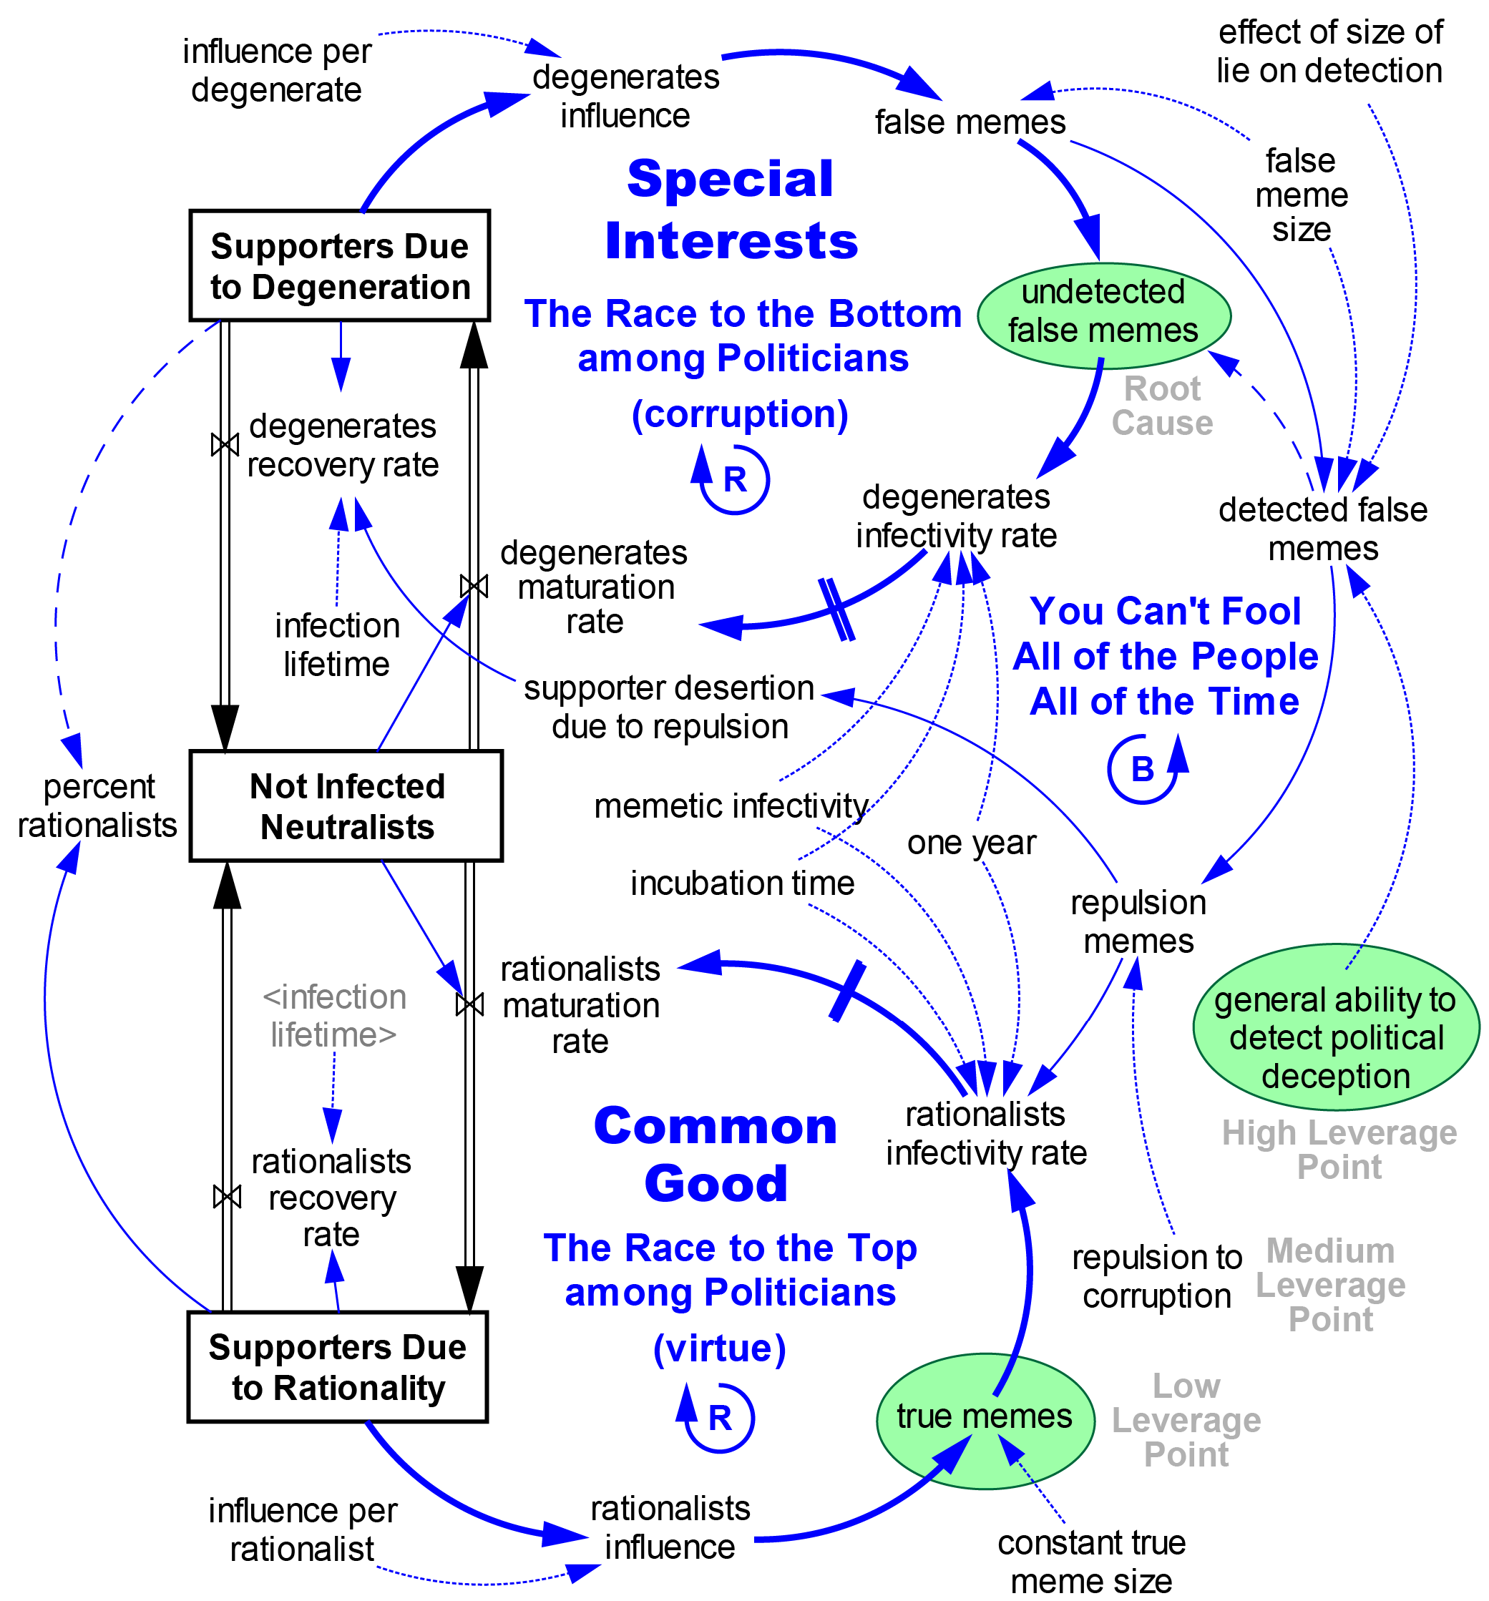
The Basic Dueling Loops of the Political Powerplace
Over time, political systems have evolved into two main groups: those supporting special interests and those supporting the interests of all, i.e. the common good. These two groups are reflected in the two main political parties of our age, generally known as progressives and conservatives, or the left and right. This is a universal pattern due to the structure of the system.
Examples of special interests are large for-profit corporations, the rich, religious fundamentalists, and in the United States, the gun lobby. In The Race to the Bottom among Politicians, politicians compete to see who can appeal to special interests the most. Special interests are by definition a minority, so the only way a minority (and its political representatives) can convince a majority of voters to support their position is deception, force, bribery, and favoritism. The latter three are expensive or illegal, which explains why deception has long been the preferred strategy. Deception is deplorable, so the special interest supporters are labeled “degenerates.” They have degenerated from the norm of rational, good behavior.
The race to the bottom works like this: The Supporters Due to Degeneration use their degenerates influence to promote mass deception, called false memes on the model. A meme is a learned mental belief like “growth is good” or a certain politician is bad because a negative ad says he is. Some false memes are detected and some are not. Undetected false memes appear to be true, so they are accepted as the truth. These memes infect the minds of some of the Not Infected Neutralists. It takes time for people to change their minds, so after a period of maturation, some supporters move from the stock of Not Infected Neutralists to Supporters Due to Degeneration. This increases the number of degenerate supporters and we’re back where we started. The loop grows in strength with each cycle, so it’s a reinforcing feedback loop. Such loops can grow to formidable strength.
Opposed to the race to the bottom is The Race to the Top among Politicians. Since this loop appeals to those seeking to optimize the common good for all, it has no need to resort to deception. Instead, it depends on promoting the truth, as represented by the true memes node. This explains why the central strategy of public interest activists is more-of-the-truth. This is done with articles, movies like Al Gore’s An Inconvenient Truth, books, speeches, marches, lobbying, and so on.
The key to understanding the Dueling Loops model is that if one side has even a slight advantage, over time it will win by attracting the most supporters. Our analysis found that the race to the bottom is the dominant loop most of the time because it contains an inherent advantage. As modeled by false meme size, the size of a falsehood can be inflated, which increases its infective appeal. But the size of the truth cannot be inflated, as modeled by constant true meme size. A degenerate politician can make all sorts of false promises, false attacks, false claims, and so on. But a virtuous politician can never promise more than he or she can deliver or claim more than the facts allow. In essence, a degenerate politician can claim that 2 + 2 = 5, or 7, or even 27. But a virtuous politician can never claim more that 2 + 2 = 4. This inherent advantage remains hidden from all but the most analytical eye and explains why so many problems in Table 1 remain unsolved. A dominant race to the bottom causes high change resistance to solving problems whose solution would run against the interests of powerful special interests.
The good news is there is a high leverage point that has never been pushed on in a prolonged focused manner. The high leverage point is general ability to detect political deception, also known as truth literacy. Right now this is low, which causes undetected false memes to be high. But if truth literacy is raised, the undetected false memes fall to a low level and the race to the bottom collapses, as most supporters move to the race to the top. After this change resistance is low and common good problems are easily solved because the system now “wants” to solve them.

Time to Kick the Tires
As far as we can tell, no other tool like SIP exists. Lack of such a tool has been holding people back from solving problems like those listed in Table 1. Scholars, activists, and NGOs have been struggling with one arm tied behind their backs and blindfolded at the same time, because they have been unable to see the root cause structure of what they are grappling with. This is much like an astronomer without a telescope. It’s also like a doctor who is unable to correctly diagnose a patient’s illness. If the illness is serious the patient will die, despite anything the doctor can logically do to help.
While the present version of SIP and its supporting materials is quite young and wet behind the ears, it does seem to be a solid enough foundation to build upon. All forms of science must start somewhere.
What the thwinkers at Thwink.org would like you to do is to closely examine SIP and the preliminary analysis results. Kick the tires. Play devil’s advocate. Be skeptical. Look it all over and tell us where we have gone wrong. What are the flaws in the process? In the preliminary analysis? In our explanation of the process and results?

And then, once we have incorporated your feedback into improving the tool and its results, why not pick the tool up and use it yourself? There are thousands of unsolved social problems out there, seen and unseen, large and small, just waiting for identification, analysis, and solution.
Thwink.org is a small independent “thwink” tank founded in 2001. Our focus is analyzing how to solve the global environmental sustainability problem as a whole, using the most effective methods available. Please see our website for much more information. info@thwink.org 404-408-0104

