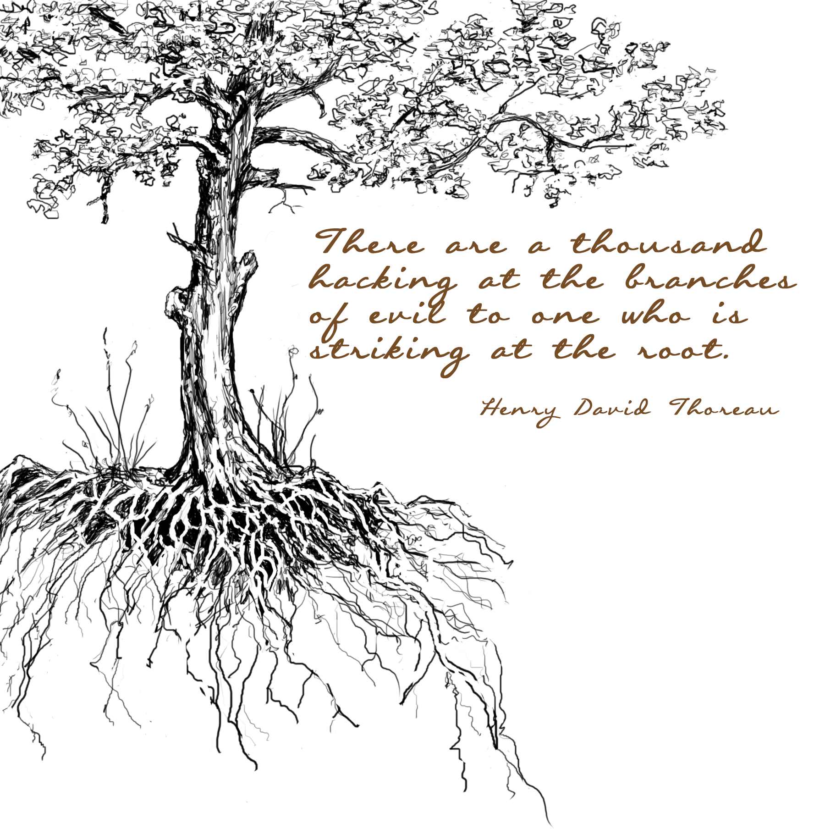
Striking at the Root
with Common Property Rights

MILLIONS OF DEDICATED ENVIRONMENTALISTS have worked on the sustainability problem for generations. Countless and frequently brilliant solutions have been tried. While some have worked at the local level, and a few have worked at the international level like the stratospheric ozone layer problem, none have worked at the systemic level. Problems like climate change, deforestation, desertification, freshwater shortages, and thousands of types of pollution are growing worse with no solution in sight.
Why?
Because popular solutions do not resolve root causes.
To solve the sustainability problem we must listen to the distant voice of Henry David Thoreau. In 1854, after living in a tiny cabin on the bank of Walden Pond for a deliberate two years, two months, and two days, Thoreau published his great classic, Walden or Life in the Woods. In it he wrote these immortal lines:
"I went to the woods because I wished to live deliberately, to front only the essential facts of life, and see if I could not learn what it had to teach, and not, when I came to die, discover that I had not lived.”
What did these two years, two months, and two days teach Thoreau? For our purpose his most sublime insight consists of this sentence:
"There are a thousand hacking at the branches of evil to one who is striking at the root.”
When Thoreau penned those words he was invoking one of the most important principles in all of science:
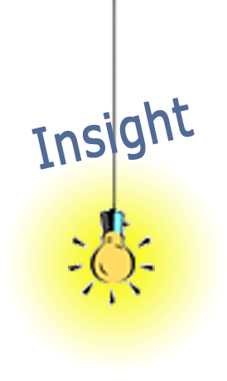
All problems arise from their root causes.

Once you accept this fundamental principle, everything changes. Hacking away at the branches of evil with solutions like better politicians who care about the environment, renewable energy, local cleanup campaigns, corporate social responsibility appeals, and the Three Rs of reduce, reuse, recycle no longer looks like a worthy strategy because solutions like these only treat the symptoms. They do not resolve root causes.
Systemic means affecting most or all of a system rather than a small portion of the system. Nearly the entire human population is behaving unsustainably, so the sustainability problem is clearly a systemic problem. It therefore requires systemic solutions, ones that make deep fundamental changes to the system by resolving the root causes. There is no other way.
Systemic solutions resolve root causes. A systemic solution is the same thing as a root cause solution. Systemic solutions change the fundamental way a system works by changing the structure of its key feedback loops. For example:
At the time the autocratic ruler problem was just as big as today’s sustainability problem. It looked just as unsolvable. But now, in retrospect, the solution looks simple. We take it for granted. It’s the way things are.
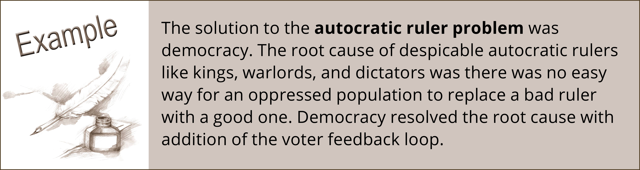
That’s how the solution to the sustainability problem could be.
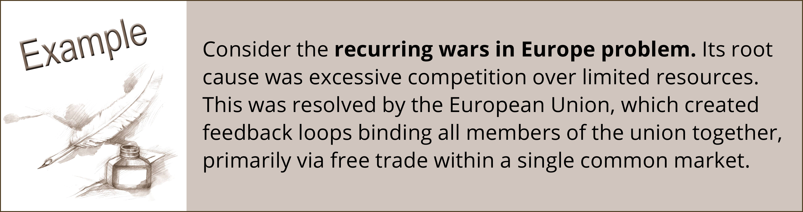
Let’s take a look at another classic example of a systemic solution:
Today another war in Europe on the scale of World War One or Two is unthinkable. The problem is 100% solved. The solution has become a part of the European way of life. It’s woven into the very core of their existence.
That’s how the solution to the sustainability problem could be.

So what’s the root cause of the environmental sustainability problem?
If we put on our systems thinking hats and look at the problem from a new perspective, the root cause just about jumps off the page.
Examine the diagram below. This captures the traditional thinking that dominates environmentalism, from grassroots organizations all the way up to governments and the United Nations Environmental Program.
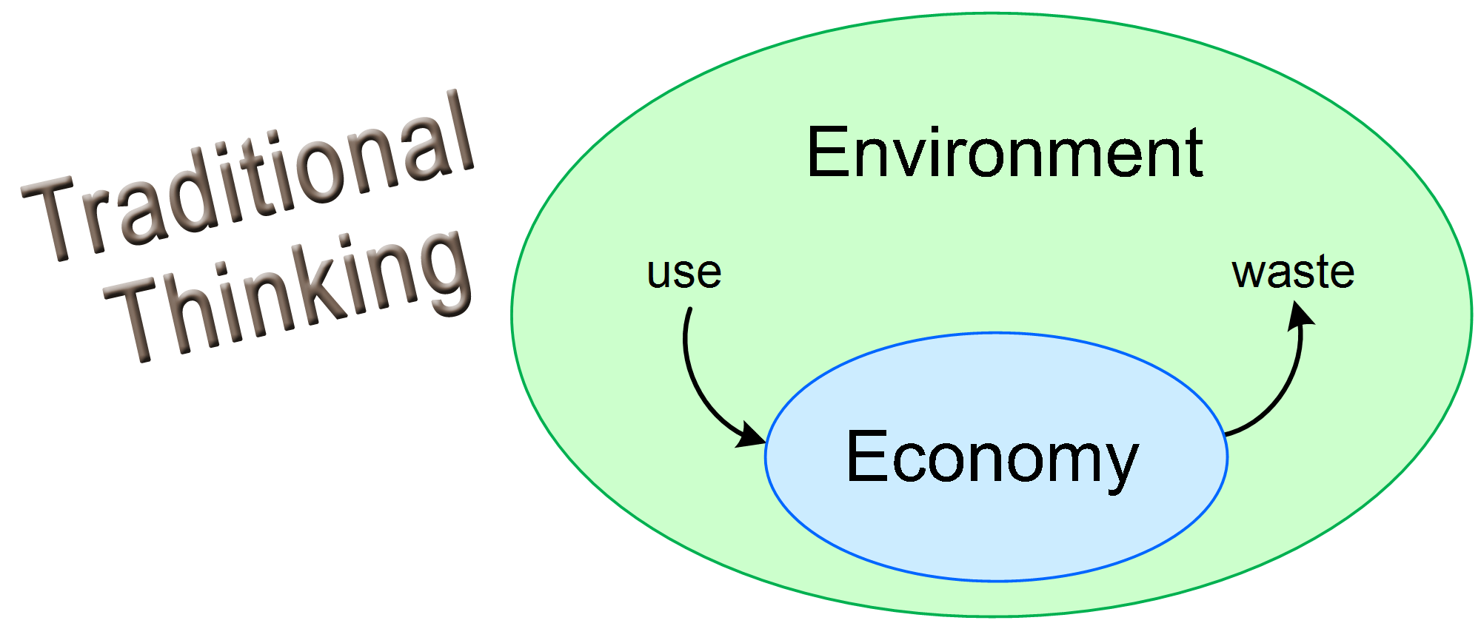
This viewpoint sees the sustainability problem as too much use and waste of environmental resources. The world’s economy, especially since the Industrial Revolution, is using natural resources faster than they can be replenished. The economy is creating waste faster than it can be naturally recycled. All this excessive environmental impact is unsustainable.
Thus the obvious solution is actions that reduce use and waste, like the ones we mentioned before: better politicians who care about the environment, renewable energy, local cleanup campaigns, corporate social responsibility appeals, and the Three Rs of reduce, reuse, and recycle. But this solution strategy has failed, as this graph demonstrates:
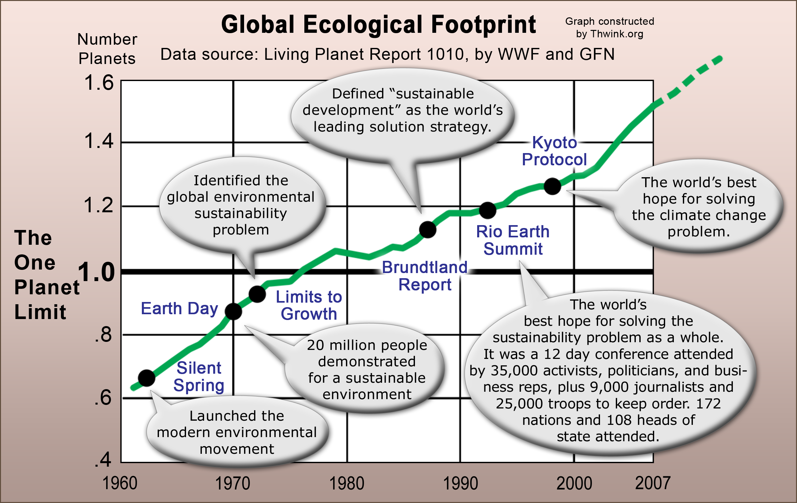
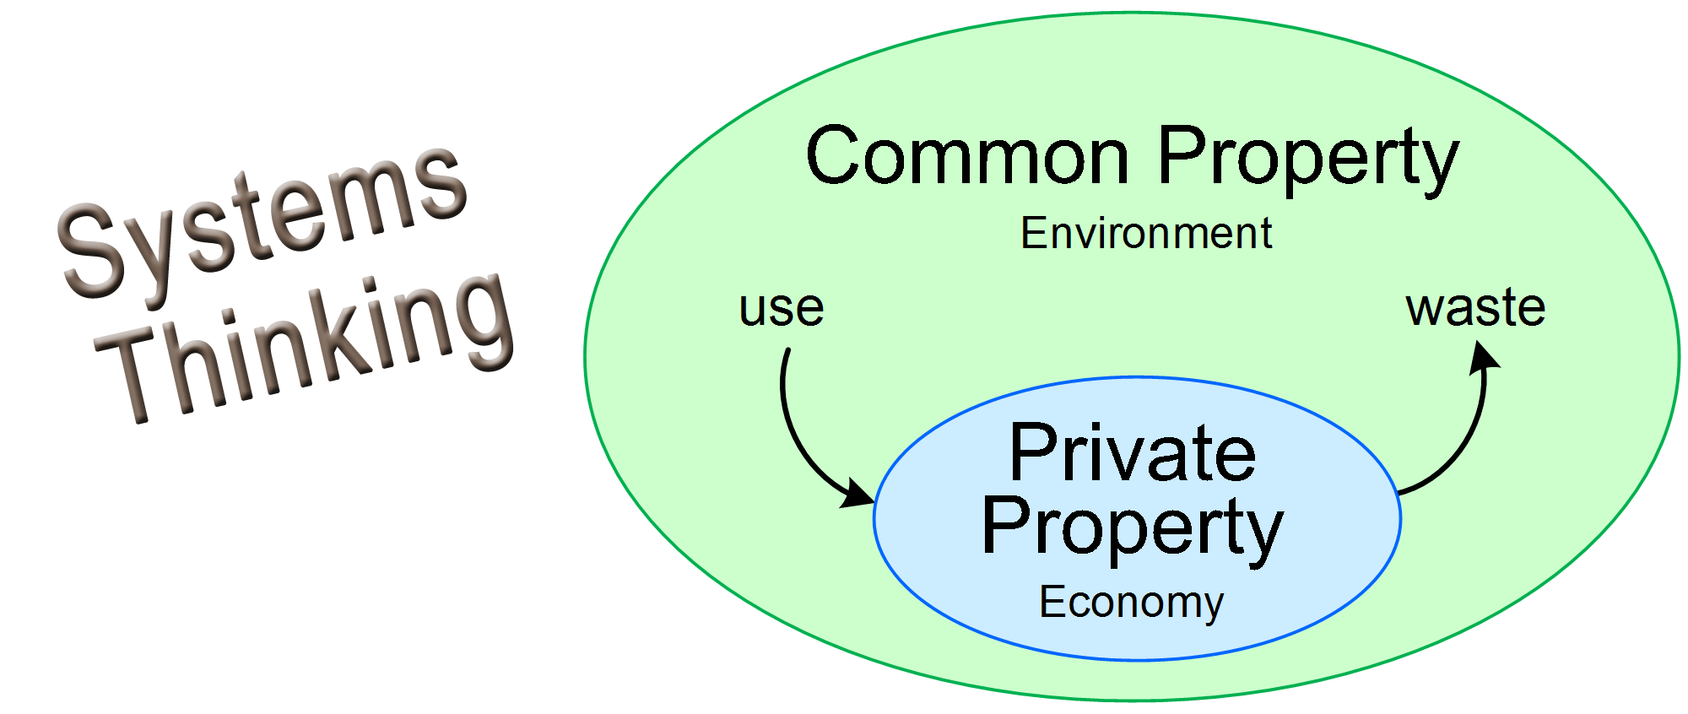
Here’s the breakthrough. If we put on our systems thinking hat and go looking for a systemic solution, we see the problem from an entirely different angle:
Common property is those natural resources we share and use together, like the air we breathe and the water we drink. Private property is just the opposite. It’s what we don’t share. It’s what we own and use individually. This distinction allows us to see the problem in a completely different manner.
Now our mind’s eye is no longer filled with use and waste as the dominant feature of the problem. Instead, we see two systems. One system, Private Property, is well managed. It’s highly efficient at turning private property into the goods and services that seven billion people depend on.
However the other system, Common Property, is not well managed. It’s unable to cope with all that use and waste. It’s overwhelmed. It’s being poorly managed in an unsustainable manner.
Why is that? What’s the root cause?
Note how we’re no longer asking: What’s the root cause of the sustainability problem? We’re asking: What’s the root cause of why Common Property is so poorly managed? That is a simpler and much easier question to answer.
The answer is almost as simple as the diagram. The root cause is this:
Pricing costs of managing Common Property are presently so high that Common Property cannot be managed sustainably.
We live in a market economy. Pricing costs are the costs of using prices for transactions. These are very low for Private Property. For example, when you buy groceries the prices are already set. You incur no additional costs for agreeing on a price. The sale transaction proceeds smoothly and efficiently because pricing costs are low. The same holds for all types of Private Property. Billions of transactions occur daily. They have such low pricing costs the world’s Private Property system runs smoothly and efficiently.
But pricing costs for Common Property are sky high. There’s no set price for all that use and waste in the diagram. (It’s priceless, pun intended.) Instead, every time a new environmental sustainability problem is discovered, the price of use and waste has to be laboriously set on a custom basis that takes so long (and is so expensive) that it seldom happens. Let’s explain this.
Imagine a badly polluted river. There’s no set price for dumping pollution in it so people and corporations can do whatever they want. To solve the problem local activists form an environmental organization that wants to see the river cleaned up so that it’s fishable, drinkable, and swimmable once again. Call them a riverkeeper.
Everything would be fine if there was already a price per unit of pollution. Then the riverkeeper could efficiently manage the river by charging a fee per unit of pollution. The riverkeeper could use that income to buy the things necessary for a sustainable ecosystem service, like education on best practices, R&D to find alternatives to polluting chemicals, cost assistance to help farmers setup wider buffers, and so on. This would be much like the way prices and expenses are used to manage Private Property.
But since no price per unit of pollution exists, the riverkeeper must take an entirely different approach. This differs so radically from the way Private Property is managed it can only be called bizarre, Stone Age, and backward.
First the riverkeeper has to raise the funds for its expenses. That’s a huge amount of work, especially in hard times like after the 2008 Great Recession or in poor countries. The riverkeeper also has to drum up a sizable number of volunteers, since funding will invariably be too low to pay everyone. Then the riverkeeper takes two basic approaches to reducing pollution: working with pollution sources and working with the government to enforce existing laws or pass new laws.
We all know how well this works. It doesn’t. In the few cases where it does, the law becomes strict enough and the fines behind the law become high enough (and are enforced enough) to bring down pollution to an acceptably low level. Bad behavior now has a price. It’s the applicable fine. There may also be some offenders who, due to pressure from the riverkeeper, voluntary reduce their pollution to a sustainable level.
If the riverkeeper had mountain-sized piles of money it could hire lobbyists, back environmental minded politicians with expensive campaigns, run expensive ads for public support, and get the necessary laws passed and enforced. But that would cost so much it’s unaffordable. These costs are the costs of using prices for pollution transactions. This explains why the pricing costs for solving river pollution problems are so high that these problems are usually never solved or never fully solved.
But this could change if the root cause was resolved. How can that best be done? How can we radically lower pricing costs for managing the world’s Common Property?
There’s an easy answer just sitting there in our systems thinking diagram. All we have to do is figure out why the Private Property system works so well and apply that knowledge to the Common Property system.
Study of the Private Property system shows that at its core it depends on one mechanism that’s so simple we’ve come to take it for granted. This is the concept, and the law, of Private Property Rights.
Because of these rights the pricing costs for managing Private Property are low. They’re near zero. Private Property owners have the right to set prices at whatever it takes to manage their property the way they want. That makes Private Property transactions efficient because the property manager can instantly and inexpensively set prices.
So why not apply this to Common Property? Why not create Common Property Rights?
That’s the breakthrough that will solve the sustainability problem because it resolves the root cause of why the economy is improperly coupled to the environment. The solution greatly strengthens the Growth of Sustainable Technology and the Impact Reduction feedback loops.
Suppose our noble riverkeeper lived in a world with Common Property Rights. Now solving the polluted river problem would be as easy as starting a new business where there was a ready market for your service. The riverkeeper would gain the right to manage the health of the river in the same manner that all Private Property entered the Private Property system. It would file a claim. Once accepted the claim would bring the river into the Common Property system, where the riverkeeper would be responsible for the sustainable stewardship of the river. The riverkeeper would no longer live a precarious financial existence because fees per unit of pollution would provide all the income needed to manage the problem. The riverkeeper would set the fee rate at the level need to provide a sustainable ecosystem service, just like corporations set prices to provide goods and services.
Common Property Rights is a simple solution. It’s an efficient solution. It’s probably our best solution, because it’s the mirror image of Private Property Rights. The only difference is one system of rights manages Private Property and the other system manages Common Property. What could be more simple and efficient?
Let’s remember what happened once the world had a mature Private Property Rights system in a few places. That made transactions so efficient that the world was primed for an explosion in the growth of Private Property transactions. Sure enough, the explosion came when the Industrial Revolution ignited in England and then rapidly spread around the world.
Think of the benefits of that revolution and why it happened. The singular reason, the most important precondition, was Private Property Rights.

WHY CAN’T WE DO THE SAME FOR COMMON PROPERTY? Why can’t we create a mature Common Property Rights system designed to make Common Property transactions so efficient that there’s bound to be an explosion in Common Property management transactions?
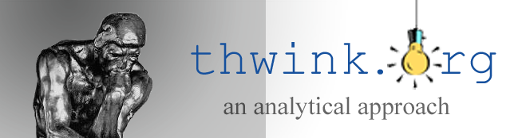
That explosion will launch the Sustainability Revolution. Once it starts it will spread like wildfire around the globe because there are so many environmental problems needing sustainable management.
Jack Harich
1164 DeLeon Court
Clarkston, GA 30021 US
404-296-5284
info@thwink.org
Philip Bangerter
31 Flinders Cres
Forest Lake QLD 4078
Australia
PBangerter@hatch.com.au
Where will that revolution start?
Will it start with you?

Pricing costs are called “transaction costs” in academic research. This term is so awkward and hard to understand we’ve decided to use “pricing costs” instead.
These feedback loops are explained in The World’s Property Management System diagram, in the Common Property Rights book available at Thwink.org.

