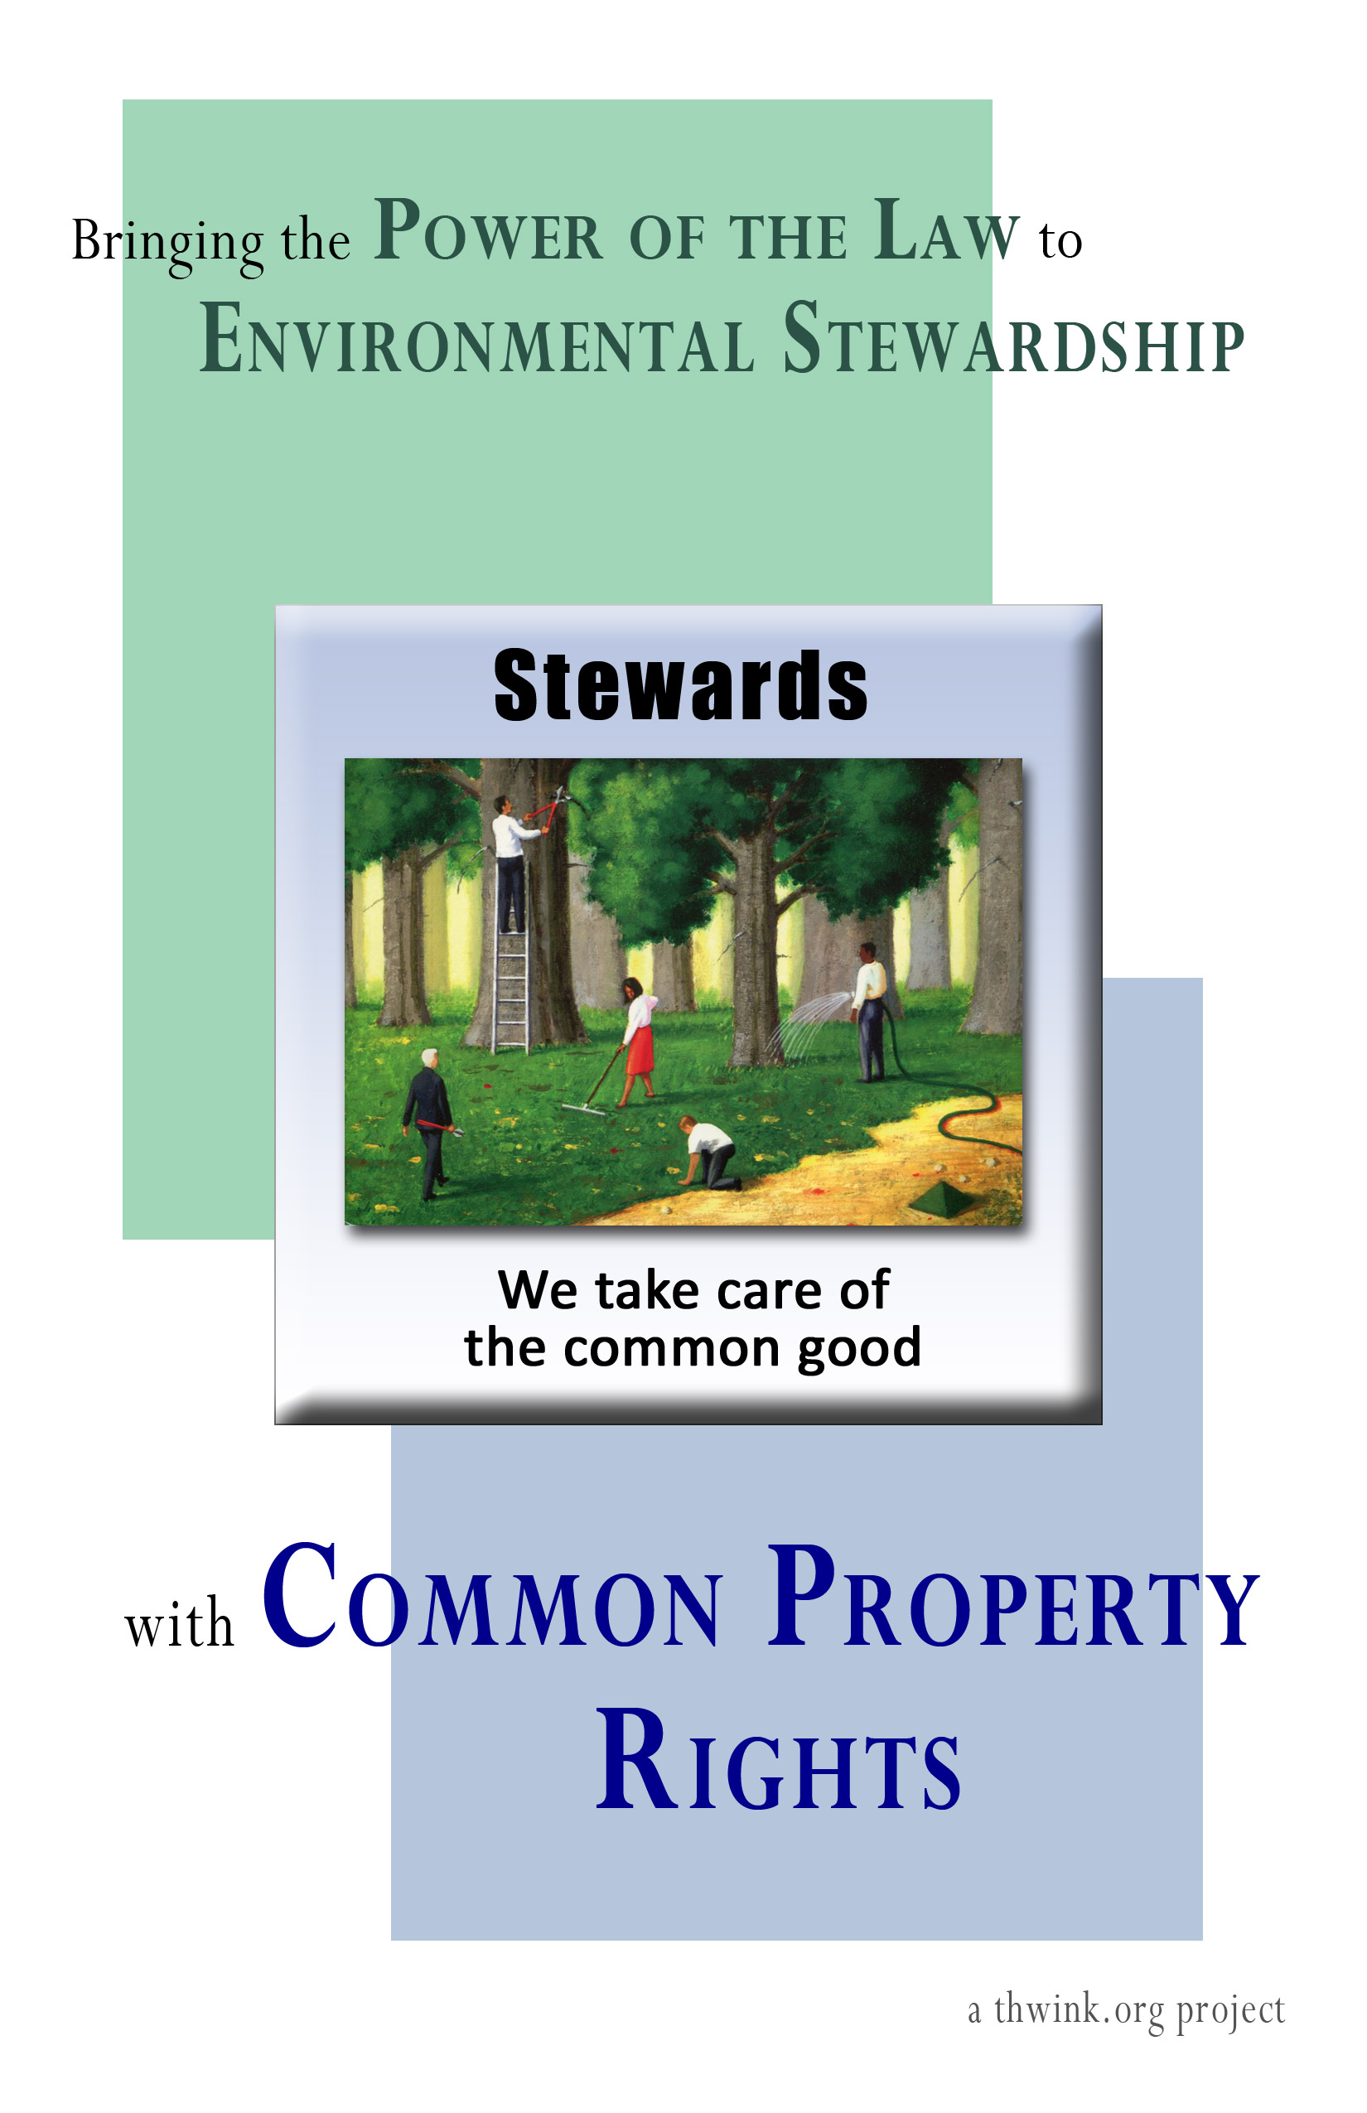

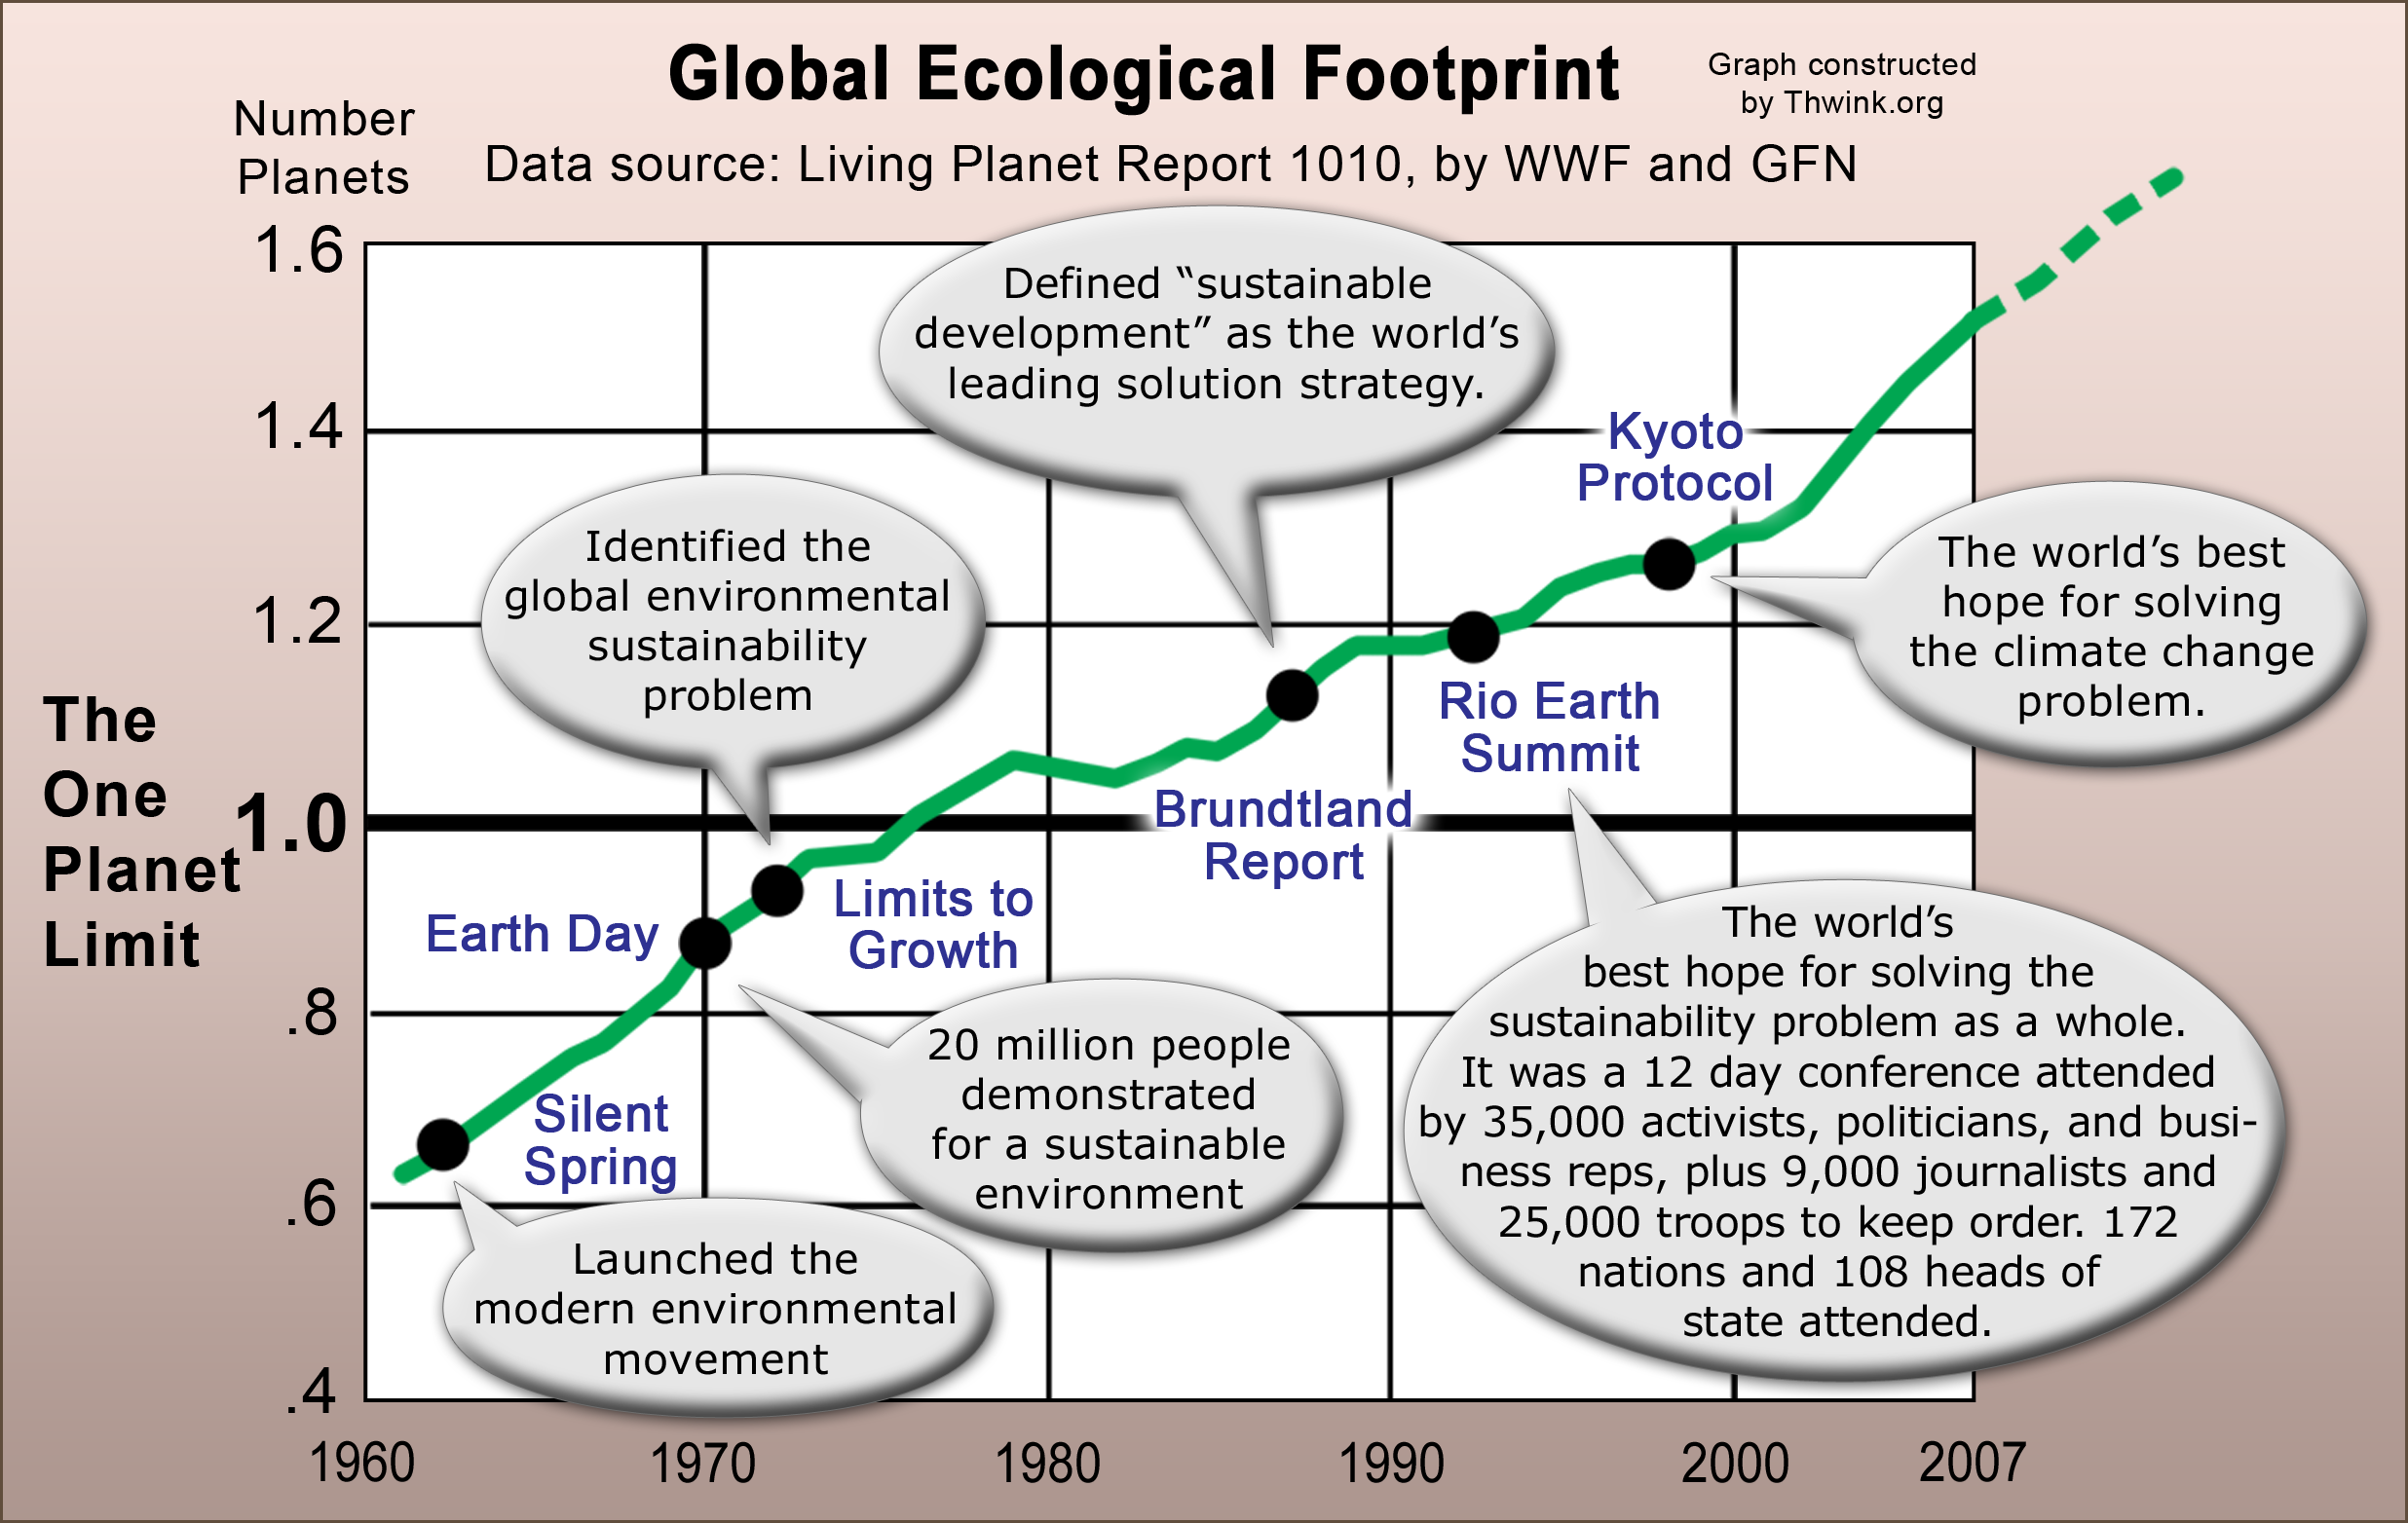
DESPITE THE EFFORTS OF MILLIONS OF ENVIRONMENTALISTS for over forty years, the sustainability problem is growing worse with no solution in sight. The world’s Ecological Footprint is now at about 50% overshoot with no sign of dropping to a sustainable level in time to avoid collapse. We’re winning a few battles but losing the war.
So what can we do?
We can try a systemic solution.

COMMON PROPERTY RIGHTS is a comprehensive system for managing the world's common property sustainably. That’s a dry definition, but its benefits are anything but dry. The great advantage of Common Property Rights over other solutions is:
It’s efficient – It's the mirror image of the world's already existing Private Property Rights system, so it promises to be just as supremely efficient.
It’s generic – It applies to all types of environmental problems, just like Private Property Rights applies to all types of private property.
It’s self-replicating – Once the solution is in place it’s designed to naturally spread to include and solve all the world's environmental sustainability problems, including those unknown today.
Efficient. Generic. Self-replicating. No other solution offers these qualities, including pollution taxes, emissions trading, regulations, conservation, cooperative management, and privatization.
These three qualities are how we can bring the Power of the Law to environmental stewardship. Even better, the solution is ready to implement.
So how would you like to make history and be one of the world’s first legal environmental stewards?
A steward is a non-profit corporation whose chartered goal is to manage the health of a common environmental property sustainably, such as a pollution problem or a depleted fish stock. The Common Property Rights solution revolves around stewards, just as Private Property Rights revolves around corporations in industrialized countries.
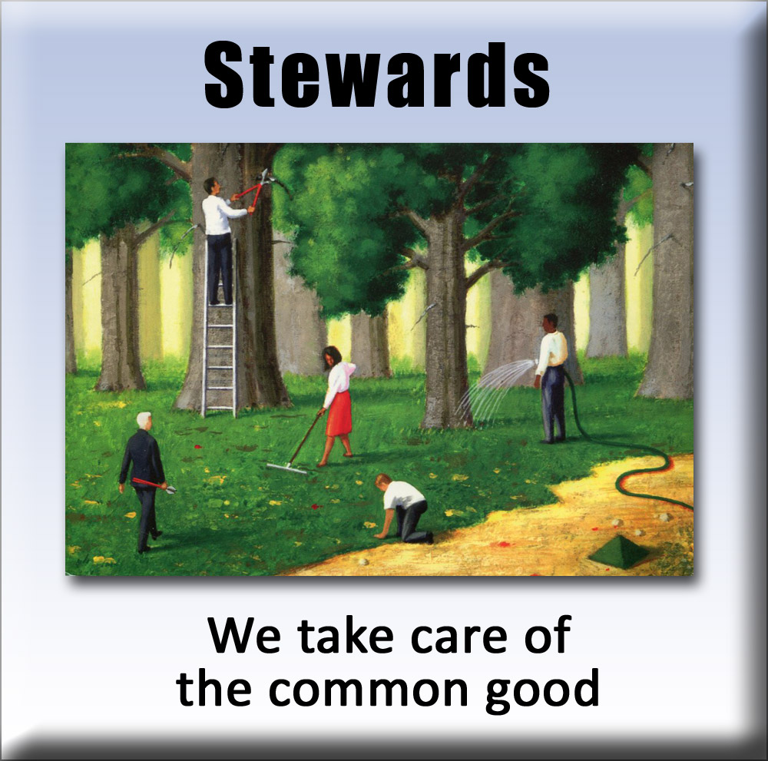
If you’re an environmentalist imagine how much easier your work will be once you’re a steward. No longer will you have to dream up a custom new solution to each new problem and hope you can get it accepted. No longer will you have to spend endless hours in campaigning, lobbying, fundraising, and bargaining with a dizzying menagerie of stakeholders. Instead, your work becomes much easier because you now have the Power of the Law on your side.
This enticing vision of the future is not as far fetched as it may seem because the human system is naturally evolving towards Common Property Rights. Hundreds of thousands of environmental organizations are already acting as stewards. Each is struggling to generate the income they need to solve the problem. Most are also struggling to get the new laws (rights) they need to be good stewards passed and enforced. These de facto stewards are already part of a Common Property Rights system, because they’re trying to manage common property via the legal rights needed to do that.
Wouldn’t it be nice if all the rights stewards need were already there?
If they were, then the sustainability problem could be solved tomorrow.
Explaining what Common Property Rights is begins with understanding what kind of problem we’re really solving.
What Kind of Problem Is the Sustainability Problem?
The biosphere we live in consists of two main types of property: private and common property.
Private property is the tangible and intangible things owned by people or organizations over which their owners have exclusive and absolute legal rights. Private Property Rights are created by groups of people to bring order to their lives. Private Property Rights are so fundamental that without them civilization would collapse into a seething mass of banditry.
Common property is the air we breathe, the water we drink, and all sorts of natural resources and ecosystem cycles we share and depend on. Once we walk outside into the fresh air we can see that most of the biosphere is not private property. It’s common property.
So what exactly is the sustainability problem?
To answer that question we must think differently. Out of the box. The 30,000 foot view. Cast aside all preconceptions. Open the mind.
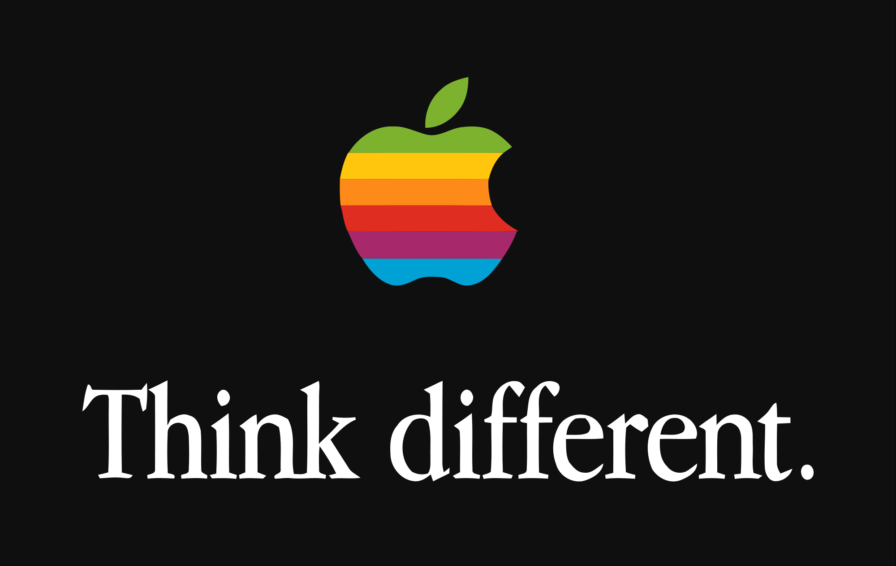
Once we enter the zone of a new perspective, we will discover that the solution to the sustainability problem has been sitting under our noses for centuries.
The clue to the way forward lies in the world’s existing private property system. That system is better known as the economy. The problem is the economy is trashing the greater system it lives within, the environment. We can draw the relationships between the two systems like this:
Now things get interesting. We’re zeroing in on the blockbuster insight that maybe, just maybe, will make all the difference in solving the problem.
It’s like in 1928 when Alexander Fleming noticed an odd mold growing in a Petri dish. Something looked strange. The mold seemed to be killing the bacteria growing in the dish. In a flash of insight Fleming realized that this mold, whatever it was, had potential. Fleming had discovered penicillin, which later became the world’s first antibacterial wonder drug.
So what can we notice that we haven’t seen before?
Study the diagram. What’s really going on at the highest appropriate level of abstraction?
What we have at the low level is obvious. The economy and the environment are improperly coupled. The economy is destroying the environment. We have an excessive environmental impact problem. The problem is thus universally considered to be too much use and waste. That’s the problem everyone is trying to solve, so their solutions reflect that mindset.
But what happens if we think differently, put on our systems thinking hats, and look at the problem from a higher level? There we see the problem as two interconnected systems. They’re connected by use and waste.

Now everything changes. We see one system, private property, is well managed. Taken all by itself it’s doing fine. But the other system, common property, is doing terrible. It’s somehow being poorly managed because it’s not responding sustainably to all that use and waste. Therefore we don’t have an excessive impact problem. What we really have is a property management problem.
That’s the insight. It may not sound like much, but wait and see what we can do with it.
Now a further question arises. If what we have is a property management problem, how can we solve that problem? How can we best manage the world’s huge amounts of common property for the long term benefit of all?
How Can We Best Manage Common Property?
Looking at the problem this way opens up a fresh line of attack.
If we peer at the sustainability problem as if it was a property management problem, we see that so far the problem of how to productively manage common property is unsolved. But guess what? The problem was solved long ago for private property. The world's private property management system works so well we take it for granted. It's incredibly efficient and effective because it's been refined by thousands of years of evolution. It became especially efficient around the beginning of the Industrial Revolution.
So why not take what we've learned from how to manage private property and apply it to common property?
Civilization knows from experience that it takes a comprehensive solution system to manage a complex problem system.
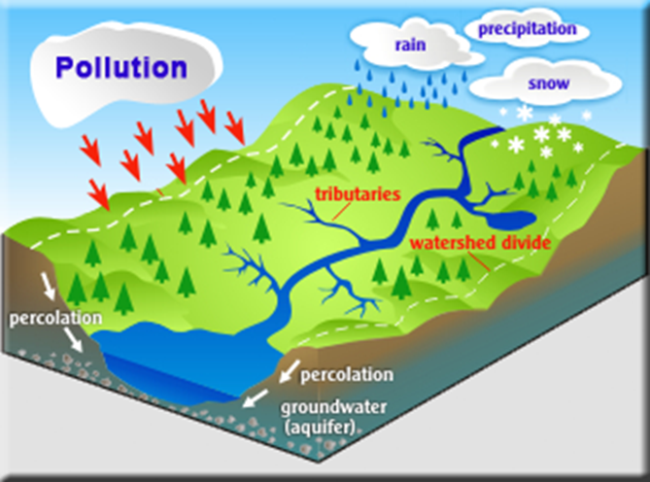
For example, the problem system might be a watershed suffering from pollution. These systems are so complex we’re still learning how they behave. They’re every bit as complex as a sector of industry. The disastrous experiment of centrally planned USSR style communism showed that centrally planned economies don’t work. They’re top down rather than a comprehensive system. They fail because no large social system can be centrally managed efficiently. That can only be done with the comprehensive system provided by thousands of independent social agents and a mature Private Property Rights system.
The same holds true for centrally planned regulation of the environment and its millions of complex subsystems. That perennially popular solution won’t work either. It’s not efficient enough. Instead, we need to apply what does work on managing private property to managing common property.
Otherwise we have learned nothing from history.
The only rights we have are those we give ourselves.
How Private Property Rights Work

Until the invention of modern democracy, the biggest problem the average person had was lack of Private Property Rights. A king could take
what he wanted anytime he wanted, under the tradition of the divine
right of kings. He could set taxes to whatever he wanted. The law was
not the people’s law. It was the king’s law in the king’s courts, where
your property and even your ultimate property, your life, was subject
to the whims of those laws. That began to change, first in England,
with the signing of the Magna Carta:

The 1215 charter required King John of England
to proclaim certain liberties, and accept that his will was not arbitrary, for example by explicitly accepting that no "freeman" (in the sense of non-serf) could be punished except through the law of the land, a right which is still in existence today.
Magna Carta was the first document forced onto an English King by a group of his subjects, the feudal barons, in an attempt to limit his powers by law and protect their privileges.
Lord Denning described [the Magna Carta] as "the greatest constitutional document of all times – the foundation of the freedom of the individual against the arbitrary authority of the despot."

Private Property Rights are the foundation of modern civilization.
The key component of a mature Private Property Rights system is
the enabling legislation that defines the system. After that, the gov-
ernment’s role is to oversee the system in general and enforce the law.
The law itself defines how individual social agents (like people, states within a nation, and artificial entities like corporations) should behave toward one another so as to optimize the common good of all.
Over the centuries more components were added until we had a mature Private Property Rights system. This includes free market trading and corporations, who carry out private property management at large scales far more efficiently that any single person could do alone.
Today’s Private Property Rights system consists of these seven main components:
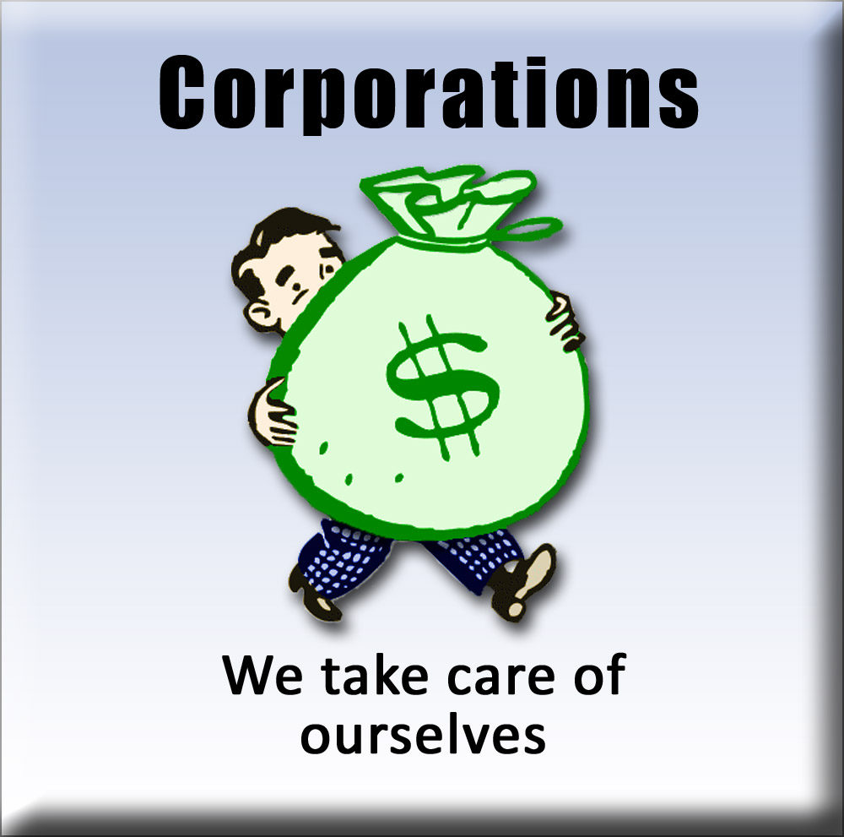
1. Enabling legislation – Defines the system by defining its components and how they interact.
2. Corporations – This social agent uses the system to achieve its goals. The entire system revolves around corporations since they run the system. The social agents of people and government play supporting roles.
3. Claims – Corporations file claims on any unclaimed private property. All land was claimed by nations long ago. Private property in the form of patents, copyrights, and natural resources such as oil and gas is still being claimed. Claims are how property enters the system.
4. Goals – The goal of each corporation is stated in its charter and is controlled by the type of corporation. The goal of for-profit corporations is to maximize short term profits for their owners. The goal of non-profits is to perform some kind of beneficial service for society. Since most work is done by for-profits they dominant the system. Their goal is the implicit goal of the human system, which is another huge insight.
5. Prices – Corporations set prices for purchase or use of their private property.
6. Expenses – Corporations use the income from prices to purchase what’s needed to provide the goods and services they sell.
7. Monitor results – The results of a corporation’s actions are continually monitored so for-profits can calculate profits and non-profits can measure results. This allows managers to adjust prices and how expenses are spent, in order to best achieve their goal.
It’s an elegant system. These seven components are all it takes to run the world’s many economies that over seven billion people depend on.
The system is deeply flawed, however. It assumes the health of the greater system it lives within, the environment, need not be considered. Nowhere in the above system does environmental impact become automatically included in the decisions behind prices and expenses.
For the longest time this flaw didn’t matter. But now it does. The long delays in environmental destruction are beginning to catch up with the world’s growing economies. The effects of climate change, innumerable types of pollution, and looming natural resource shortages increase every day. It’s all because the above system considers only private property. So the logical solution is to clone the above system and use it to design a nearly identical system to manage the world’s common property.
Now let’s take these same seven components and see how they can form a Common Property Rights system.
How Common Property Rights Work
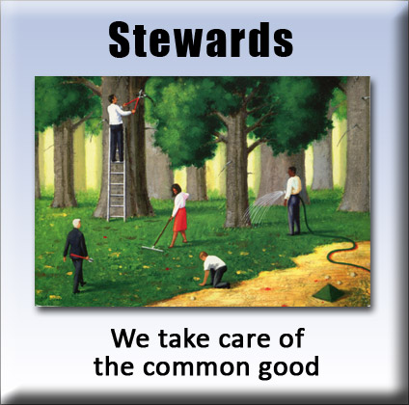
1. Enabling legislation – Defines the system by defining its components and how they interact. This can be simple because so much of private property law is reusable. It’s easily applied to common property. All that need be specified is the differences between Private and Common Property Rights.
2. Stewards – Non-profit stewardship corporations are formed. Each has the chartered goal of performing a specific service for the good of humanity. Stewards are public servants who work for the common good, rather than for themselves.
3. Claims – Stewards file claims on any unclaimed common properties needing wise stewardship. Claims allow the solution to spread naturally and efficiently, and to eventually solve the entire problem. This is identical to how all land was claimed long ago. Once a claim is accepted the steward doesn’t own the property. It owns the right to manage it for the long term common good of all.
4. Targets – After a claim is approved the government and the steward set the targets for that common property, such as allowable levels of pollution. The objective is to meet the sustainability targets with the lowest fees possible. Just as prices on new products come down to the lowest possible level over time, fees will do the same.
5. Fees – Stewards charge fees for use of the common property. This is a “user fee” per unit of ecosystem service use, such as one dollar per pound of a pollutant or ten cents per codfish caught. A fee is not a tax. Psychologically and legally, fees are the price of providing a sustainable ecosystem service. Fees will start out low to avoid shocking the system, and then will be gradually raised to the level required to meet the targets.
6. Buys – Fees are spent on buys, as the steward "buys" the health of its common property back. Buys are the expenses of providing a sustainable ecosystem service, such as education, R&D, implementation cost assistance, and cost of monitoring. Special care will be taken to minimize transition hardships.
7. Monitor results – Stewards monitor the health of their common property, in order to adjust fees up or down and to adjust how buys are spent. The idea is to raise fees just high enough to meet the targets.
It’s an elegant system. These seven components are all it will take to manage the world’s millions of units of common property.
It’s the system that should have been there all along. But we forgot. Because of that historic oversight there will be some squawking and transition awkwardness as Common Property Rights is introduced. But fifty years from now Common Property Rights will be taken for granted, just as Private Property Rights are today.
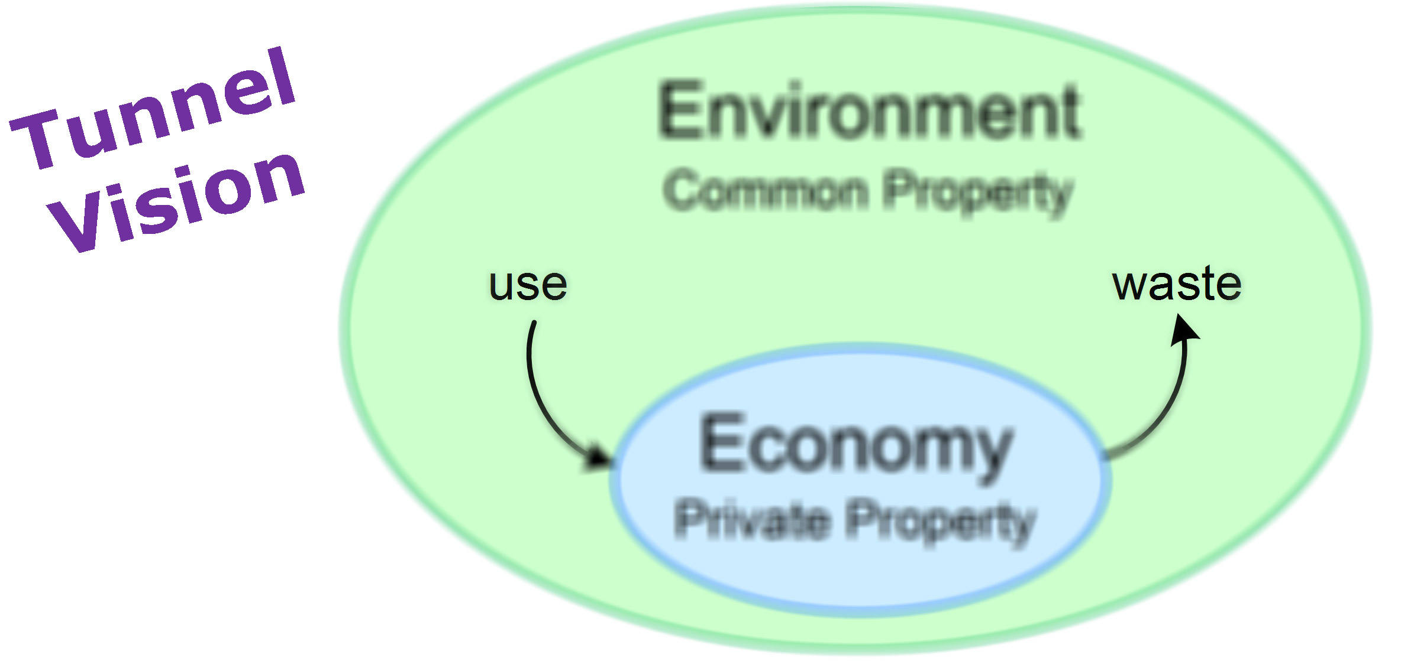
These are large because Common Property Rights is a systemic solution to a systemic problem, while popular solutions are non-systemic. Why this is so may be seen in this diagram:
The Enormous Advantages of Common Property Rights
Use and waste are all traditional thinking sees clearly. Due to tunnel vision the rest is a hazy blur, so conventional solutions try to directly reduce use and waste to sustainable levels. This fails because it’s not systemic. It doesn’t treat the problem as a system that needs restructuring but as symptoms that need fixing. Popular solutions are thus symptomatic solutions.
When we look at the problem with our systems thinking hat on, we see a very different situation:
This is a radically different viewpoint with elephant-sized advantages. WHY is there such excessive use and waste? Systems thinkers ask such questions and take the time to analyze the system to find the answers. Here the answer is excessive use and waste occurs because private property is well managed but common property is not. That’s a problem Common Property Rights can solve and popular solutions cannot.
Common Property Rights solves the poor management of common property problem with a comprehensive system of seven components. This gives Common Property Rights these three crucial qualities:
It’s efficient because it’s the mirror image of Private Property Rights, which has proven to be highly efficient.
It’s generic because it applies to all types of environmental problems, just as Private Property Rights applies to all types of private property.
It’s self-replicating because of claims and stewards. Stewards appear to file a claim whenever concerned activists see a common property that needs wise stewardship to be sustainable.
How efficient is Common Property Rights? That can be seen in the two graphs at the top of the next page.
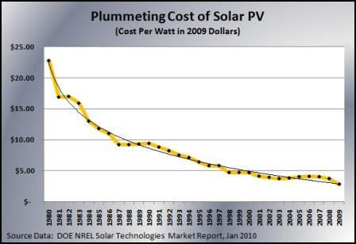
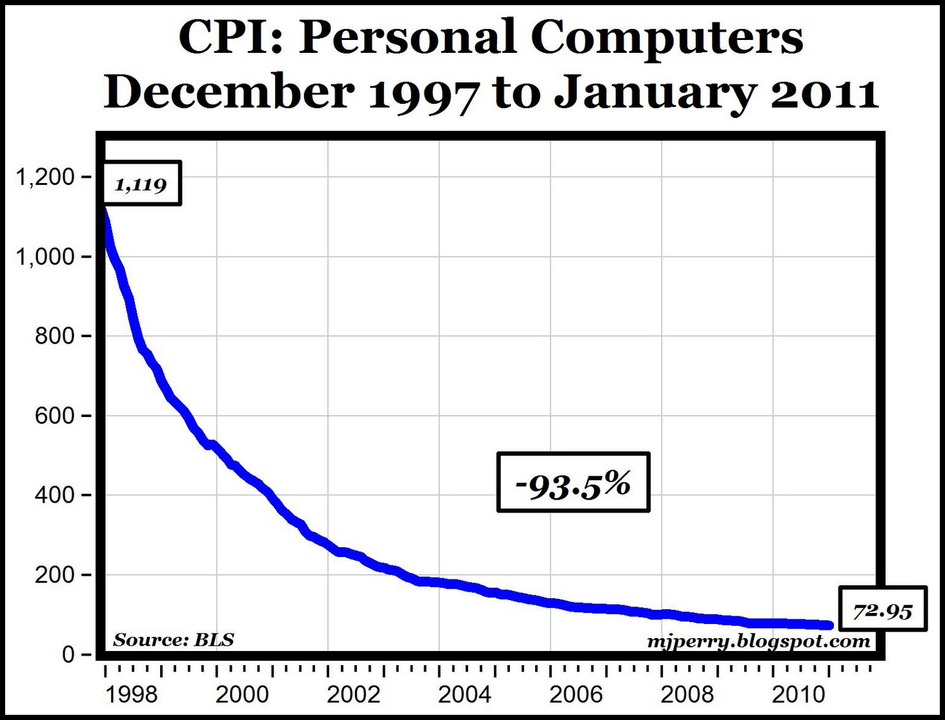
The price on a radical new product or service tends to start high and then fall exponentially over time. The curves above are for private property prices. We can expect similar curves for Common Property Rights fees because Private and Common Property Rights systems are based on the same underlying pattern. Fees will start high and fall low via a similar curve. The curve will probably be S shaped, due to the initial delay in development of so much new technology and practices to reduce environmental impact.
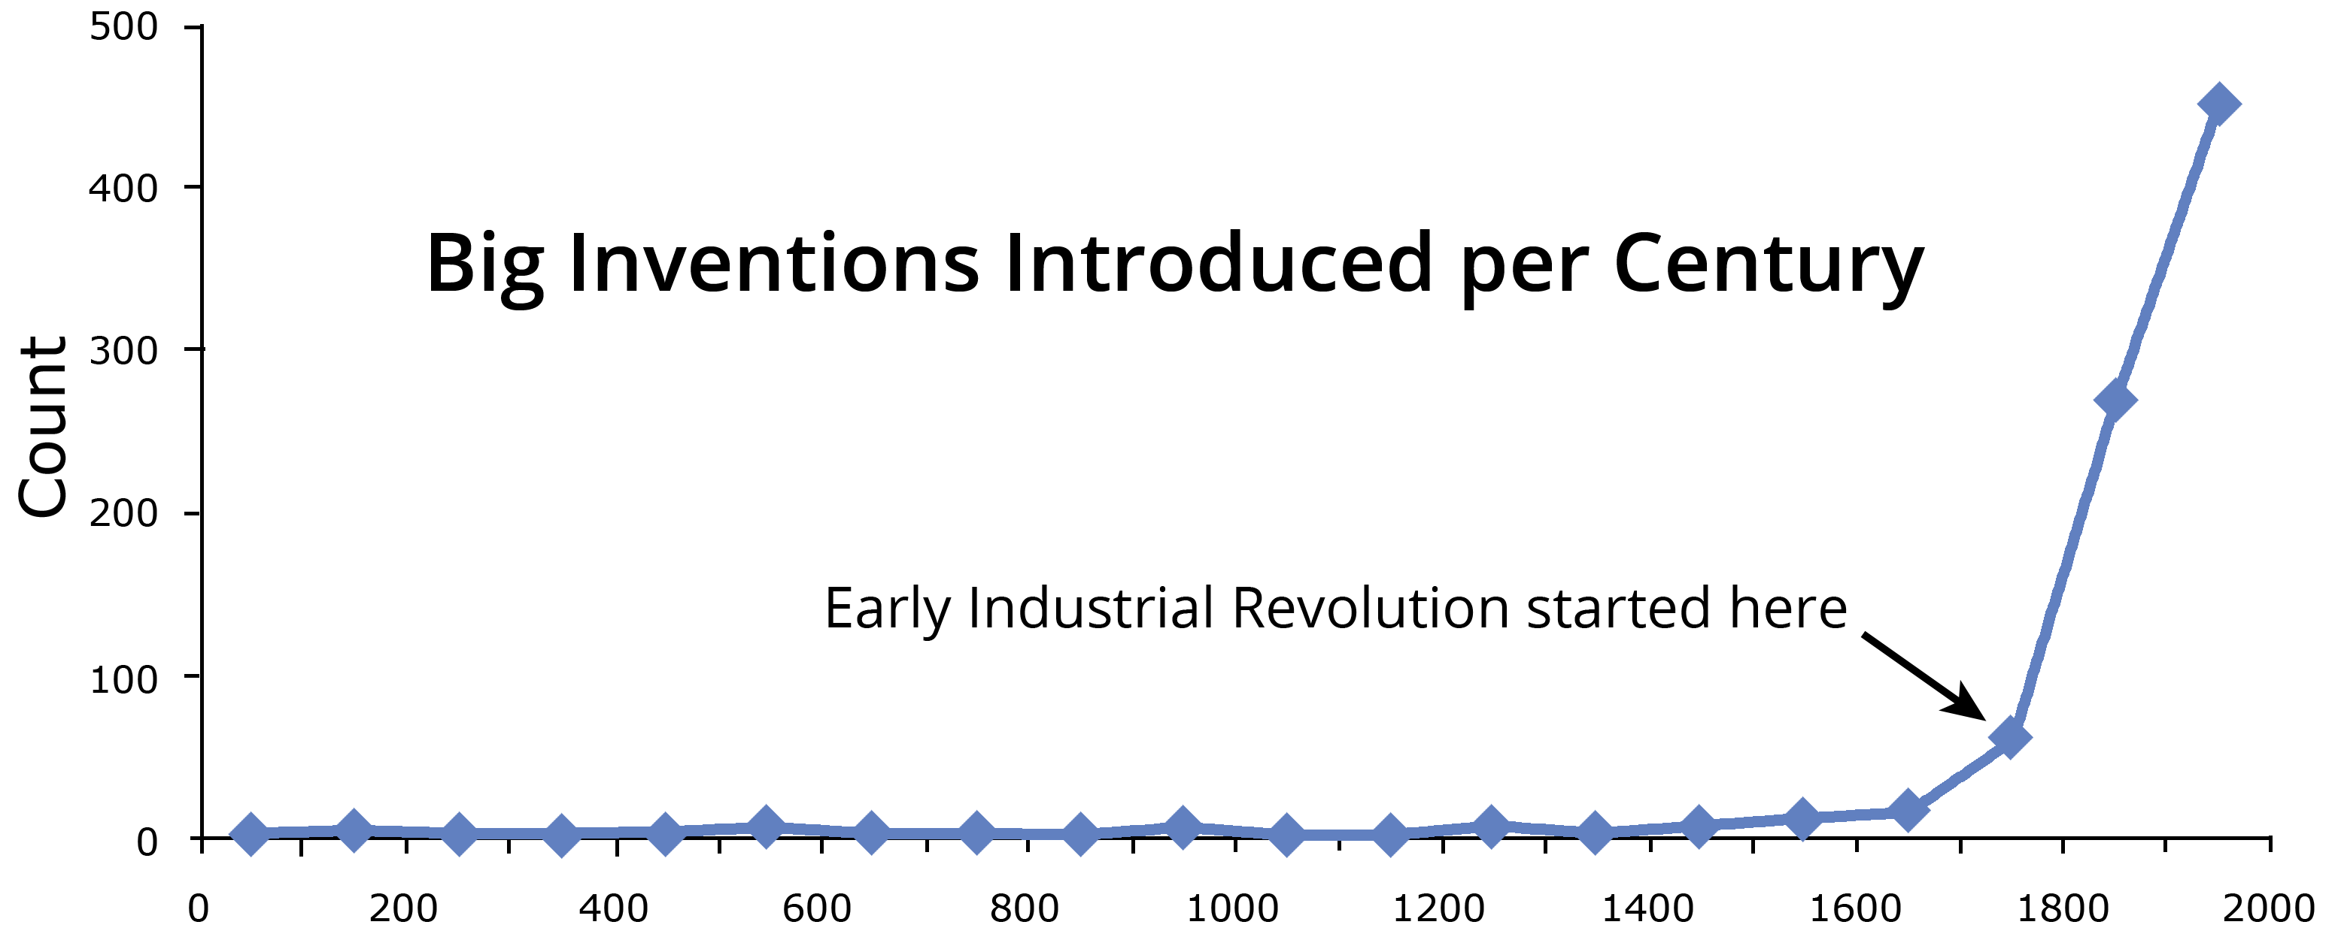
How generic is Common Property Rights? That too may be seen in this graph:
Each new big invention of all types spawns thousands of new products of all types, since the economy (the world’s Private Property Rights system) is generic. It can produce anything as long as it’s private property. Common Property Rights will do the same because it’s just as generic. It can manage any common property.
The big invention curve took off around 1750 (at the early stage of the Industrial Revolution) because that’s when the world’s economic system matured. A similar curve will take off when the Sustainability Revolution begins, due to maturation of the world’s Common Property Rights system.
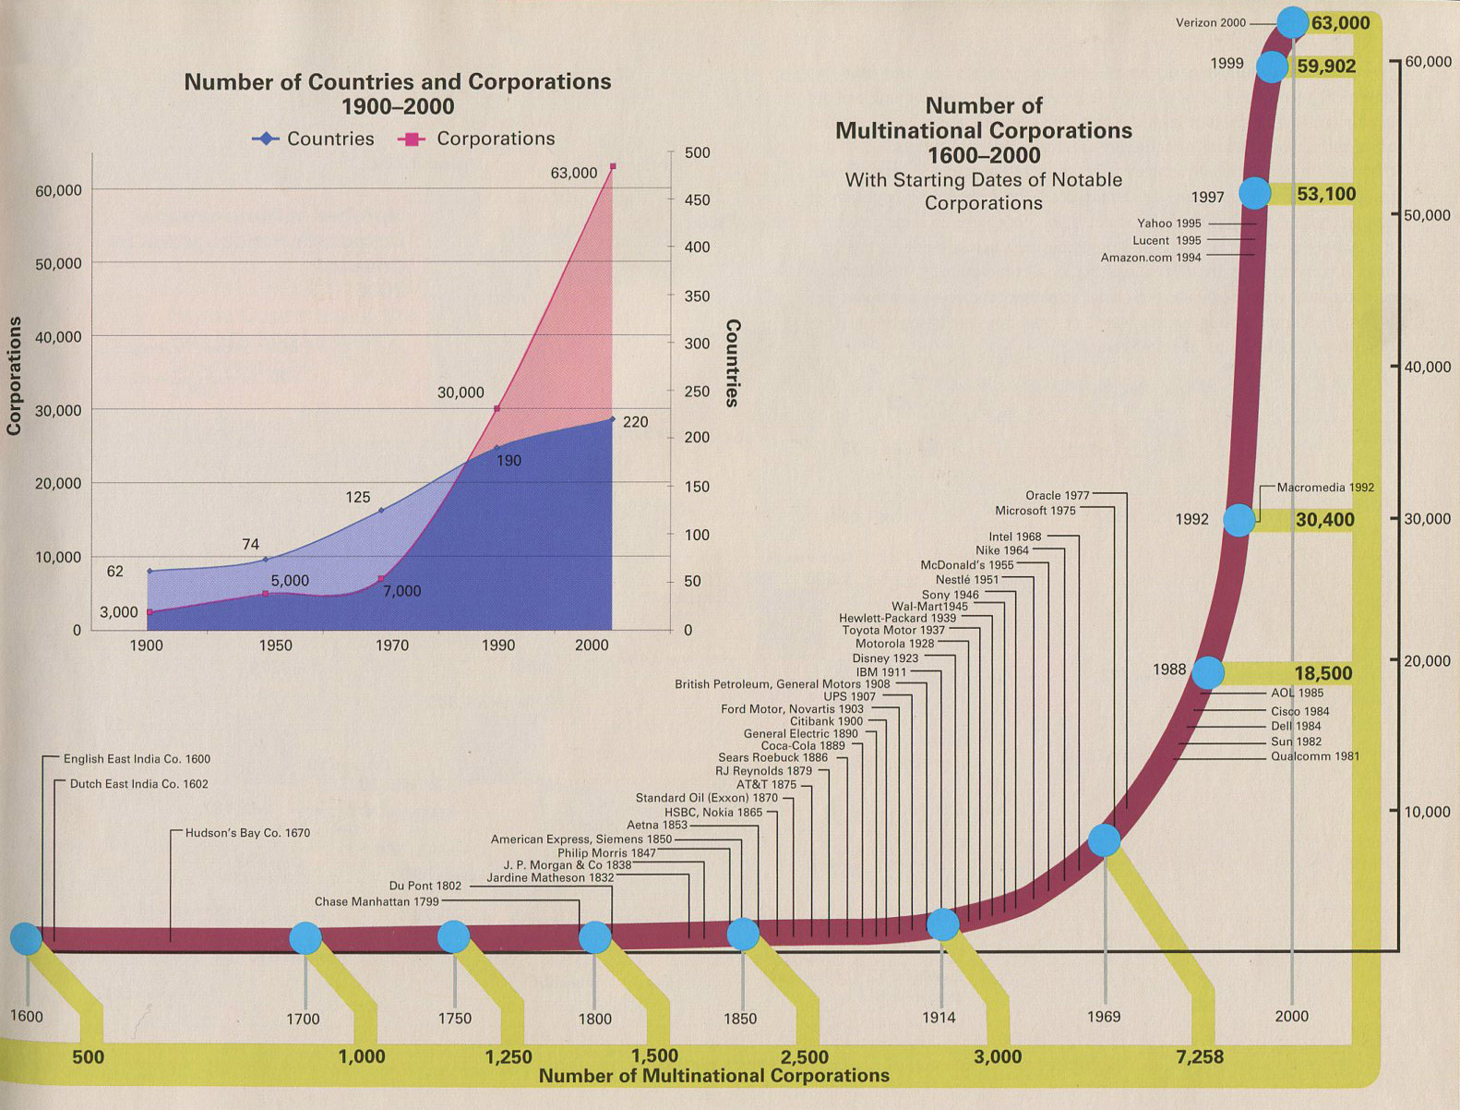
Lastly, how self-replicating is Common Property Rights? One more curve should illustrate that:

The curve shows how well the Private Property Rights system did at replicating multinational corporations. Phenomenally well. The usual exponential growth phase appears once again. The curve took off not when the Private Property Rights system matured, but when the key social agent in the global aspect of that system matured and its niche became available.
The same will happen once the world’s Common Property Rights system is born and a niche opens up for stewards to fill. We can expect an explosion of replications, as stewardship corporations cover the globe.
Next, let’s use these three qualities to contemplate why the sustainability solutions we’ve tried so far have largely failed.
Popular solutions aren’t efficient, generic, and self-replicating because they push on the system in only a small number of places (except for privatization). Common Property Rights pushes on the system in seven places. Furthermore, it pushes in the right places because it’s the mirror image of Private Property Rights.
Why Popular Solutions Can’t Solve the Problem
Let’s examine six leading popular solutions to see why they don’t have these three qualities. Notice how all of them focus on reducing use and waste, rather than changing the structure of the system.
1. Pollution Taxes – (Such as carbon taxes.) This pushes on the same point fees push on. That’s not enough to be efficient. The Private Property Rights system would not work if had prices and no expenses. Pollution taxes are not generic because they consider only pollution and omit natural resource use and depletion. This solution is not self-replicating because it lacks claims and stewards.
2. Emissions Trading – (aka cap and trade) The idea behind this solution was to let free market forces solve the problem. That’s wishful thinking because emissions trading is a form of prices and quotas. It pushes on the system in only these two places. Again, that’s not enough to be efficient. It’s also not generic because quotas cannot be set for all uses of ecosystem services without raising a firestorm of protest and hardship, since people consume widely varying amounts for legitimate reasons. Finally, it’s not self-replicating because it lacks claims and stewards.
3. Regulations – (Prescriptive laws, fines, and limits) Regulations have long been the main solution. If members of a society are doing something undesirable, then passing new laws to punish them for doing that and to prescribe what to do instead seems like a perfectly obvious solution. Countless regulations, like fines for littering and commitment to binding targets in the Kyoto Protocol, have not worked. Why? They push on the system in only one place: “Don’t do that.” That fails miserably because regulations are a form of command-and-control. Compared to price signals, no governance system can accurately tell all users of all ecosystem services how much to do or not do, and dynamically change that as often as needed.
Regulations are thus the most inefficient solution possible because they assume that complex systems are simple. They’re not. They’re complex, too complex to be solved by a solution as naive as regulations.
Regulations are generic since they can be used on any problem. But that hardly matters because they’re not efficient. They’re also not self-replicating because they lack claims and stewards.
Related to this is the Power of the Law strategy many environmental NGOs use. They pick a problem (like a pollution problem or a watershed needing general wise stewardship), find offenders, and then get the government to enforce existing laws. They may also approach the offenders themselves and try to educate them to behave more sustainably. Some also do general public involvement and education programs. A few focus on prevention, like preventing new coal power plants from being built.
While this strategy helps some, it cannot solve the complete problem because existing regulations are incomplete. They always will be, for the reasons mentioned above. How can you use the Power of the Law to solve the problem if the laws you need are not there?
4. Conservation of natural resources – This is the oldest solution of them all, beginning with practices like soil conservation in ancient China. Modern conservation began with creation of Yellowstone National Park in 1872, the world’s first national park. By 2006 there were 6,555 national parks worldwide. In addition to parks there are conservation organizations, like the World Wildlife Fund whose “mission is to conserve nature and reduce the most pressing threats to the diversity of life on Earth.”
Natural resource conservation has proven to be a failed strategy because it’s impossible to make the system as a whole sustainable by preserving portions of it. It’s not a systemic solution since it pushes on the system in only one place: protection. It lacks any of the seven components of Common Property Rights so it’s not efficient, generic, or self-replicating.
5. Cooperative Management – Also called collective management, this solution was popularized by the work of Elinor Ostrom, winner of the 2009 Nobel Prize in economics for “her analysis of economic governance, especially the commons.” The solution centers on group management of “common pool resources,” usually agriculture related resources like forests, fisheries, and irrigation systems.
Of the seven components of Common Property Rights, cooperative management has enabling legislation (voluntary agreement), stewards (the cooperative), targets, and monitor results. It’s thus not nearly as efficient as a system with all seven components. It’s not generic because it’s voluntary, only works on very small units of the global system, and relies on a tight network of personal relationships. It’s not highly self-replicating because it lacks claims.
6. Privatization – This is the transfer of public (government) management of a resource to the private (corporate) sector. In practice the managing corporation has usually been for-profit. Results have in general been poor but the push to privatize persists. Water is the most common application. Here’s why: “The [World] Bank estimates the potential water market at $1 trillion. After the collapse of technology stocks, Fortune magazine identified the water business as the most profitable industry for investors.”
Privatization has all seven components of a Private Property Rights system since it treats common property as private property. But privatization fails since it’s run for a profit rather than for the common good, as stewards would do.
Privatization is inefficient because the goal is short-term maximization of profit. It’s so inefficient that water prices typically rise considerably, which has led to cancellation of many privatization contracts.
Privatization is generic. It’s also self-replicating in a sense because for-profit corporations have a strong incentive to look for privatization opportunities. But until the profit motive disappears, privatization won’t work because it’s not efficient from a social and environmental sustainability perspective. If the profit motive did disappear by replacing profit goals with sustainability targets, privatization would be the same as Common Property Rights if claims and fees were added, and corporations became stewards.
These six examples explain why popular solutions can’t solve the environmental sustainability problem. But Common Property Rights probably can. Let’s turn our attention to how that could be done, starting tomorrow.
Once the world has enough stewards the sustainability problem is solved. Our challenge is to quickly startup as many stewards as possible, get them to the point of self-replication, and then stand back and watch environmental stewards cover the globe.
The Key Requirements for a Stewardship Startup
Wouldn’t that be a wonderful thing to see?
It can happen. However, stewardship startups can’t work everywhere at first since Common Property Rights is so different from what people are accustomed to. That forces us to carefully look around for places where the solution would work.
The four key requirements for a successful CPR startup are:
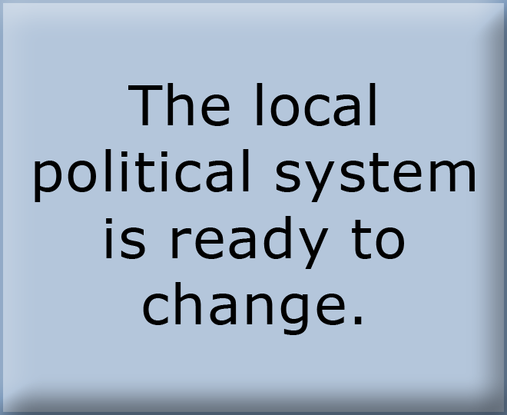
1. A pocket of low change resistance, such as a county, town, city, or maybe even a state. – Otherwise the all-important enabling legislation will not be passed. The local legislature must be open to the idea of allowing stewards to file claims on unclaimed common properties needing wise stewardship and if the claim is accepted, to charge fees per unit of ecosystem service use. The enabling legislation can start small with a test pilot project using non-generic legislation for a single steward for a limited period of time. Later the law can be upgraded to be generic.
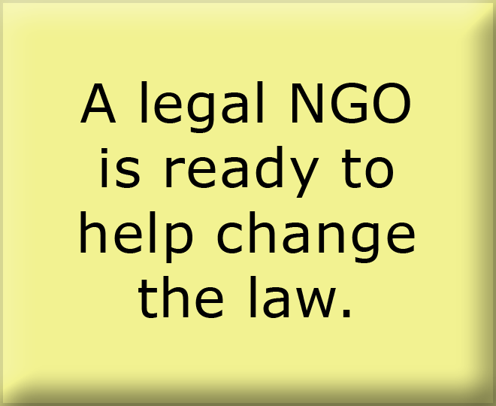
2. An existing well established legal NGO to get the pilot enabling legislation passed and later the full non-generic legislation – Examples are the US Southern Environmental Law Center (SELC) and GreenLaw. Using SELC's phrasing, legal NGO's use "the Power of the Law" to get offenders to behave more sustainably. But that can only solve a small fraction of the total environmental sustainability problem, because the Power of the Law only applies to existing law. We need so many new laws that what's really needed is a single generic new law that covers all environmental problems. That's what the enabling legislation does and is why Common Property Rights should be very appealing to legal NGOs.
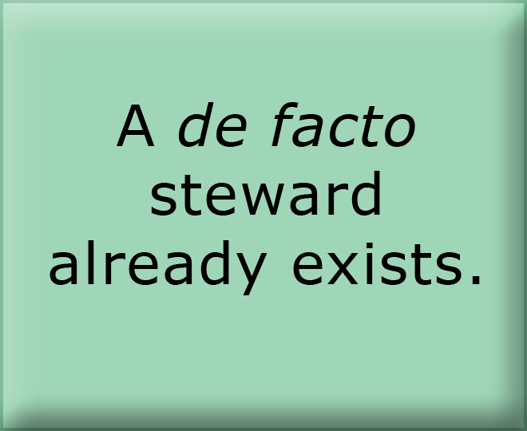
3. An existing well established environmental NGO who is already a de facto steward – One example is US Upper Chattahoochee Riverkeeper, whose “mission is to advocate and secure the protection and stewardship of the Chattahoochee River, its tributaries and watershed....” They’re a member of the Waterkeeper Alliance, who has nearly 200 de facto steward members. Very few de facto stewards are fully achieving their mission due to lack of the necessary income and favorable law, which is why Common Property Rights should be very appealing to environmental NGOs.
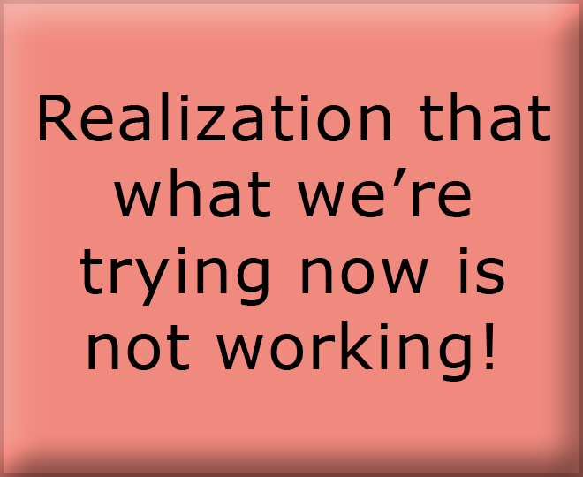
4. Expression of pain – Both the existing legal and environmental NGOs must be expressing strong dissatisfaction with progress on solving the sustainability problem or they will not be receptive to a solution as novel as Common Property Rights. This means they are seeing high change resistance and are acknowledging that present approaches are not working. They will thus be receptive to considering something new.
“In the new Congress, we are encountering a severe backlash against essential environmental safeguards. Under the guise of reining in federal spending, anti-environmental forces are attempting to gut the enforcement of federal protections and to put the brakes on EPA just as it was beginning to make real progress on pressing issues, such as regulating global warming pollution and placing strict limits on toxic emissions from burning coal. Big polluters can only be amazed at their sudden good luck. The same thing is happening in several of our states. We will not let these forces get the upper hand.”
Here's an outstanding example of expression of pain from the Southern Environmental Law Center: (retrieved March 7, 2012)

To summarize, these appear to be the minimum preconditions for a successful Common Property Rights startup:
It won’t be easy because it’s such a different approach. Many people will reject it outright as unworkable for a million and one reasons.
But a few will think differently.
All it takes is the very first steward. Steward number one is the catalyst that initiates the chain reaction. To accelerate the reaction several “first stewards” would be better. Here are some ideas to get the job done:
How You Can Do a Stewardship Startup
- Find a spot on the planet that satisfies the four key requirements.
- Change resistance is the crux so focus on that. The real hurdle is getting the temporary non-generic enabling legislation passed. This applies only to the test steward for a period of 5 or 10 years or so.
- Explain to your elected representatives how Common Property Rights works. Show them how it’s a better mousetrap. Explain why it can solve the sustainability problem and other solutions cannot. What you’d like to do is run an experiment. There’s little to lose and a lot to gain.
- Get the temporary enabling legislation passed.
- Incorporate a stewardship corporation, file a claim, and get the claim accepted.
- Get fee-based stewardship of your common property running smoothly. This will take a few years.
- As you go, collect the data demonstrating how well Common Property Rights can or can't work. Improve the mechanism of Common Property Rights as you go.
- If things go well, use experimental results to get the temporary non-generic enabling legislation upgraded to permanent generic legislation. The first time this happens will be the actual birth of Common Property Rights as a comprehensive solution. This would be a historic occasion worth celebrating.
- That political unit is now open for claims. Dozens to hundreds of de facto stewards will incorporate as real stewards and start filing claims.
- Those stewards will spread the solution to other political units.
- More and more enabling legislation will be passed. Mongolian hordes of stewards will materialize as if out of nowhere, due to the pent-up desires of hundreds of thousands of de facto stewards around the planet.
- The solution will self-replicate until there are enough stewards to solve the complete global environmental sustainability problem.

Imagine what it would be like to live in such a world!
Bringing the Power of the Law to
Environmental Stewardship
THE SYSTEM ON THE RIGHT IS THE MIRROR IMAGE of the system on the left. The world’s Private Property Rights system works extraordinarily well, due to exquisite design and the Power of the Law behind it. All the Common Property Rights system needs to work just as well is the Power of the Law behind it too.
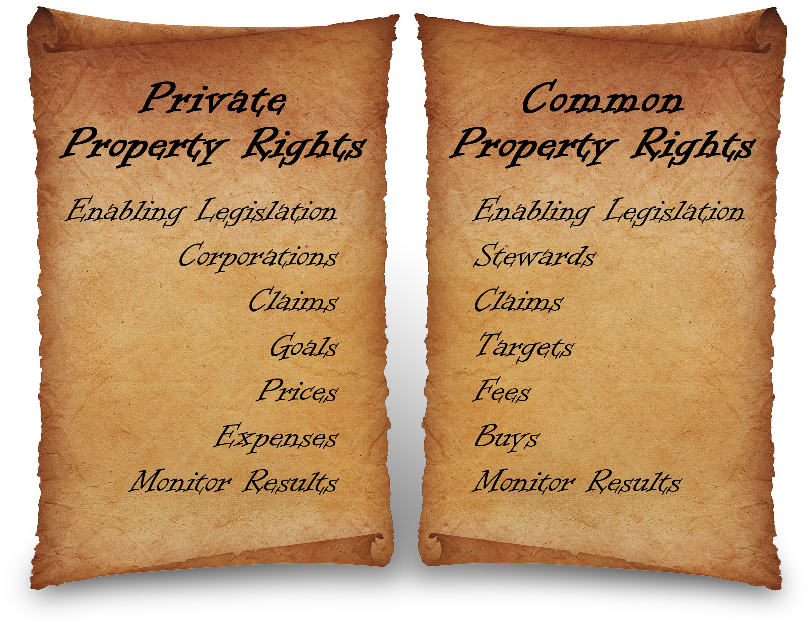
Then both systems will be efficient, generic, and self-replicating.


For further information including videos, the analysis behind the solution, and the Common Property Rights book, see Thwink.org.
Jack Harich
1164 DeLeon Court
Clarkston, GA 30021 US
404-296-5284
info@thwink.org
Philip Bangerter
31 Flinders Cres
Forest Lake QLD 4078
Australia philip.bangerter@usq.edu.au
The only rights we have are those we give ourselves.

The single sentence definition of private property is from www.businessdictionary.com/definition/private-property.html.
The quote about the Magna Carta is from http://en.wikipedia.org/wiki/Magna_Carta.
Three graphs from http://blogs.scientificamerican.com/guest-blog/2011/03/16/smaller-cheaper-faster-does-moores-law-apply-to-solar-cells/, http://mjperry.blogspot.com/2011/03/great-deflation-computer-prices.html, http://akinokure.blogspot.com/2011/02/great-stagnation-of-inventions-in-two.html. Inventions graph reconstructed and improved by Thwink.org.
From Global Inc. An Atlas of the Multinational Corporation, Gabel and Bruner, 2003, p3.
Source: http://en.wikipedia.org/wiki/National_park.
Source: http://en.wikipedia.org/wiki/Elinor_Ostrom
From Water Wars: Privatization, Pollution, and Profit, Vandana Shiva, 2002, p88.
The environmental organization examples are all in the US. They are: http://www.southernenvironment.org/about/from_our_president/ http://greenlaw.org/Mission http://www.chattahoochee.org/mission-and-history.php Similar examples could be found anywhere in the world.

