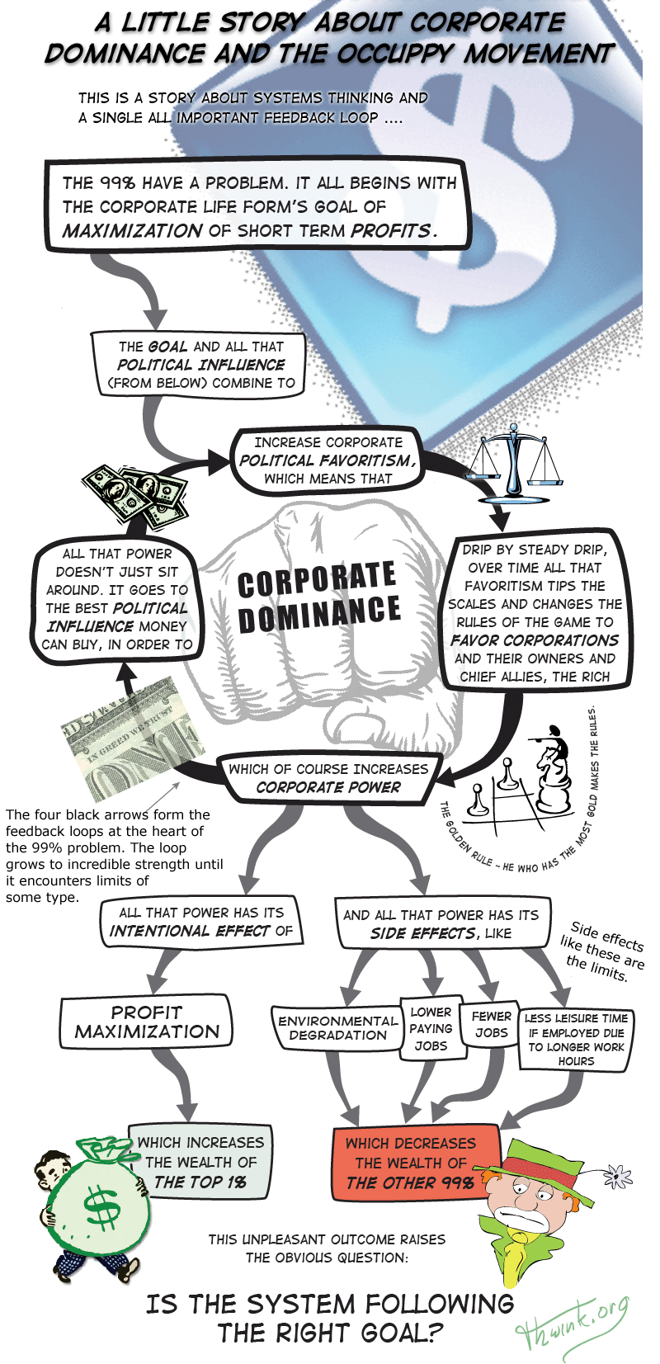

Of course not. The system is following the wrong goal. That's what is causing all those side effects. Let's take the time to analyze the problem using the above illustration as our starting point.

How can we solve the corporate dominance problem?
The Occupy Movement has made extraordinary gains. It has shifted attention from the Great Recession and a host of lesser issues to excessive income inequality, which is a far more important issue. But more than that, the movement has put its finger on a deep underlying trend: corporate dominance. The About page on OccupyWallStreet.org describes the problem this way:
Occupy Wall Street is... fighting back against the corrosive power of major banks and multinational corporations over the democratic process, and the role of Wall Street in creating an economic collapse that has caused the greatest recession in generations. The movement is inspired by popular uprisings in Egypt and Tunisia, and aims to fight back against the richest 1% of people that are writing the rules of an unfair global economy that is foreclosing on our future. (Dec 3, 2011)
The illustration on page 1 used arrows of influence and a single feedback loop to explain the source of this “corrosive power,” why it has grown so strong, and its inevitable effects. This exposes the structure of the problem at the fundamental level. That's important, because unless movement members understand the root cause and the main feedback loops involved, we will be unable to devise a solution that works. We will instead fall back on more superficial solutions. As in the past, these will not work because they fail to resolve the root cause.
That root cause is what drives the Corporate Dominance loop to grow to incredible strength, until it reaches limits of some type. Loop growth is now bumping into its limits, which is why the movement appeared. It's an effort to draw attention to the real problem and solve it.
So what exactly is the main root cause?
First, let's remember that corporations are an artificial life form created by people to serve people. Corporations are a type of social agent. Other types of social agents are governments, clubs, religions, families, and political parties. An agent is any entity with a goal and the ability to pursue that goal. Social agents are the building blocks of social systems, so correct agent design is crucial.
Second, corporations have done society plenty of good. In fact corporations and their managers are basically good. It's their goals and the side effects of pursuing those goals that's not so good. If any hostility is to be directed, it should not be toward corporations but toward the fact they have the wrong goal. That was the key point of the systems thinking style illustration. As Upton Sinclair reminded us: “It is difficult to get a man to understand something, when his salary depends upon his not understanding it!”
Here's a hypothesis for the root cause of the undesirable side effects diagrammed above, as well as many more:
The main root cause is mutually exclusive goals between the corporate life form and Homo sapiens. Large for-profit corporations now dominate the planet. Their goal is maximization of short term profits. The goal of people is to optimize long term quality of life, for those living and their descendents. These goals are so incompatible they cannot both be achieved in the same system, as the above story illustrated. One life form will win and one will lose in the struggle for dominance.

Given this root cause, what solutions will work?
The facts of life in the corporate jungle are harsh. He who makes the most profits wins. The iron law of Survival of the Fittest cannot be changed. Any for-profit corporation in a competitive market who does anything but maximize profits will sooner or later be selected out of the system. They will whither and die. It's a system designed to produce highly competitive ruthless winners.
Given this basic fact:
1. Will repealing Citizens United in the US and similar actions in other nations solve the problem? No, because that does not resolve the root cause. Large for-profit corporations were already dominant and highly destructive (via side effects) before Citizens United. That decision was merely one more drip in the "drip by steady drip over time" that has tipped the system to favor corporations over people.
2. Will campaign finance reform solve the problem? No. That too does nothing to resolve the root cause. Campaign finance reform has been tried again and again. It's made a small difference. But then the corporate life form evolves to the new reality and continues its dominance tactics.
3. What about Corporate Social Responsibility (CSR) campaigns? Can that work? No again. CSR has influenced plenty of large for-profit corporations. But nearly all take up CSR only as a token gesture. They greenwash. They trumpet the little things they've done to help others because that's good for business. But behind that facade nothing has changed because their goal has not changed.
4. What about repealing corporate personhood? Won't that work? No. It will help only a little. It would not change the way business managers choose between what's good for society and what's good for profits. The consequences of that decision are side effects like those listed above.
Corporations were causing detrimental side effects long before (in the US) they received personhood rights in the 1886 case of Santa Clara v. Southern Pacific, where "the Supreme Court ruled that the Fourteenth Amendment equal protection clause guarantees constitutional protections to corporations in addition to natural persons." For example:
"I see in the near future a crisis approaching that unnerves me and causes me to tremble for the safety of my country. . . . corporations have been enthroned and an era of corruption in high places will follow, and the money power of the country will endeavor to prolong its reign by working upon the prejudices of the people until all wealth is aggregated in a few hands and the Republic is destroyed." ~ U.S. President Abraham Lincoln, Nov. 21, 1864
Repealing corporate personhood would not change what Lincoln foresaw, because the corporate life form doesn't need personhood to "prolong its reign by working upon the prejudices of the people until all wealth is aggregated in a few hands and the Republic is destroyed." All it needs is money and the profit motive.
Here's another example:
"The real difficulty is with the vast wealth and power in the hands of the few and the unscrupulous who represent or control capital. Hundreds of laws of Congress and the state legislatures are in the interest of these men and against the interests of workingmen. These need to be exposed and repealed. All laws on corporations, on taxation, on trusts, wills, descent, and the like, need examination and extensive change. This is a government of the people, by the people, and for the people no longer. It is a government of corporations, by corporations, and for corporations." ~ President Rutherford Hayes, the eventual winner of the 1876 US presidential election, which was settled by corporate dominated secret negotiations. Hayes wrote these words later in 1888.
Repealing corporate personhood will not solve the corporate dominance problem. To do that one must strike at the root.
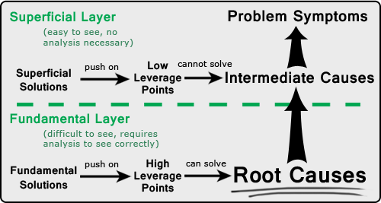
Even legally preventing corporations from doing all sorts of things (like lobbying and political donations) will make little difference, because their owners (the rich), their many employees, the news organizations they control, and the many writers, talk show "experts" and think tanks they sponsor can just do it for them. Solutions like the above are examples of superficial solutions. They attempt to resolve intermediate causes rather than the more difficult to find root causes.
(1) Why was the Citizens United case brought to court? (2) Why is there so much corporate money in politics? (3) Why are corporations socially irresponsible? (4) Why do corporations want personhood so strongly? The answer to all four questions is because that maximizes profits. The root cause of profit maximization is what caused all four of these intermediate causes.
So wouldn't it make sense to focus our efforts on the root cause? Shouldn't we take heed of what Henry David Thoreau wrote in Walden in 1854?
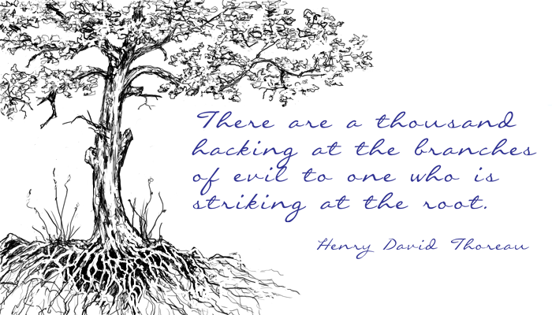
How can we best resolve the root cause of the problem?
This is straightforward. If corporate and people goals are incompatible, then one or both goals must be changed until they are in agreement. Since democracy is of the people, by the people, and for the people, it makes little sense to compromise and change the goal of people.
Therefore the solution is to change the goal of the corporate life form to one that aligns with that of people. As long as the top goal of corporations remains unchanged, the system will behave about the same because the goal of the dominant agent in a social system determines the general behavior of the system. This brings us to what will be:
The New Corporate Goal
The goal of corporations is providing the goods and services needed to optimize quality of life for people in a socially, environmentally, and economically sustainable way.
There will be considerable change resistance from the corporate life form (and their chief ally, the rich) to changing their goal. But that too has a root cause that can be found and resolved, because knowledge is power.
Suppose we overcame change resistance and then resolved the root cause. What would the new system look like at a high level of systems thinking? Part Two offers a possible answer.
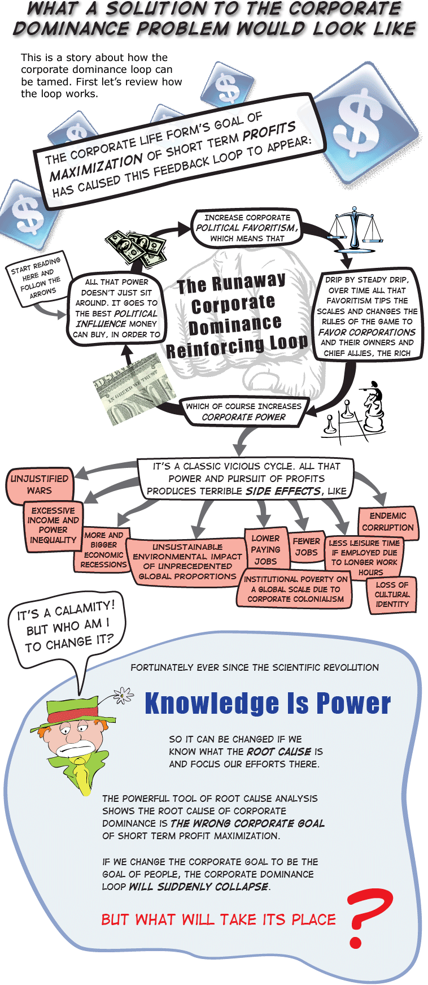

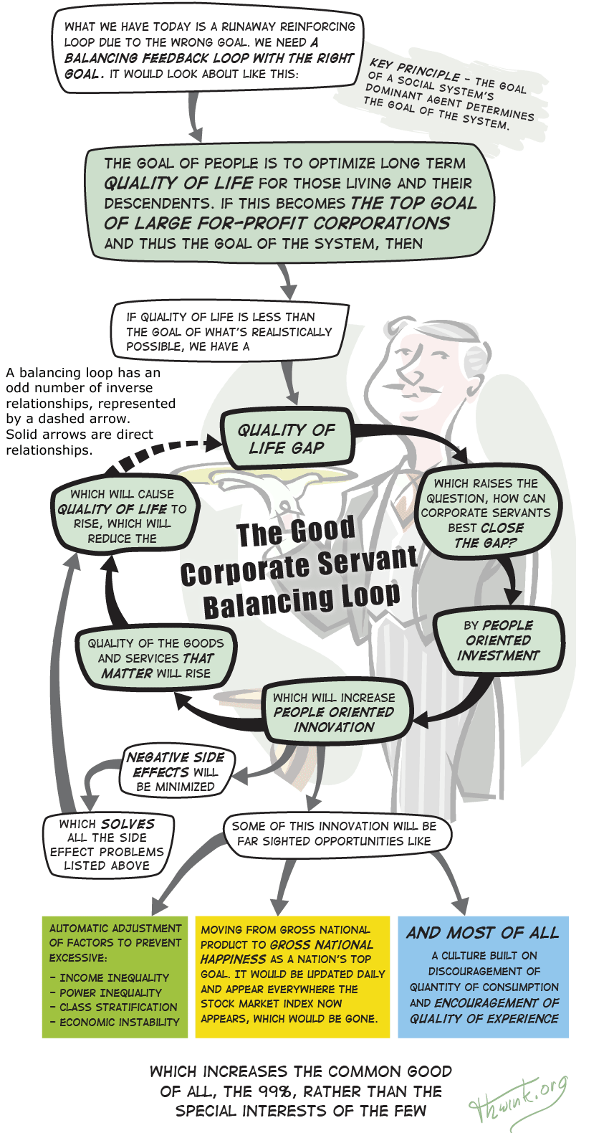
The 99% means the vast majority of people. Optimizing their quality of life is the common good and the goal of democracy. This goal can be achieved only if it is the top goal of the system's dominant agents, since the goal of a social system's dominant agents determine the goal's of the system.
No one can predict where a balancing loop with an optimize-quality-of-life goal will take the human system. The innovative examples shown above are mere conjecture, because no human political system has ever been in the optimize-quality-of-life mode for long.
Suppose progressives could unite behind the common vision of reengineering society to have the optimize-quality-of-life goal. This seems to be our dream anyhow. All this article is doing is analyzing how to get there. It appears this can be done by destroying The Runaway Corporate Dominance Reinforcing Loop and simultaneously creating The Good Corporate Servant Balancing Loop, all by changing the goal of the modern corporation. This requires:

Moving from Corporation 1.0 to 2.0
The modern for-profit corporation was never rigorously designed. It evolved. This has led to what we have today. Let's call this Corporation 1.0.
Corporation 1.0's one and only goal is short term profit maximization. This goal caused The Runaway Corporate Dominance Reinforcing loop drawn above to appear. The node on the right shows how "drip by steady drip, over time all that favoritism tips the scales and changes the rules of the game to favor corporations." On the next page is the stunning result of centuries of that steady drip:

The Competitive Advantage of Two Life Forms
Attribute | The Modern  Corporation | Homo  sapiens
1. Can physically manipulate its surroundings | No | Yes
2. Is legally considered a person | Yes | Yes
3. Maximum life span | Infinite | About 120 years
4. Can be in many places at the same time | Yes | No
5. Can own slaves like itself | Yes | No
6. Speed of procreation | Hours | Nine months
7. Can cut itself up into little pieces, each of which  can become a new life form | Yes | No
8. Can hibernate indefinitely in hard times | Yes | No
9. Body size limit | Unlimited | About 8 feet high
10. Brain size limit | Unlimited | About 1,500 grams
11. Owners have limited liability | Yes | No, since no owners
12. Has international organization with high efficiency of decision making and full power of enforcement of decisions for its life form type | Yes, the World Trade  Organization | No, the United Nations
Primary energy input | Money via sales | Food
13. Requires a physical form for its primary energy | No | Yes
14. Can transmit its primary energy instantaneously over great distances | Yes | No
15. Can store its primary energy indefinitely | Yes | No
16. Can store infinite amounts of its primary energy at no cost | Yes | No
17. Financial impact of storing its primary energy | Makes a profit by charging interest | Must pay  storage costs
In the first attribute Homo sapiens has the advantage. In the second attribute they are equal. In all the rest corporations have the overwhelming advantage. Poor Homo sapiens doesn't stand a chance, unless we put everything else aside and focus our efforts on one single thing: resolving the root cause of the corporate dominance problem. As Part One explained:
The main root cause is mutually exclusive goals between the corporate life form and Homo sapiens. Large for-profit corporations now dominate the planet. Their goal is maximization of short term profits. The goal of people is to optimize long term quality of life, for those living and their descendents. These goals are so incompatible they cannot both be achieved in the same system.
If the root cause is the wrong goal, then the solution is the right goal. The goal of Corporation 2.0 would be providing the goods and services needed to optimize quality of life for people in a socially, environmentally, and economically sustainable way. There is no need for pursuit of profits in that goal. In fact, the newly engineered Corporation 2.0 should have no incentive to maximize profits, since that causes the corporate dominance loop to appear. Therefore Corporation 2.0 should be non-profit. This is a radical change. But once you understand the analysis it's fully justified.
Retained earnings would be allowed. These internal profits are necessary to build the assets necessary to carry out the corporate life form's new goal, which can be summarized as "optimize quality of life for people." Dividends to owners or stockholders would no longer be allowed. Gone is the perverse incentive to maximize short term dividends at the expense of all sorts of terrible side effects.
The monumental benefit of Corporation 2.0 being non-profit is the corrosive impact of short term profit maximization disappears as a fundamental driver of the human system. The new way of corporate thinking will run about like this: “I’m no longer going to argue my company must resist anything that hurts my profits, because that’s no longer my bottom line. Instead, my new bottom line is to serve the needs of people. If my government or my fellow citizens propose a way to do that better, and I can’t think of an even better way, then I’m all for it.”
With one simple change to the law, everything changes. All a state or nation needs to do is pass legislation about like this:
Corporate law is hereby amended to redefine allowable types of non-federal corporations. The type widely known as for-profit is no longer permitted. This leaves the other type, non-profit, as the only allowable type. This act shall take effect on the last day of this year.
The five defining characteristics of the modern for-profit corporation have until now been: (1) separate legal personality, (2) delegated management, (3) limited liability, (4) transferable shares, and (5) investor ownership. Hereafter the last three characteristics are prohibited except in the case of non-profit worker cooperatives. For-profit corporate stock may no longer be bought or sold. Nor may dividends be paid on it.

The intent of this law is to align the goal of the modern corporation with that of Homo sapiens, whose goal is to optimize the common good for all living people and their descendents.
To implement this intent, all for-profit corporate charters shall be revised to be non-profit and shall include this statement:
This corporation is an artificial life form created by humans to serve their needs and is thus not a natural person. Nor is it an artificial person. It is an artificial servant. The overriding goal of this servant shall be to serve the needs of its human master to the best of its abilities, by providing goods and/or services that benefit the common good first and its customers second. No other goal shall have a greater or equal priority.
To allow a smooth ten year transition that does not disrupt the welfare of the people, a percentage of corporations, chosen at random, shall be converted each year. This shall start at .125% in the first year and increase to .25%, .5%, 1%, 2%, 4%, 8%, 16%, 32%, and finally 36.25% in the tenth year. For-profit corporations are encouraged to convert earlier than the year they are selected, since this will enhance their reputation as a trustworthy servant and thus increase their likelihood of survival.
At the end of each year, for that year’s converting corporations all their stock shall change to the equivalent of loans by shareholders to corporations. Loan value per share shall be calculated as the tangible book value of a corporation divided by the total number of shares. The full principle of these loans shall be paid off to loan owners over a period of thirty years. During that time interest on the remaining principle shall be paid quarterly at a rate of, for each stock, the average dividend rate for the last five years for common shares and the stipulated dividend rate for preferred shares divided by average share value.
This is of course only a rough illustrative example in plain English.
The hodgepodge of different incorporation laws in the states of some countries should be replaced by uniform national laws. This eliminates the tendency for a race to the bottom among states to break out, as states compete for more revenue via weaker incorporation laws. For the same reason, uniform international law should eventually be implemented.
A powerful hypnotic fallacy promoted by the corporate life form is that profits are necessary to motivate invention and entrepreneurs. What they really mean is profits in their present form of dividends to outside owners. There are other approaches, namely a non-profit approach.
Non-profit corporations can do anything for-profit corporations can do. This has been proven by many non-profits. An outstanding example is the Mondragon Corporation of Spain, a highly successful worker cooperative of 100,000 members.
The Corporation’s companies manufacture consumer goods, capital goods, industrial components, products and systems for construction, and services to business. [including] refrigerators, washing machines, ovens, dishwashers, and boilers... chip removing and sheet metal forming machine tools... automation and control products for machine tools, packaging machinery, machinery for automating assembly processes and processing wood, forklift trucks, electric transformers, integrated equipment for the catering industry, cold stores, and refrigeration equipment.... [for the auto industry] brakes, axles, suspension, transmission, engines, aluminium wheel rims, fluid conduction, and other internal and external vehicle components. ... business consultancy services, architecture and engineering, property consulting, design and innovation, systems engineering for electromechanical installations, and integrated logistics engineering.
The Mondragon Corporation, thousands of credit unions and agricultural coops, hundreds of thousands of NGOs, and more are an example of what a solution to the corporate dominance problem would look like. Each is living proof this solution can work... because it already has worked. All we need to do is scale up this already proven solution.

The dream
Mahatma Gandhi had a dream. Martin Luther King had a dream. So did Nelson Mandela, the Polish Solidarity Trade Union, and Harriet Beecher Stowe. All these visionaries dreamed it was possible to throw off an oppressor. All of them ultimately won.
It can be done again by solving the complete sustainability problem.
The sustainability problem includes the social, environmental, and economic sustainability problems. It thus includes the corporate dominance problem, because that problem is the foremost underlying cause of all these forms of unsustainability.
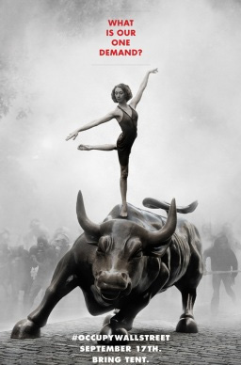
Solve the root cause of the corporate dominance problem and the most powerful life form on the planet will now be working for the human system instead of against it.
The poster asks "What is our one demand?" Now we know with some precision. The AdBusters Blog post on July 26, 2011 was titled "Is America Ripe for a Tahir Moment?" It stated that:
Our one simple demand is: STOP THE MONIED CORRUPTION
AT THE HEART OF OUR DEMOCRACY!

How can this demand be implemented? Given the root cause of monied corruption, the answer is just as simple:
CHANGE THE GOAL OF CORPORATIONS TO ONE THAT SUPPORTS THE GOAL OF DEMOCRACY.

That is our ultimate one demand.

This article is online at: www.thwink.org/sustain/articles/016/CorporateDominanceLoop.htm
Thwink.org is a sustainability research organization. The site contains further info about root causes, high leverage points, corporate dominance, and approaches to solving difficult social problems.
The site is oriented toward the environmental sustainability problem. However, the analysis shows that solving that problem requires solving the corporate dominance problem, because the corporate life form’s goal of short term profit maximization is incompatible with the goal of long term sustainability.

This pamphlet was prepared by:
Jack Harich
1164 DeLeon Court
Clarkston, GA 30021
404-296-5284
