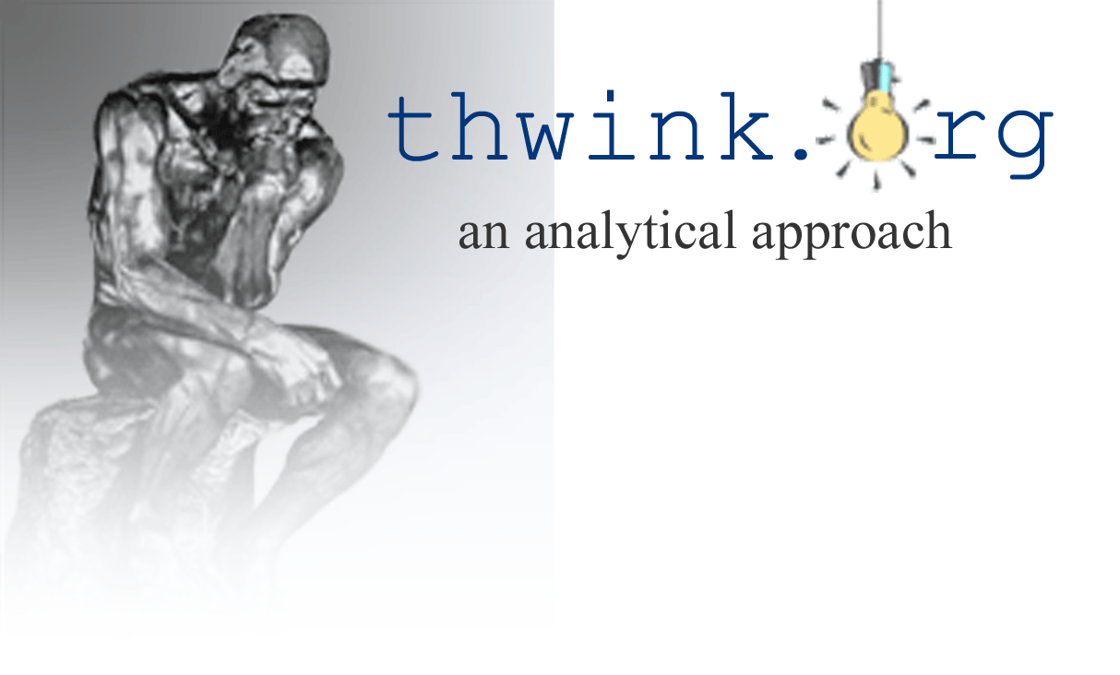
Prepared especially for the Georgia Sierra Club’s annual retreat
September 26, 2011

New Tools for Activists

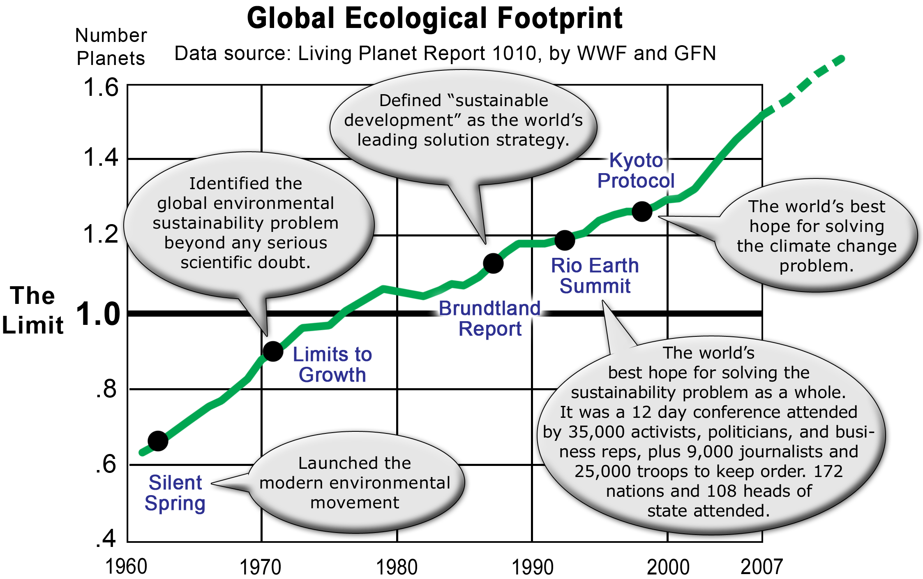
The Sierra Club has made tremendous contributions since its founding by John Muir in 1892. But despite winning a long string of campaign battles the club is losing the war, as the graph below shows.
The ecological footprint measures how many planets it would take to provide the ecological services the world is consuming. The footprint is calculated by the World Wildlife Fund and the Global Footprint Network. The latest updates were in 2003 and 2007. Both times they had to extend the top of the graph because footprint growth has become unstoppable. The footprint keeps right on rising and running off the chart, as the projected future growth on the right predicts will happen next time the graph is updated. Worse yet, curve growth didn’t slow down when it passed the limit that one planet can support in the late 20th century. Since then the world has been in ecological overshoot.
There’s a historical pattern at play here. Countless individuals, organizations, and politicians have tried as hard as they can to solve the sustainability problem. Solution after solution has been proposed. Some have been implemented. Major advances have occurred, such as the five events shown on the graph. But despite all these noble efforts, the problem remains unsolved. WHY is this? WHY is the human system unable to solve the environmental sustainability problem, despite decades of effort by millions of environmentalists? WHAT are we doing wrong?
Unless the Sierra Club can answer these questions deeply and correctly, its future will be about the same as its past. It will continue to win a few battles (such as stopping over 150 new coal power plants) but lose the war.

The 2011 Sierra Club Strategic Brief
The strategic brief is the club’s central plan. It “establishes the high-priority goals and strategies for this year.” It recognizes these are grim times for environmentalism: (bolding added)
Barely more than two years ago, Barack Obama assumed the presidency after an historic election that offered the promise of ‘transformational environmental reform’....
But we haven’t produced anything near the progress that was anticipated. Nor have we come close to delivering what the world needs. Failure to pass a climate bill in the U.S. handcuffed international negotiations, and the bill’s long and drawn-out public demise prevented other climate policy solutions from gaining any traction. There’s still been no meaningful response to the oil disaster from last summer. These defeats lay bare the weaknesses of our movement, and the current limits to the Sierra Club’s effectiveness.
What are the underlying causes of this weakness? How can the club best proceed to:
...look carefully at the vulnerabilities of our organization and movement, and better prepare ourselves for the next battles ahead.
There’s a clue in “look carefully.” A powerful tool for looking carefully into a problem is analysis. But what kind of analysis do we need?

The first new tool: root cause analysis
Difficult problems can be solved only by resolving their root causes. This is one of the most fundamental principles of all of science. It applies to any type of problem.
If you’ve been working on a problem for a long time and solutions are failing, there are only three possible reasons: the problem is insolvable, poor solution management, or use of solutions that do not resolve root causes. The last reason explains why the Sierra Club, as well as the environmental movement, has been unable to solve the sustainability problem: Popular solutions do not resolve root causes. Instead, they resolve intermediate causes. Once “our organization and movement” realizes this everything will change. The work of environmentalists will snap into effectiveness and the sustainability problem will at last be solved.
Environmentalists have been trying to violate the laws of physics without realizing it. Every effect has a cause. The chain of cause and effect always leads from root causes to intermediate causes to problem symptoms. The “weakness of our movement” is it has skipped root cause analysis. Instead, activists have intuitively assumed that solutions like alternative energy and conservation will work because they can “solve” the problem. This is a false assumption. Popular solutions like these do not resolve root causes. They resolve intermediate causes, as explained in this diagram:
According to Wikipedia a root cause is “an underlying cause that leads to an outcome or effect of interest. Commonly, 'root cause' is used to describe the earliest event in the causal chain where an intervention [a fundamental solution] could realistically have prevented the outcome.”
Building on this definition, Wikipedia says root cause analysis is “a class of problem solving methods aimed at identifying the root causes of problems or events. The practice of root cause analysis is predicated on the belief that problems are best solved by attempting to correct or eliminate root causes [with fundamental solutions], as opposed to merely addressing the immediately obvious symptoms [with symptomatic solutions].”
Let’s construct a causal chain for a typical Sierra Club problem and solution. The most pressing sustainability problem is climate change. The club’s leading current solution is the Beyond Coal Campaign, started in 2002. This is apparently going so well that Bloomberg Philanthropies recently committed $50 million to the campaign. The July 21, 2011 press release said: (bolding added)
Bloomberg added: “The Beyond Coal Campaign has had great success in stopping more than 150 new coal-fired power plants over the past few years and is empowering local communities to lead from the front while Congress continues to watch from the back. That is why I’m pleased to support the Sierra Club and its allies, and I encourage others to do the same.”
Here’s the causal chain for this problem:
Too much burning of coal is one of the many intermediate causes of climate change. The burning of coal is directly harmful behavior. So why not stop it with the Beyond Coal Campaign? This logic seems impeccable. Plus the campaign is working. Over 150 new coal plants have been stopped. It looks like a great solution.
But if we apply root cause analysis we come to an entirely different conclusion. The campaign is actually a drop in the bucket. It’s addressing such a tiny part of the total sustainability problem that the problem as a whole continues to grow worse. The club is once again winning the battle but losing the war. That’s why the club’s strategic brief lamented the sad fact that the club faces failure and defeat.
WHY is this happening? WHY is there too much burning of coal, as well as all sorts of other intermediate causes of climate change?
If we study Michael Brune’s book, Coming Clean: Breaking America's Addiction to Oil and Coal, we can find a pattern of behavior pointing toward the root cause. The book says: (bolding added)
Corporate leaders aren't the only ones standing in the way of progress, however.
Because the Bush administration opposed the state's law, it took the EPA a full eighteen months to even schedule a hearing....
Breaking our addiction to oil and coal is both patriotic and principled. Yet many are losing confidence that we can beet this challenge. ... Big Oil and King Coal may have armies of lobbyists, lawyers, foreign diplomats, and even military advisers....
But even as Obama embraced the idea of clean energy, he knew that a backlash was building. Unwilling to take on the oil industry and its allies in Congress....
Countless officials have railed against Big Oil, vowed to cut oil consumption, and then utterly failed to adopt the policies to get the job done.
There’s a pattern here. These quotes are the telltale symptoms of strong change resistance. What is the source of that resistance? It’s Big Oil, King Coal, the oil industry and its allies in Congress, and so on. It’s any large for-profit corporation who feels threatened by change that might reduce its short term profits. This explains why Rachael Carson faced the same strong change resistance when she published Silent Spring in 1962. The book was immediately attacked by the agri-chemical industry.
The same resistance has appeared countless times. WHY? Because hidden in the structure of the human system lies an unresolved root cause.
Large for-profit corporations have swept the world. Industrialization is another word for control of a nation’s economy/culture/government by large for-profit corporations. They control it by determining what is invented, what is produced and consumed, what jobs are available, what the press says, what politicians say, and what laws are ultimately passed. This is easy to do because of the immense amounts of money available to large for-profit corporations compared to small corporations, non-profits, and most citizens. Money talks. Elections are now, on the average, won by whoever raises the most money. Where does most political ad money, lobbying money, campaign money, biased think tank funding, and so on come from? Large for-profit corporations and their chief ally and owners, the rich.
Large for-profit corporations are so ubiquitous and work so cohesively together to promote their interests they are best called the corporate life form. This is Corporatis profitis. Its top goal is to maximize the net present value (short term value) of profits.
But there’s a problem. This is not the goal of people. The goal of Homo sapiens is to optimize the long term value of quality of life for those living and their descendents. These two goals are so mutually exclusive they cannot both be achieved. One goal must prevail at the expense of the other. The result of that is one life form prevails at the expense of the other. The end result is where we are today. Corporate sales and profits continue to grow, while personal income stagnates and quality of life falls, due to problems like environmental pollution and natural resource shortages.
This leads to the root cause of the climate change problem: mutually exclusive goals between Corporatis profitis and Homo sapiens. That causes resistance to anything that threatens to reduce short term profits. It’s the reason Obama has been unable to fulfill his “promise of transformational environmental reform.” It’s the reason for “failure to pass a climate bill in the U.S.” It’s the reason for the defeats the club has been facing for over a century.
Root cause analysis finds the root causes of a problem. That information makes solving the problem relatively easy because we can now design solutions to push on high leverage instead of low leverage points. The high leverage point for resolving the root cause is fairly obvious. It’s correctness of goals for artificial life forms, since we don’t want to change the goal of natural life forms (people). A sample solution element to do this is Corporation 2.0. This reengineers the modern corporation from version 1.0 to 2.o. The newly designed corporation has the new goal of optimizing some aspect of serving humanity, plus other changes such as loss of personhood and limited liability. For details of Corporation 2.0 as well as the analysis and other solution elements, see the book Common Property Rights: A Process Driven Approach to Solving the Complete Sustainability Problem at Thwink.org.
Once the root cause is resolved the human system will shift into a new mode. It will behave completely differently. Gone will be the high systemic change resistance that’s been the bane of activists ever since they started working on the sustainability problem. Solving common good problems, because this advances the goal of Homo sapiens, would now benefit 2.0 corporations. Because large corporations are the dominant social agent on the planet, this would have the effect of solving the sustainability problem in the fastest and most efficient manner strategically possible. Imagine what it would be like for large corporations to work as hard to solve the sustainability problem as they have worked in the past to not solve it. Furthermore, think how hard 2.0 corporations would work to avoid other problems like war, institutional poverty, and economic bubbles, because these too cause their masters to suffer.
How can the club best proceed to assimilate the powerful new tool of root cause analysis? The same way science and business manages its key tasks: by using a process that fits the problem.

The second new tool: a process that fits the problem
Sophisticated root cause analysis requires a fundamental change in the way activists think and work. Rather than an informal intuitive approach to problem solving, activists need to do what science and business did long ago: switch to a formal process driven approach to problem solving. They need to follow this key principle: The more difficult the problem, the better the process used to solve it must be. A shorter version is: The process must fit the problem.
A process is a reusable series of steps to achieve a goal. There’s the process of long division, the process of building a house, the process of raising a family or growing a field of wheat, and the process a nation’s constitution provides for running its government. Processes are everywhere. They rule our lives because we run our lives with them. Without the right millions of processes used every day, modern civilization would shudder and collapse back into the Dark Ages.
Doctors use a simple process of diagnosis first, treatment second. Business uses the process of double entry accounting as the foundation for achieving profit goals. Business also uses countless other processes, like annual planning, a hierarchy of control, and how to run a marketing campaign. Science bases its work on the Scientific Method, a process for determining if a hypothesis is (probably) true or false.
But when we examine the field of public interest activism, what do we find? No standard formal process whatsoever. Instead, we see well intentioned individuals and institutions putting forth one solution after another that have tremendous intuitive appeal. They are plausible. They should work. But in practice they seldom do on difficult problems. WHY is this?
It’s because intuitively derived solutions rarely resolve root causes. In difficult problems root causes are very hard to find, especially multiple root causes. Long analysis, careful verification of all key hypotheses, exacting experimentation and measurement, detailed modeling, and so on is required. It’s not at all obvious how to do this efficiently and effectively. That’s why a formally defined process is required.
Over the past ten years Thwink.org has developed a process that can serve as an example of a suitable process for environmentalists. This is the System Improvement Process (SIP). It was designed from scratch to solve difficult social problems. SIP contains a total of 23 steps and is summarized in the diagram on the next page. For a full description of SIP see the Common Property Rights book.
Briefly, here’s how the process works. SIP first defines the overall problem. Then it breaks the one big problem down into the three subproblems present in all difficult social problems:
A. How to overcome change resistance.
B. How to achieve proper coupling.
C. How to avoid excessive model drift.
Change resistance is the tendency for a system to continue its current behavior, despite the application of force to change that behavior. When someone proposes a serious solution that will help and the system rejects it that’s change resistance.
We’ve already seen tangible examples of change resistance in the quotes from Michael Brune’s book. Once you know what change resistance is, it’s everywhere. It’s the reason thousands of perfectly workable solutions have been rejected for decades. It’s the reason the U.S. Senate voted an astounding 95 to zero against signing the Kyoto Protocol in 1999, despite a democratic President and a strongly pro-environmental Vice-President, Al Gore, at the time.
Proper coupling occurs when the behavior of one system affects the behavior of one or more other systems in a desirable manner, using the appropriate feedback loops, so the systems work together in harmony in accordance with design objectives. For example, if you never got hungry you would starve to death. You would be improperly coupled to the world around you. In the environmental sustainability problem the human system is improperly coupled to the greater system it lives within: the environment. Most popular solutions (such as the Kyoto Protocol, conservation, and population control) are proper coupling solutions since the proper coupling problem is commonly seen as the problem to solve.
Model drift occurs when situations appear that a solution model cannot handle and the model cannot be patched up to accommodate them. If these anomalies are relatively small, the model is still useful and model drift is said to have occurred. But if the exceptions accumulate and become major, then the model is now a hindrance to those using it. Excessive model drift has occurred and the model is broken. It’s so useless the solution no longer works as originally intended. This may or may not be noticed by some or even the majority of model users, who often erroneously claim the present model still works.
So many solutions are in model drift in most nations that they are in a continual state of crisis management, because previously solved problems keep reappearing. For example, most nations have never fully solved the cyclic recession problem, the political corruption problem, the institutional poverty problem, and the excessive disparity in income/wealth problem. Add the environmental sustainability problem and you have an imposing suite of problems that can overwhelm a society’s capacity to solve them simultaneously.
All three subproblems must be solved for a problem to be completely and permanently solved. In difficult social problems, change resistance is the crux. It must be solved first because until change resistance is overcome proper coupling is impossible.
This is an important insight that once fully accepted will have deep ramifications. The Sierra Club’s many campaigns will have little effect on the overall sustainability problem until the change resistance subproblem is solved. This implies a refocus of how the club is organized. Currently there is no significant analysis function of the problems the club is working on. That void can be filled the same way business handles its own analysis problem: by creation of a well staffed, well funded, process driven R&D department. The output of R&D becomes the input for the club’s main departments of conservation and communications—just as the output of R&D feeds manufacturing and marketing in the business world.
Once the one big problem is decomposed into three or more subproblems, root cause analysis is employed to find the root causes. This is the most important step in the process. Get it right and the problem is mostly solved. Get it wrong and no amount of ingenious solutions, heroic effort, or inspirational prose will solve the problem because difficult problems can be solved only by resolving their root causes. That’s why you should spend about 80% of your time in analysis. A company’s products are no better than its R&D. An NGO’s solutions are no better than its analysis.
Only after the root causes are found does attention shift to solution development. But even then, analysis continues. The model used to find the root causes is used to find the intermediate causes, the low leverage points, and the symptomatic solutions activists have been using in a vain attempt to resolve the intermediate causes. This is crucial since part of the solution is to stop such wasteful effort. This may come as shock because it means that some of the most cherished solution strategies of traditional activism will need to be abandoned, scaled back, or radically redesigned to closely support the main solution elements that resolve the root causes.
Once the analysis step is reasonably complete, solution convergence begins. Here the collection of solution elements for solving the problem are converged upon by generating candidate solution elements and testing them against specific high leverage points. This goes relatively quickly because how the system behaves is so will known. This step includes further modeling, experimentation, and pilot testing in order to refine the solution elements to ones that can be proven to work.
There is no such thing as a simple solution to a complex problem. The Common Property Rights book presents twelve sample solution elements. All are required to solve the complete sustainability problem.
The final step of SIP is implementation. We’re dealing with public interest problems here, so at this point problem solvers hand off their analysis, solution convergence work, and final recommended solution elements to government or an appropriate institution. Because a high quality root cause analysis has been done and solution elements are well tested, what is usually the hardest step, implementation, now becomes the easiest.
That’s how the process works. But how do we go deep enough to know how the system works? How can we see the structure of the social system and how it works in convincing detail? How can we rapidly test our many findings and assumptions as we go, no matter how complex they become? For that we need another tool.

The third new tool: model based problem solving
If you look back at the SIP diagram you’ll see feedback loops mentioned several times. In fact, all five substeps of analysis depend on study of the system’s feedback loops. This is best done by use of a simulation model, which means that SIP depends on model based problem solving.
A model is a simplified representation of reality. A simulation model takes that representation and allows you to run the model so you can see how the system behaves over time. This is extremely useful for predicting how the system will respond to various forces, such as deep underlying trends, growth constraints, unexpected events, and solution policies. Simulation models are so vital for understanding the behavior of complex systems that their use is the norm in science and business. Examples are weather prediction models, climate change models, quantum physics models, and economic models.
The sustainability problem is primarily a social problem. It’s unsound social behavior that’s causing the problem. Yet when we examine the work of environmental organizations, from tiny ones all the way up to big ones like the Sierra Club, the World Wildlife Fund, the United Nations Environmental Programme, and the European Union Environmental Directorate General, what kinds of simulation models of the social side of the sustainability problem do we find? None. There are models but they focus on the technical side of the problem, such as climate change models, ecological system models, and the World3 model of The Limits to Growth.
The System Improvement Process was designed to solve difficult social problems. It uses simulation modeling to perform the analysis step. Difficult social system problems are so complex and counter intuitive they cannot be correctly understood without simulation modeling, just as so many other fields cannot understand their problems without modeling.
On the next page is the key model from the Common Property Rights book. The Dueling Loops model contains three main feedback loops. The model explains an amazing amount of system behavior. It explains why there’s so much political corruption and why it has proven to be so difficult to eradicate. It also explains why special interests get their way most of the time, usually at the expense of not solving problems whose solution would benefit the common good, such as the sustainability problem. Until activists can see how the system behaves using models like this one, they will be powerless to take effective action.
The Dueling Loops model does more than explain why the problem is happening. It shows where the high leverage points are for resolving the root causes. It also shows where the low leverage points are that problem solvers are pushing on now and why that doesn’t work. It’s a rich model, packed full of insights and usefulness.
At first glance the model will probably appear hopelessly complicated and impossible to understand. It may appear that simulation models can only be understood by exalted wizards in ivory towers who’ve had a lifetime of training in modeling. This is not true. The general nature of models like the one shown can be understood by any activist who is willing to put in several hours or days of study, either in self-study or presentation and discussion. For example, the Dueling Loops model can be understood by watching the Dueling Loops Videos at Thwink.org. These twelve videos average 8 minutes apiece. Or you can read the Dueling Loops paper or pamphlet. Or you can study the Common Property Rights book, which presents model based problem solving at a more leisurely pace, complete with an introduction to feedback loops.

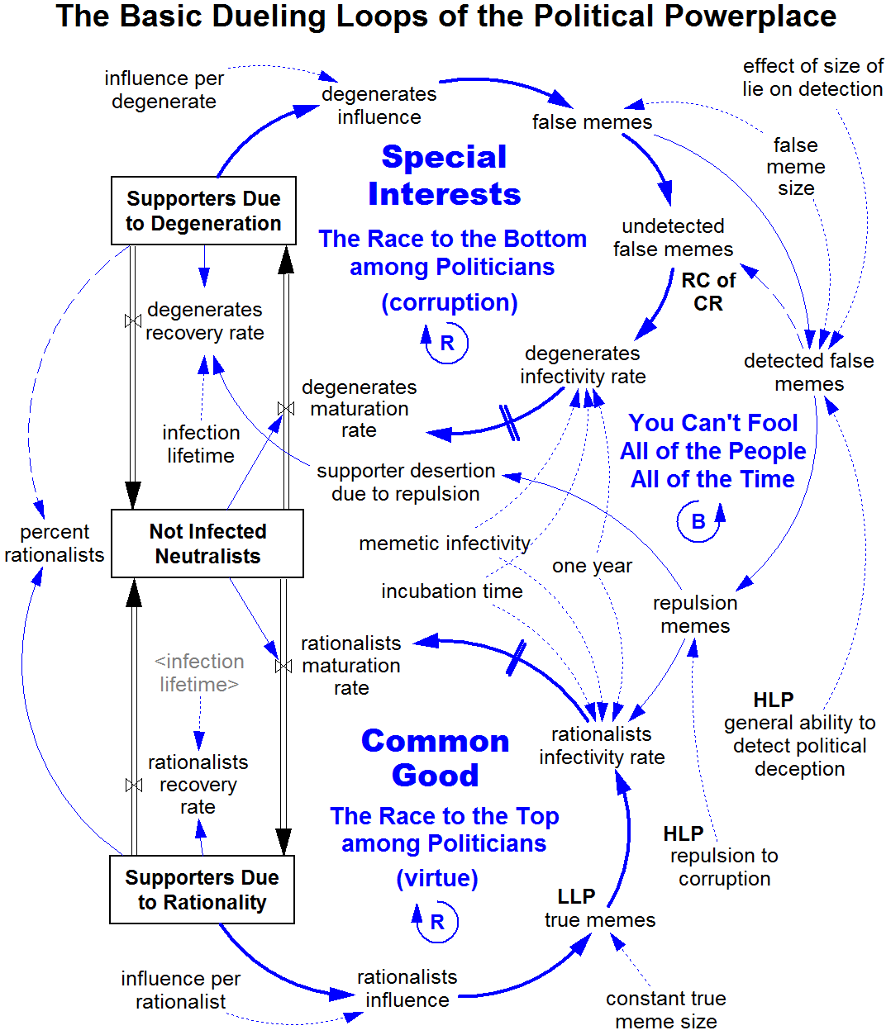
Almost anyone can learn causal loop diagram modeling, which is done with pencil and paper. That’s how the model below began. Learning how to build a computer simulation model requires a serious investment in training, study, and practice. This varies from several weeks to several years, depending on your needs and background. Fortunately not everyone needs to become a simulation modeler, just as not everyone needs to know how to build a car. They only need to be able to understand how they work and how to run them. The average organization will need only a few simulation modelers, who can build the models needed by the rest of the analysis team.
There are two high leverage points (HLP). The one making the most difference is general ability to detect political deception. (Node names are underlined.) If the model is reasonably correct then pushing there will allow us to overcome systemic change resistance to solving the sustainability problem. Currently nearly all effort is directed toward the more intuitively attractive but low leverage point (LLP) of “more of the truth,” which is the true memes point. Pushing there fails, because environmentalists simply do not have enough force to directly overcome the inherent advantage of the race to the bottom. They can only overcome it indirectly by pushing elsewhere on high leverage points. This will reduce undetected false memes and thereby resolve the root cause of successful change resistance (RC of CR).

Putting it all together
If we put these new tools together here’s what they can do. On the next page is the Summary of Analysis Results for Executing SIP on the Global Environmental Sustainability Problem. The club’s results will be different because these results are a first iteration and are tentative. They have not yet been extensively tested or independently verified.
The key message is there is a way to systematically analyze and solve the sustainability problem. Its root causes can be found. Once they are found the high leverage points for resolving the root causes can be pinpointed. Once that’s done specific solution elements for pushing on the high leverage points can be designed, tested, and implemented. A methodical approach like this is the same approach that business and science have taken for centuries to so effectively solve their central problems. Why can’t public interest activism do the same?
Let’s imagine what could happen if the club applied these tools and performed its own analysis. The 2011 Sierra Club Strategic Brief contains these four sections:
1. Context
2. Overarching Priority
3. Key Conservation Goals
4. Conditions Necessary for Success
The Context section describes the problem (“we haven’t produced anything near the progress that was anticipated”), takes a quick look at the present (“we currently do not have sufficient strength to take on the oil and coal industries in a head-to-head national confrontation”), takes a quick look at the past (“the most important victories the Club has achieved over the past two years – stopping the coal rush – have been a series of local fights in which we were able to mobilize collective power against isolated opponents”), and then presents the club’s solution strategy (“Here we’ll go back to basics by engaging in bottoms-up organizing to create a compelling national narrative. ... The strategies outlined below seek to build on the Club’s strengths, using local issues to build a compelling national narrative that will help us to confront the dominance of the coal and oil industries.”).

Summary of Analysis Results of Executing SIP on the
Global Environmental Sustainability Problem
1. Problem Definition |  |  |  | How to achieve global environmental sustainability  in terms of the desired system goal state
2. Analysis | Subproblems |  |  | A.  How to Overcome Change Resistance | B.  How to  Achieve Social  Proper Coupling | C.  How to Avoid Excessive Model Drift | D.  How to Achieve Economic  Proper Coupling
2. Analysis | A |  | Subproblem  symptoms | Successful opposition to passing proposed laws for solving the problem | Large for-profit corporations are dominating political decision making destructively | Failure to correct failing solutions when they first start failing | The economic system is causing unsustainable environmental impact
2. Analysis |  |  | Improperly coupled systems | Not applicable | Corporate and human life forms | Not applicable | Economic and environment systems
2. Analysis |  |  | Analysis model | Basic Dueling Loops of the Political Powerplace | Complete Dueling Loops model.  This adds the Alignment Growth loop. |  | The World’s Property Management System
2. Analysis |  |  | Immediate cause dominant loops | The Race to the Bottom  among Politicians |  | Intelligent Adaptation loop in evolutionary algorithm model | Growth of Industrial Technology and Limits to Growth  (the IPAT factors)
2. Analysis | B. Root cause of why those loops are dominant |  |  | High political deception effectiveness | Mutually exclusive goals between top two social life forms, Corporatis profitis & Homo sapiens | Low quality of political decisions | High transaction costs for managing common property sustainably
2. Analysis | C | Intermediate causes |  | The universal fallacious paradigm, primarily Growth Is Good | Disagreement from corporate proxies on what to do | Laws giving corporations advantages over people | Externalized costs of environmental impact
2. Analysis | C | Low leverage points |  | More of the truth: identify it, promote it, magnify it | Logical and emotional appeals and bargaining | Trying to directly reverse laws that favor corporations | Internalize costs
2. Analysis | C | Symptomatic solutions |  | Technical research, environmental magazines and articles, awareness campaigns, marches, sit-ins, lawsuits, lobbying, etc. | Corporate social responsibility appeals, green investment funds, NGO/corporate alliances, etc. | Media use, campaigns, lobbying to get old laws repealed | Two main groups  of solutions: prescriptive regulation and market-based
2. Analysis | D. Loops that should be dominant to resolve root cause |  |  | You Can’t Fool All of the People All of the Time | Alignment Growth |  | Growth of Sustainable Technology and Impact Reduction
2. Analysis | E. High leverage point to make those loops go dominant |  |  | General ability to detect political deception | Correctness of goals for artificial life forms | Maturity of the political decision making process | Allow firms to appear to lower transaction costs
3. Solution Convergence |  |  |  | Nine solution elements | Corporation 2.0, Corporatis publicus | Politician Decision Ratings | Common Property Rights
4. Implementation |  |  |  | Not yet ready for implementation because process execution is incomplete.
But where is the analysis that should come between problem definition and solution? There is none. It’s been skipped. There’s only a quick intuitive look at the past and present. This can work on easy problems. But it cannot work on problems as complex and difficult as the environmental sustainability problem because an intuitive approach cannot find and resolve the well hidden root causes.
Suppose the club adopted these new tools and performed a preliminary analysis by 2013. The 2013 Sierra Club Strategic Brief might contain these sections:
1. Problem Definition
2. Analysis Results
3. Primary Solution Strategies
4. Solution Elements
5. The Strategic Plan
6. Conditions Necessary for Success
The (1) Problem Definition section would define and describe the problem the club is addressing. The (2) Analysis Results section would present the analysis using a table like the Summary of Analysis Results, along with discussion of the results. This would be the highlight of the document and the longest section, since it’s the one that matters most. The (3) Primary Solution Strategies section would present the solution strategies by reviewing the high leverage points in greater depth. The (4) Solution Elements section would present the actual solution in the form of a collection of solution elements, each of which pushed on a specific high leverage point. (5) The Strategic Plan would contain a sequential plan (perhaps with a Gantt chart) for further analysis and solution element implementation since a phased approach is required for such a challenging analysis and to make such large mode changes to the system over time. Finally, the (6) Conditions Necessary for Success section would summarize and review the key policies, changes, and projects necessary to successfully implement the plan.
The result would make John Muir smile with satisfaction.

For further information please see the Thwink.org website.

See http://clubhouse.sierraclub.org/people/committees/board/2011-strategic-brief.aspx
See http://action.sierraclub.org/site/MessageViewer?em_id=211461.0

