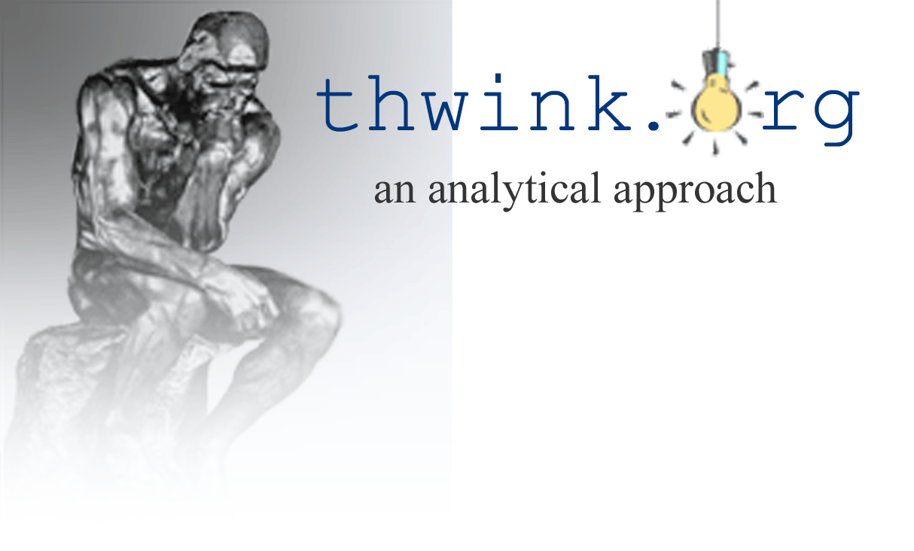
Prepared especially for the Georgia Sierra Club’s annual retreat
September 26, 2011

The New Dominant Life Form

Let’s define a life form as any independent agent that follows the three fundamental requirements of evolution: replication, mutation, and survival of the fittest.
Here’s a question: What life form has the ability to replicate instantly with almost no expenditure of energy, can mutate during replication or at any time thereafter, and, when it has failed in the battle of survival of the fittest, sells little pieces of itself to its competitors in order to minimize its own pain of death? These are fantastic powers no human could hope to have. But what if we go further, and ask what life form has the miraculous power of being in many places at the same time, has an infinite life span, and can cleave off chunks of itself and have them instantly come alive? That would make it a formidable competitor indeed, one that could run rings around any other plant or animal. Darwin would be astounded.
But there’s more: What life form totally dominates mankind, by controlling most jobs in developed countries, by determining the path of nearly all of new technology, products, and services, by controlling elections and political decisions more than any other life form, and by defining the very evolution of culture to its advantage through demand advertising, ownership of the media, and new product design? If that is not enough, what life form controls the billions of boxes in our homes that provide us with most of our “news,” and most of our new knowledge once we have finished school, while at the same time subconsciously indoctrinating us to be high volume, complacent consumers? To top it off, what life form is spreading exponentially from industrialized countries to the rest of the world, and will soon dominate them all? The answer is obvious. It’s large for-profit corporations, which is the New Dominant Life Form, also known as Corporatis profitis.
Thus the dominant life form on Earth is no longer Homo sapiens. Instead, it is large for-profit corporations and their allies, notably the rich.
The corporate life form has achieved dominance by successful exploitation of the race to the bottom and mass deception. It can thus endlessly thwart or delay all efforts to significantly change the human system to environmental sustainability, and just as endlessly continue to maximize Gross World Product growth so as to achieve its goal. Globalization is really the deliberate spread of the New Dominant Life Form into new economic niches, cloaked in the fallacious but appealing premise that free market/corporate system, driven by profit maximization, is the most efficient and best system possible.
The goal of an agent determines its behavior. The goal of most for-profit corporations is to maximize the net present value of profits. The goal of most people, once past the survival and security stage, is to maximize quality of life for themselves and their descendents.
These goals are mutually exclusive. As a result, as things get better for the New Dominant Life Form they get worse for the previously dominant life form: Homo sapiens. For example, as Gross World Product continues to rise, sales and profits soar to unprecedented heights. However, so does pollution and natural resource depletion. While the consequences of these effects are delayed, it is only a matter of time before the quality of life for Homo sapiens begins to fall.
Please note this is not an indictment of all corporations and their managers. Most are doing the best they can, and are basically good. Each agent, from its own perspective, is behaving rationally. It is the life form as a whole that has the emergent property of behaving unsustainably.
This is the real enemy environmentalists are battling. Don’t blame the problem on “bad” politicians. These are mere proxies for the real opponent: the modern corporation and its allies. Its allies include top corporate management, stockholders, the rich (the key ally), the military, and politicians, plus various large special interest groups as expediency requires, such as the religious right.
It is a paradox why Homo sapiens would create an entity that is more powerful that itself and has a mutually exclusive goal. Such a creation is guaranteed to cause its creator great harm, if not eventual extinction. But it’s really not a paradox at all—it's an experiment gone awry. So awry that the time has come to end the experiment by redesigning that creation….
That creation has steadily pulled ahead of it closest rival. Step by tiny step, it has relentlessly changed the rules of the game to favor itself. This has been done so cleverly and in such small, imperceptible increments that few citizens have noticed. But when you pause to examine the outcome the findings are shocking, as the table on the next page reveals.
Only in the first attribute does Homo sapiens have the advantage. In the second attribute they are equal. In all the rest the modern corporation has the overwhelming advantage.
The Competitive Advantage of Two Life Forms
Attribute | The Modern  Corporation | Homo  sapiens
1. Can physically manipulate its surroundings | No | Yes
2. Is legally considered a person | Yes | Yes
3. Maximum life span | Infinite | About 120 years
4. Can be in many places at the same time | Yes | No
5. Can own slaves like itself | Yes | No
6. Speed of procreation | Hours | Nine months
7. Can cut itself up into little pieces, each of which  can become a new life form | Yes | No
8. Can hibernate indefinitely in hard times | Yes | No
9. Body size limit | Unlimited | About 8 feet high
10. Brain size limit | Unlimited | About 1,500 grams
11. Owners have limited liability | Yes | No, since no owners
12. Has international organization with high efficiency of decision making and full power of enforcement of decisions for its life form type | Yes, the World Trade  Organization | No, the United Nations
Primary energy input | Money via sales | Food
13. Requires a physical form for its primary energy | No | Yes
14. Can transmit its primary energy instantaneously over great distances | Yes | No
15. Can store its primary energy indefinitely | Yes | No
16. Can store infinite amounts of its primary energy at no cost | Yes | No
17. Financial impact of storing its primary energy | Makes a profit by charging interest | Must pay  storage costs
Galloping galoshes! Decision by legal decision the modern corporation has built up an astronomical lead over Homo sapiens. These are huge, order of magnitude advantages. There is little question who is going to continue to win the battle for dominance unless things change.
Mutually exclusive goals between Corporatis profitis and Homo sapiens is the main root cause of change resistance to solving the sustainability problem. It’s why the U.S. Senate voted 95 to zero against the Kyoto Protocol in 1999. It’s why the 2010 BP Deepwater Horizon oil spill occurred—too many safeguards were shortchanged because they reduced profits. It’s why the Obama administration has been unable to deliver on its promise of “transformational environmental reform.” It’s why numerous Republican politicians are climate change deniers and want to reduce the regulatory power of the Environmental Protection Agency. It’s why Sharon Beder wrote her book on Global Spin: The Corporate Assault on Environmentalism. It’s why “prevailing against the oil and coal industries” is so difficult, as Michael Brune explains in his book Coming Clean: Breaking America’s Addiction to Oil and Coal.
What’s the solution? It’s not shaming corporations into being more socially responsible because that conflicts with their top goal. It’s not lobbying for better environmental regulations, because the ones we really need seldom become law due to change resistance. Nor is it campaigns to enforce existing environmental law, to promote the three R’s of reduce, reuse, recycle, or to promote more use of renewable energy and less burning of fossil fuel. It’s also not trying to elect “good” politicians instead of “bad” ones or campaign finance reform. Solutions like these can help only a little. They have low leverage because they do nothing to resolve the root cause. Instead we must go deep and change the goal of the New Dominant Life Form so that it aligns with that of Homo sapiens.
One way to do this is to reengineer Corporation 1.0, which is what we have today, into Corporation 2.0. The new top goal would be to serve humanity by providing a needed product or service. Corporations would be seen as servants of the people, since that’s who created them and that’s who they are designed to serve. To eliminate the tendency of the profit goal to blind corporations to everything else, Corporation 2.0 would be non-profit. Dividends to owners or stockholders would no longer be allowed. Profits would be reinvested in the business, refunded to members of consumer cooperatives, or paid out to workers of worker cooperatives.
The monumental benefit of Corporation 2.0 being non-profit is the corrosive impact of short term profit maximization disappears as a fundamental driver of the human system. The new way of corporate thinking will run about like this: “I’m no longer going to argue my company must resist anything that hurts my profits, because that’s no longer my bottom line. Instead, my new bottom line is to serve the needs of people. If my government or my fellow citizens propose a way to do that better, and I can’t think of an even better way, then I’m all for it.”
Once a majority of corporations are 2.0 corporations everything will change. The human system will now “want” to solve the sustainability problem, just as strongly as it doesn’t want to solve it today. That will lead to solution of the sustainability problem in the fastest and most efficient manner possible, because the New Dominant Life Form and Home sapiens will now be rowing the boat in the same direction.

